CONTENTS

Abstract ------------------------------------------------------------------------------------------------ 5
Introduction -------------------------------------------------------------------------------- 6
Web Standards ------------------------------------------------------------------------------ 7
Web Designing History -------------------------------------------------------------------- 8
Scope of Web Designing ----------------------------------------------------------------- 9
Objective ---------------------------------------------------------------------------------------------- 10
Methodology ----------------------------------------------------------------------------------------- 11
Limitations -------------------------------------------------------------------------------------------- 12
Screenshots ------------------------------------------------------------------------------------------ 13
Codes -------------------------------------------------------------------------------------------------- 16
Future Prospects ------------------------------------------------------------------------------------ 22
Conclusion -------------------------------------------------------------------------------------------- 23
References ------------------------------------------------------------------------------------------- 24
Appendices ------------------------------------------------------------------------------------------- 25

ABSTRACT

The aim of this paper is to examine the domain of World Wide Web site development and propose a methodology to assist with this process.
During the research for the project, I studied HTML, CSS and Javascript and accordingly implemented the theories into designing a homepage with five more links namely, Invitation, City Population, Login Form, Shipping Calculator and Sample layout.
The homepage contains links to the different aspects of the term paper report as well as the hyperlinks to webpages developed as a part of practice for the same.
The invitation page, displays a frame within the homepage, through which, when respective text fields are filled out by the user, it displays a text area, inviting the user at the entered location.
The city population web page, contain select boxes having pre-defined input names of the state and the city, of which the user desires to get population. And when a particular index is selected, it displays its population.
The login form is a demonstration of the ability of CSS in making a page look appealing. It displays a modern looking format of a login entry into the website with options to login with username and password and register as a new user. It is not embedded with any server-client programming and hence clicking of buttons results into nothing.
Shipping Calculator page is an attempt to write pages in javascript. It displays the cost of shipping an item according to the weight and the location entered by the user through text box and the list, respectively.
Sample layout copies the format of any regular business website with features like tip of the day, advertisement, references, newsletters, sitemap, services, about etc. Due to lack of actual purpose, it is designed just as a sample.

In order to continue the project, I have started designing a game to be embedded into the website.

INTRODUCTION

The Internet is a global system of interconnected computer networks and, the web is a system of interlinked hypertext documents accessed via the Internet through web browsers.
The idea of the web was to link directly from one academic paper to another academic paper and hence, web content is dominated by the "page" concept and so, a web page is a web document or a computer file, displayed on a monitor or mobile device by the web browsers. It contains textual information, static images, animations, audio, video, illustrations, games, buttons, hyperlinks, forms etc.
A website is a set of related web pages served from a single web domain. It is hosted on at least one web server, accessible Internet or a private local area network a Uniform resource locator. All publicly accessible websites collectively constitute the World Wide Web.
Websites have many functions and can be used in various fashions:
- Blogs: A blog is now the new "home page", that is, written by a "person" and that person reveals information from her/his perspective.
- Search engine sites: A search engine results page (SERP) displays a heading, usually the name of the search engine, and then a list of websites and their addresses. What are being listed are the results from a query that may be defined as keywords. The results page lists webpages that are connected in some way with those keywords used in the query.
- Discussion boards: The driving mechanism of a discussion board is the fact that users are registered and once registered can write posts. Often a discussion board is made up of posts asking some type of question to which other users may provide answers to those questions.
- Ecommerce sites: These are largely composed of textual material and embedded with graphics displaying a picture of the item(s) for sale and are usually organized by software identified as a "shopping cart".
Web design encompasses many different skills and disciplines in the production and maintenance of websites. The different areas of web design include web graphic design; interface design; authoring, including standardised code and proprietary software; user experience design; and search engine optimization. Generally, the term web design is normally used to describe the design process relating to the front-end (client side) design of a website including writing mark up.
The web designers are responsible for the visual aspect, which includes the layout, colouring and typography of a web page having a working knowledge of using a variety of languages such as HTML, CSS, JavaScript, PHP and Flash to create a site.
WEB STANDARDS

To make internet a better place and simplify its development and understanding, it is important to follow some standards ensuring proper display of web sites without time-consuming rewrites.
Web standards are the formal, non-proprietary standards and other technical specifications that define and describe aspects of the World Wide Web. It is now a days, associated with the trend of endorsing a set of standardized best practices for building web sites, and a philosophy of web design and development that includes those methods.
W3C creates and maintains the Web standards.
When web standards are discussed, the following publications are typically seen as foundational:
- Recommendations for markup languages, such as Hypertext Markup Language (HTML), Extensible Hypertext Markup Language (XHTML), Scalable Vector Graphics (SVG), and XForms, from W3C.
- Recommendations for stylesheets, especially Cascading Style Sheets (CSS), from W3C.
- Standards for ECMAScript, more commonly JavaScript, from Ecma International.
- Recommendations for Document Object Models (DOM), from W3C.
- Properly formed names and addresses for the page and all other resources referenced from it (URIs), based upon RFC 2396, from IETF.
- Proper use of HTTP and MIME to deliver the page, return data from it and to request other resources referenced in it, based on RFC 2616, from IETF.
Web accessibility is normally based upon the Web Content Accessibility Guidelines published by the W3C's Web Accessibility Initiative.
Web pages that conform to the standard are easier for people with disabilities to use the Web and easier for search engines to access and index, easier to convert to other formats, and easier to access with program code (like JavaScript and the DOM).
Validation keeps the documents up to the standards, and free of errors.
When a web site or web page is described as complying with web standards, it usually means that the site or page has valid HTML, CSS and JavaScript. The HTML should also meet accessibility and semantic guidelines. Full standard compliance also covers proper settings for character encoding, valid RSS or valid Atom news feed, valid RDF, valid metadata, valid XML, valid object embedding, valid script embedding, browser- and resolution-independent codes, and proper server settings.
WEB DESIGNING HISTORY

In 1989, whilst working at CERN Tim Berners-Lee proposed to create a global hypertext project, which later became known as the World Wide Web. Throughout 1991 to 1993 the World Wide Web was born. Text only pages could be viewed using a simple line-mode browser. In 1993 Marc Andreessen and Eric Bina, created the Mosaic browser. At the time there were multiple browsers however the majority of them were Unix-based and were naturally text heavy. The W3C was created in October 1994, with a mission to lead the World Wide Web to its full potential by developing common protocols that promote its evolution and ensure its interoperability. The W3C continues to set standards, which can today be seen with JavaScript. In 1994 Andreessen formed Communications Corporation which later became known as Netscape Communications the Netscape 0.9 browser. Netscape created its own HTML tags without regards to the traditional standards process. During this time there were many new technologies in the field, notably Cascading Style Sheets, JavaScript, and Dynamic HTML.
In 1996, Microsoft released its first competitive browser, complete with its own features and tags. It was also the first browser to support style sheets. The HTML markup for tables was originally intended for displaying tabular data. As design and good aesthetics seemed to take precedence over good mark-up structure, and little attention was paid to semantics and web accessibility, CSS was introduced in December 1996 by the W3C to support presentation and layout; this allowed HTML code to be semantic rather than both semantic and presentational, and improved web accessibility. In 1996, Flash (originally known as FutureSplash) was developed. At the time, the Flash content development tool was relatively simple, using basic layout and drawing tools, a limited precursor to ActionScript, and a timeline, but it enabled web designers to go beyond the point of HTML, animated GIFs and JavaScript. However, because Flash required a plug-in, designers reverted to gif animations and JavaScript for widgets. But the benefits of Flash made it popular enough among specific target markets, and powerful enough to be used to develop entire sites. During 1998 Netscape released Netscape Communicator code under an open source licence.
In 2000 Internet Explorer was released for Mac.It was the first browser that fully supported HTML 4.01, CSS 1, and full support of PNG image format raising the bar in terms of standards compliance. The new options are considered by many to be better that Microsoft's Internet Explorer. The W3C has released new standards of HTML (HTML5) and CSS (CSS3), as well as new JavaScript API's each as a new but individual standard. However, it has become common to use it to refer to the entire suite of new standards (HTML5, CSS3 and JavaScript).

SCOPE OF WEB DESIGNING

Web Designing is one of the most important parts of any IT company. With IT sector spreading its cover all across the globe, demand of web designers has also increased. In today’s age where the internet plays the most important role in business and personal communication, demand of professional and personal websites has increased tremendously and so of the web designers.

Today every small or big industry requires a media to catch the attention of the proposed consumers. Similarly, educational institutes want to impart knowledge to their students through a medium which can make them accessible with variety of knowledge with just a mouse click. All these have made web designing industry more popular and it has further increased its scope. Support of web designing industry in providing every bit of service right from content writing to site launching have been very advantageous to the various customers. Web designing industry has earned a good name in past few decades. The needs of business, industry, education and public sector have made very good use of web services. Ecommerce solutions which are part of web designing have made shopping on net easy and convenient. Lots of solutions have been provided by the web designers to the people who want details about any subject. There is no field left on which we cannot easily find a good piece of knowledge. A web designer can be absorbed in different fields such as advertising agencies, publishing, audio-visual media, design studios, printers and typesetters, manufacturers and department stores, marketing firms, exhibits and displays and educational institutes and libraries. There is great need of the experience and professionalism that can make web designing successful. Effective presentation of website and proper promotion are the key things which are required to make website more accessible.

As cloud computing grows and becomes more available websites will begin to be hosted “in the cloud”. On the design end of things this may also spell out room for powerful new tools. With such a surplus of power it’s no doubt developers will need the first in-browser Photoshop or Illustrator equivalent. This process would flip the web design industry on its head for the first time in decades. Dynamic web design trends will allow for even further customization of this by possibly linking all of your accounts together. The release of CSS3′s specs has shown serious promise for browsers willing to support the new selectors.

This is one of the most exciting times to be active in the design industry. We’re seeing innovation all around and every month something new is being created or worked on. Trends will come and go over time and with each passing era we’ll see a huge leap forward in digital technology.

OBJECTIVE

The objective of the project is to understand the importance of the web as a medium of communication and the principles of creating an effective web page, including an in-depth consideration of information architecture.

Through this project, I aim to become familiar with graphic design principles that relate to web design and learn how to implement these theories into practice, develop skills in analysing the usability of a web site, Learn the language of the web, mainly HTML and CSS, be able to embed social media content into web pages, implement and understand how to interpret basic web analytics and explore the current trends of web designing.

In order to get a first-hand experience into the world of web designer, I intend to explore the various aspects of web development including research, site outline, content search, coding, designing of front-end and structure of back-end programming, adjustable responsive web navigation, validation, cross-platform and browser testing, refinement, launch, and search site submission, by designing my own sample website, with the help of existing tools.

METHODOLOGY

To fulfil the objective, I started out with learning the language HTML (Hyper Text Mark-up Language), studying its latest offering HTML 5 and its improvised features and updated tags and applying them to create a simple sample website.
Following HTML, I switched to study CSS (Cascading Style Sheets), to enhance the looks and formatting of the experimental website developed by defining its layout, colours, fonts, animations etc.
After CSS, I wanted to explore more of client side coding, and so, I started with JavaScript, understanding its basic syntax and semantic building of statements. Though during the course, due to less availability of time, I couldn’t be such well-versed with the language and hence couldn’t use it, to its maximum potential in the project.
To give the project a complete finish, I began researching Java and Python languages, which are often, used as server-side code languages now days during web development. Doing their simultaneous understanding, I was able to do their comparative study in various aspects, including the ease of programming like the absence of semicolon in python, unlike java , run time taken to compile the same code, and the variation in lines of code for the same application.
Finally, I designed a home page and five links as invitation, City Population, Login form, Shipping Calculator and a Sample layout, identical to modern websites, to conclude the project for presentation. However, I plan to continue this project, and carry it forward to create a blog and a social networking site in the future.

LIMITATIONS

This project has a lot of scope of improvement in following areas:
- Back-end programming -- Including the smooth transition and interaction of the front-end website pages and the database for functions such as retrieval of particular records through user queries, verification of user password for login into the site etc.
- Browser compatibility – The pages developed as samples, are best viewed through Google Chrome browser, though I have tried to write the codes for some of the features of the website, but couldn’t finish adding prefixes all over the source for other browsers as well.
- Adjustable responsive design – The project is suited for the desktop view only and hence, the mobile/tablet view might not be as appealing as the desktop.
- Search optimisation – Due to non-existence of any search bar navigation internally in the site or for the web, makes a bit less user-friendly, as he/she would have to find everything on his own.
- Feedback – The sites lacks the facility of user response feedback to comment / post / like / follow / subscribe according to his/her experience of interaction with the website.
- Updating and maintenance – The user is greeted with the same design of pages throughout the duration of the time of creation till the current time, without any update of revised layout and data from time to time or removal of bugs generated or update of the site according to new technologies and standards.
- Security – The project in current state is vulnerable to most of the kinds of cyber-attacks, including unauthorised access to the source code and its manipulation.
- Local Accessibility: Since the site is not yet published with its own domain, or based on any other website, it can be visible to only the few people who have access to the main server on which it is build.
- Programmer unfriendliness: The source code of the website and the corresponding style sheets are embedded with very few comments, making it difficult for another programmer to interpret the code and its function.
- Connectivity between webpages: Different links developed within the project lack the hyperlink connection among webpages and within the page itself due to unavailability of buttons like ‘Back’, ‘Home’ or ‘Top’ etc.
- Finite Scope: At the present state, the project is at a very basic level, and it could be expanded dynamically by creating database for login, ability to send notifications for invitation, confirming and linking actual location map for shipping cost calculator, deriving an actual business site from the sample layout.

SCREENSHOTS

Home Page:

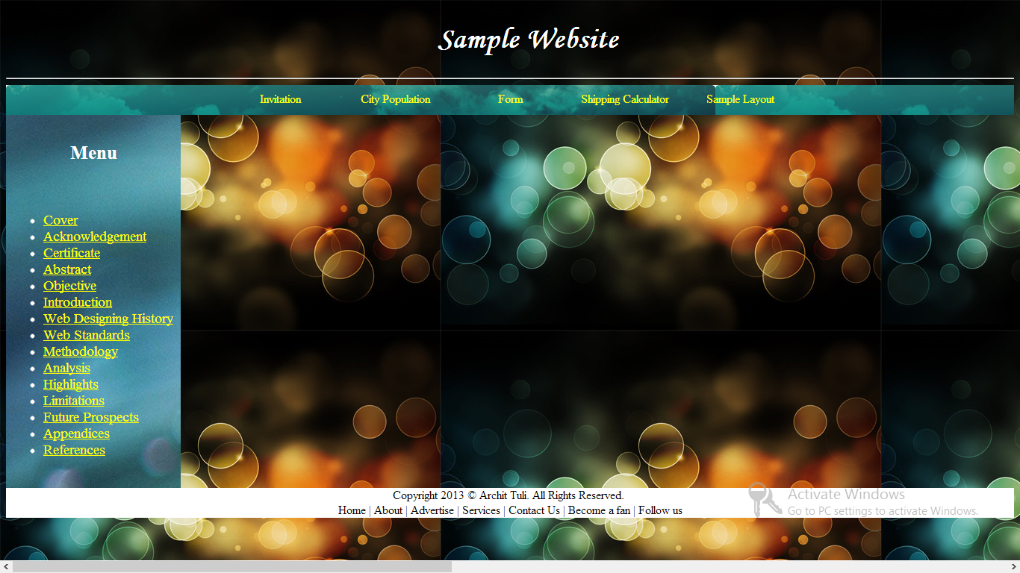

Form:

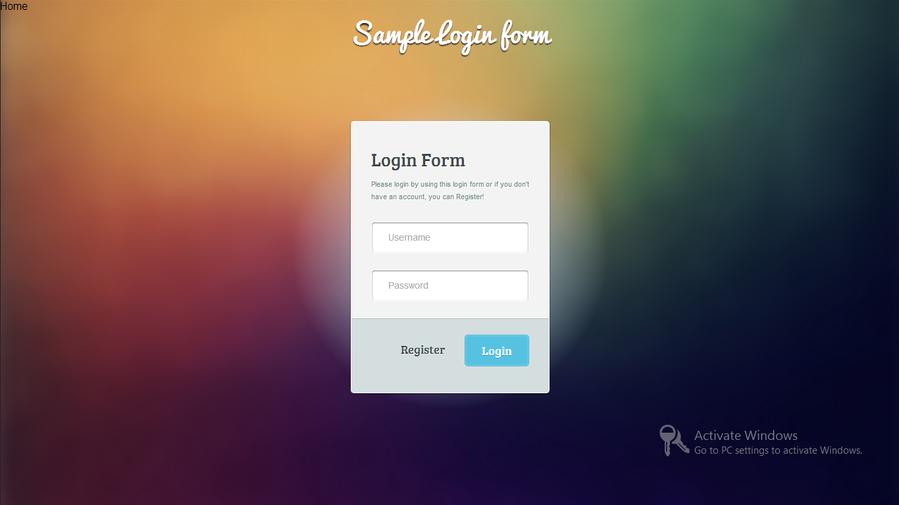

SCREENSHOTS

Invitation:

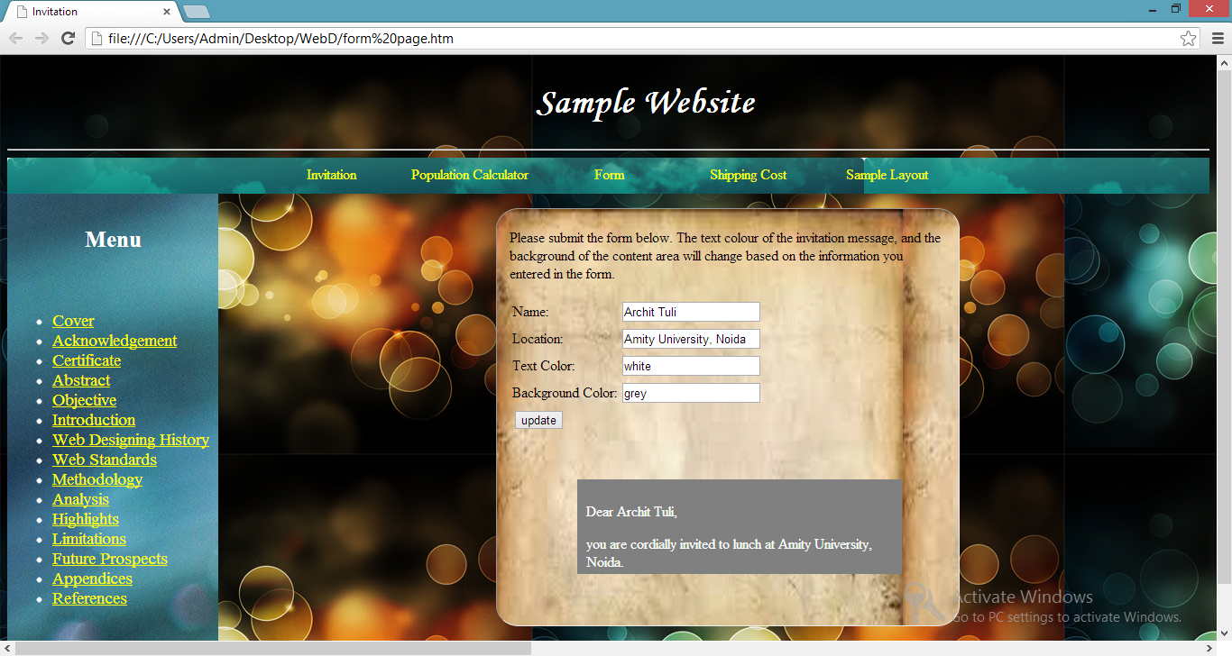

Population:

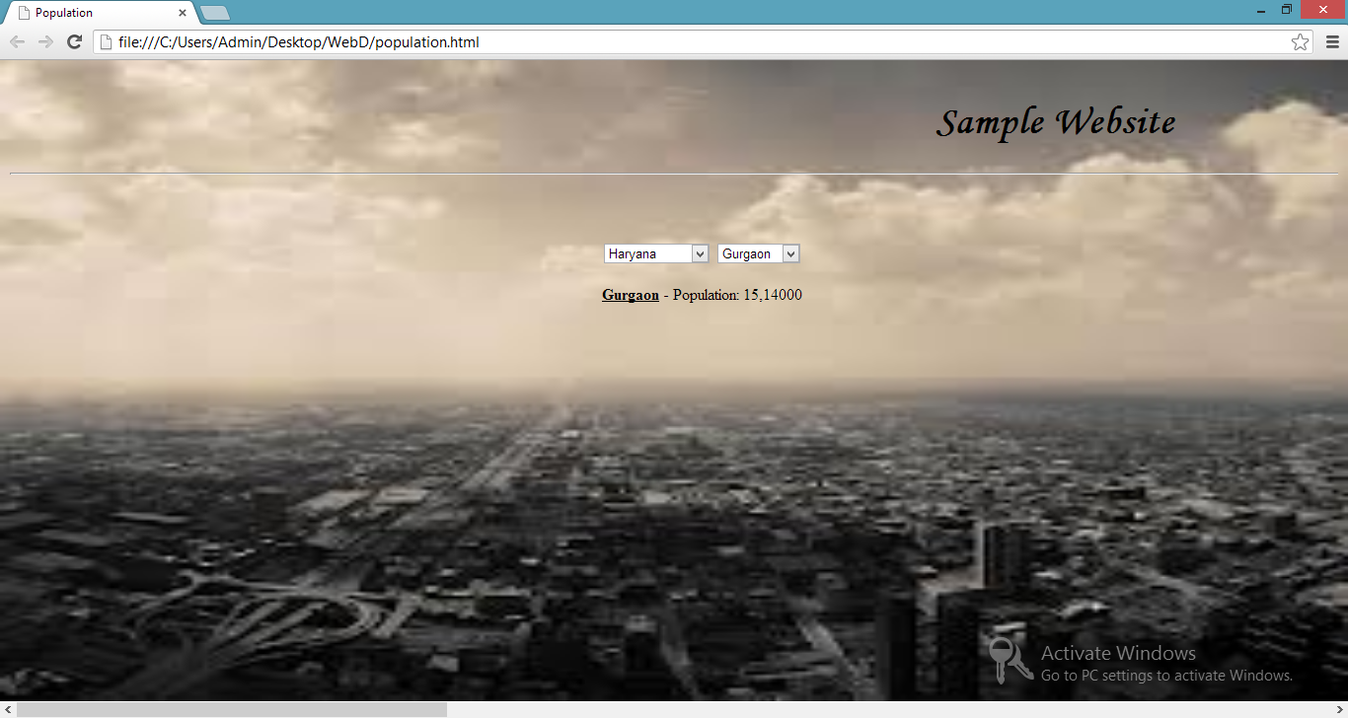

SCREENSHOTS

Shipping Calculator:

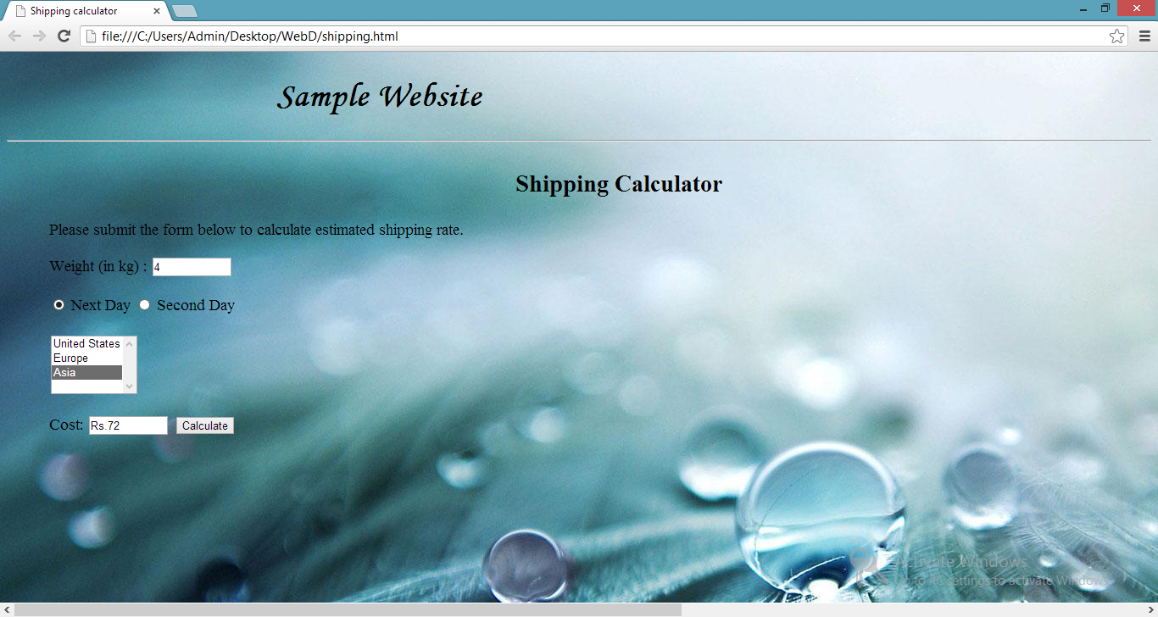

Sample Layout:

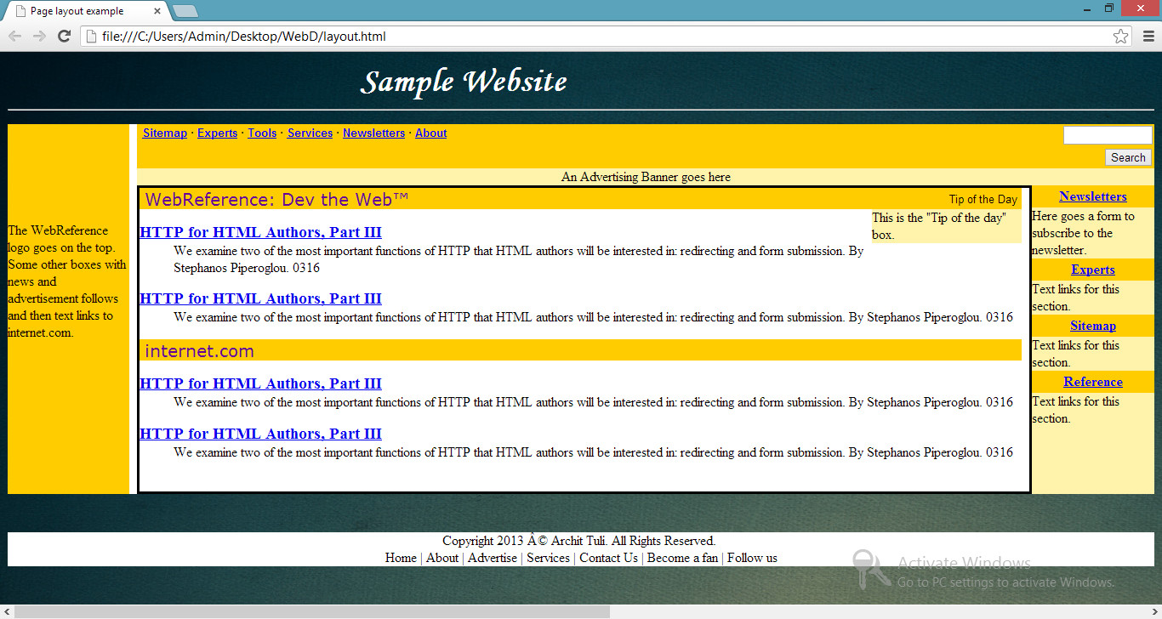

CODES

CSS Document:
a:link {color:pink;}
a:visited {color:yellow;}
a:hover { color:black;
text-decoration:none;
background-color:white;
text-transform:uppercase;
font-weight:bold;
font-size:18px;
letter-spacing:1px;
}
a:active {color:red;}

p.one {font-size:25px;text-align:center;}
#main {max-width:640px;margin: 0 auto;}
#menu {
height: 480px;
width: 150x;
float: left;
color: white;
background-repeat: repeat-y;
padding: 10px;
clear: both;
background-image: url('03.jpg');
font-size:14pt;
}
nav {background-image: url('navigation-bg.jpg');
clear:both;
text-align:center;
color:white;
height: auto;
border-bottom: 0;
font-size: 12pt;
}
nav ul {
padding: 0;
margin: 0;
height: 40px;
}
nav li {
display: inline;
}
nav a {
display: inline-block;
width: 150px;
text-align: center;
text-decoration:none;
padding:9px 0;
color:#FFF;
}
.frame{ background-image:url(image.jpg);
background-size:450px 520px;
border-radius:5%;
padding:6px;
position:absolute;
top:170px; left:550px;
border-width:thin;
}
h1 {
color:white;font-size:40px;font-family:'monotype corsiva';position:relative;
-webkit-animation-duration: 3s;
-webkit-animation-name: slidein;
-webkit-animation-iteration-count: infinite;
-webkit-animation-direction: alternate;
}
@-webkit-keyframes slidein {
from {
margin-left: 100%;
width: 300%
}
to {
margin-left: 0%;
width: 100%;
}
}

Homepage:
<!DOCTYPE html>
<html>
<head>
<title>Sample</title>

<link rel="stylesheet" href="sample web css.css" />
</head>

<body style = "background-image: url('01.jpg');background-repeat: repeat;margin-bottom: "0 auto";margin-left:auto;margin-right: "0 auto"; margin-top: "0 auto";" onload="myFunction()" >
<link rel="shortcut icon" href="favicon.ico">
<div id="main">
</div>
<h1>Sample Website</h1>
<hr>

<nav>
<ul>
<li><a href="form page.htm" target="_blank">Invitation</a></li>
<li><a href ="population.html" target="_blank">City Population</a></li>
<li><a href="C:\Users\Admin\Desktop\WebD\creating-login-form\index.html" target="_blank">Form</a></li>
<li><a href="shipping.html" target="_blank">Shipping Calculator</a></li>
<li><a href ="layout.html" target="_blank">Sample Layout</a></li>

</ul>
</nav>

<div id="container" style="display:none;">
<iframe height= "450" width="500" src="" scrolling="auto" name="iframe" class="frame" id="iframebox">
</iframe>
</div>

<div id="menu">
<p class="one"><b>Menu</b></p><br>
<ul>
<li><a href="cover.htm">Cover</a></li>
<li><a href="#" onClick="showIFrame('Acknowledgement.htm');">Acknowledgement</a></li>
<li><a href="#" onClick="showIFrame('Certificate.htm');">Certificate</a></li>
<li><a href="#" onClick="showIFrame('Abstract.htm');">Abstract</a></li>
<li><a href="#" onClick="showIFrame('Objective.htm');">Objective</a></li>
<li><a href="#" onClick="showIFrame('Introduction.htm');">Introduction</a></li>
<li><a href="#" onClick="showIFrame('Web Designing History.htm');">Web Designing History</a></li>
<li><a href="#" onClick="showIFrame('Web Standards.htm');">Web Standards</a></li>
<li><a href="#" onClick="showIFrame('Meth.htm');">Methodology</a></li>
<li><a href="#" onClick="showIFrame('Analysis.htm');">Analysis</a></li>
<li><a href="#" onClick="showIFrame('highlights.htm');">Highlights</a></li>
<li><a href="#" onClick="showIFrame('Limitations.htm');">Limitations</a></li>
<li><a href="#" onClick="showIFrame('future.htm');">Future Prospects</a></li>
<li><a href="#" onClick="showIFrame('Append.htm');">Appendices</a></li>
<li><a href="#" onClick="showIFrame('References.htm');">References</a></li>
</ul>
</div>

<div style="background-color:white;clear:both;text-align:center;">
Copyright 2013 © Archit Tuli. All Rights Reserved. <br>
Home | About | Advertise | Services | Contact Us | Become a fan | Follow us
</div>
<script>
function myFunction()
{
var x="";
var time=new Date().getHours();
if (time<10)
{
x="Good morning";
alert(x);
}
else if (time<20)
{
x="Good day";
alert(x);
}
else
{
x="Good evening";
alert(x);
}
document.getElementById("demo").innerHTML=x;
}

function showIFrame(url)
{
var container = document.getElementById('container');
var iframebox = document.getElementById('iframebox');
iframebox.src=url;
container.style.display = 'block';
}
</script>
</body>
</html>

FUTURE PROSPECTS

Web development is a broad field ranging from developing the simplest static single page of plain text to the most complex web-based internet applications, electronic businesses, and social network services.
A more comprehensive list of tasks to which web development commonly refers, may include web design, web content development, client liaison, client-side/server-side scripting, web server and network security configuration, and e-commerce development.

This project, until now explored only the mark-up language document writing and presentation styles. Further now, I aim to diversify my reach to Flash, jQuery and PHP, learning their ways and using all my existing knowledge to design a blog and a social networking site, with features of comments and posts in a reverse-chronological order with timestamps, interaction with the database, chats, responsive navigation, user friendliness, uploading pictures/videos, subscription facility, call to action buttons etc.

CONCLUSION

This project gave me an opportunity for self-development and learning by allowing me to build real websites as a part of the research.
This approach led me to discover many current limitations of the project and expanded my horizon of creativity and improved my skills of web designing.
For example, initially I designed the different sections of the layout of the website using tables, but more research made me realise a better way to organise sections, that is, by using <div> tag. Also, I learned the difference in position attributes and their effect, such as relative, absolute, static and fixed. Moreover, I realised ‘id’ in CSS should be typically used where only few elements are concerned and ‘class’ should be referred to sections having greater code.
There is major shift in consumption habits of the audience in recent years, and hence web design is evolving at a very fast rate, with flexible images, fluid grids and responsive navigation. This project is just a glimpse of the world of design section of the web development process and to make it fully functional and successful; there is much work and research to be done.

REFERENCES
Books
Web Enabled Commercial Application Development - Ivan Bayross
JavaScript Programming – Andy Harris
Web Applications – Craig Knuckles, David Yuen
Websites
www.w3schools.com
www.codeacademy.com
www.github.com
www.htmlcodes.me
www.csslab.cl
www.queness.com
www.htmlforums.com
stackoverflow.com
www.quackit.com
https://developer.mozilla.org
en.wikipedia.org
tutorialzine.com
ianlunn.co.uk
coding.smachingmagazine.com
www.ebizmba.cm
www.youthedesigner.com
bytemuse.com
www.jetbrains.com
line25.com
www.zamzar.com
www.wikihow.com
personalweb.about.com
www.softango.com
learn.shayhowe.com
lifehhacker.com
www.html.net
learnlayout.com
msdn.microsoft.com
www.w3.org
www.cssflow.com

APPENDICES

(Info-graphics available on the sample website)
- History of Web Design
- Latest Web Trends
- Web Accessibility
- Tips for web designing
- Working of Google search site
- Instant of an Internet minute
- Browser performance comparison
- Periodic table of internet
- Web site design timeline
- Responsive web design
- The brain of a blogger
- Internet Then and Now

