CONTENTS
- Abstract
- Introduction
- Semi-Conductors
- Energy Band and Electrical Conduction
- Effect on band structure
- Holes: electron absence as charge carrier
- Energy- Momentum Dispersion
- Carrier generation and recombination
- Doping
- Preparation of semi-conductors
- Application of semi-conductor and semi-conductor materials
- Types of Semi-conductor
- Semi-conductor devices
- Applications of semi-conductor devices
- PN Junction
- PN Junction as a rectifier
- Special purpose PN Junction diode

ABSTRACT
The magic word semiconductor is comprises of two words-Semi and Conductor. Semi means not completely while conductor mean something that conduct electricity. Everybody is familiar with "Electricity". It is present everywhere; it runs many appliances in your home and outside the home like TV, Bulb, Freeze, and Microwave Oven etc. In simple terms, the current must past through wires so that the electricity can reach all these appliances. So a conductor is nothing but a material having ability to conduct this electricity. Semiconductors conduct electricity to some extent, less than the conductors, how much do you think? Well, it depends on the type of material or it's mixture and size. A semiconductor is a material that has intermediate conductivity between a conductor and an insulator. It means that it has unique physical properties somewhere in between a conductor like aluminum and an insulator like glass. In a process called doping, small amounts of impurities are added to pure semiconductors causing large changes in the conductivity of the material. Examples include silicon, the basic material used in the integrated circuit, and germanium, the semiconductor used for the first transistors.
Devices made up of semiconductor material are a foundation of modern electronics . semiconductor devices include TRANSISTORS , MANY DIODES (P-N JUNCTION DIODE , LIGHT EMITTING DIODE ), SOLAR CELLS etc.

INTRODUCTION
In this project, we give a brief review of physics and some other associated phenomena necessary to understand the basics of Semiconductor and semiconductor devices. We first explain in brief the, the basic quantities such as energy band, doping, holes, dopants which are important to explain the effects of semiconductors. Then we explain the mechanism of conduction in semi conductors. The concept of holes and electrons as the charge carriers in extrinsic semiconductors is clarified.The phenomenon of drift and diffusion is given.
Nowadays all the electronic devices which we use are based on the controlled flow of electrons. Earlier, electronic devices were made of vacuum tubes like the diode valve which have 2 electrodes ; anode and cathode , triode valve which has 3 electrodes ; tetrode valve having 4 electrodes and pentode valve having 5 electrode. In these vacuum tubes, the electrons can flow in only one direction. (From cathode to anode) The vacuum tubes are bulky, operating at high voltages, consume more power, having limited life and low reliability. Then it was realized that some solid state semiconductors and their junctions can be helpful of controlling the number and direction of flow of charge carriers through them. The discovery of semiconductor junction , i.e, junction diodes and transistors, replaced the vacuum tubes because of their disadvantages. The semiconductor junction led to the discovery of integrated circuits which have revolutionized the electronic industry as they have been used in the working of TV and computer which are very commonly used in our daily life.

- SEMICONDUCTOR

1.1 A semiconductor can broadly be characterized as a material which has electrical conductivity between a conductor like copper and an insulator like glass. As against the behaviour of a metal, the conductivity of a semiconductor increases with an increase in temperature. The semiconductor can display very useful property like passing current more easily in one direction than the other.

1.2 With the controlled addition of impurities or by application of electrical fields or light, the conductive properties of a semiconductor can be modified. Semiconductors have very useful application for amplification of signals, switching and energy conversion. In order to understand the properties of semiconductors, we have to rely on quantum physics which would amply explain the motion of electrons through a lattice of atoms

1.3 Application of semiconductors is, indeed, tremendous. These semiconductors are the foundation of modern electronics including their application in radios, computers and telephones. Semiconductor based electronic components have a very wide and varied application in transistors, solar cells and even many kinds of diodes including the Light – Emitting Diode (LED), photodiodes, the silicon controlled rectifier and other digital and analog integrated circuits. Increasing understanding of semiconductor materials and fabrication processes has made possible continuing increases in the complexity and speed of semiconductor devices. This effect is known as Moore’s Law.

ENERGY BAND AND ELECTRICAL CONDUCTION

The electrons in semiconductors can have energies only within certain energy bands (i.e. ranges of levels of energy) between the energy of the ground state, corresponding to electrons tightly bound to the atomic nuclei of the material, and the free electron energy, which is the energy required for an electron to escape entirely from the material. The energy bands each correspond to a large number of discrete quantum states of the electrons, and most of the states with low energy (closer to the nucleus) are full, up to a particular band called the VALENCE BAND . Semiconductors and insulators are distinguished from metals because the valence band in the semiconductor materials is nearly filled under usual operating conditions , thus causing more electrons to be available in the "conduction band," which is the band immediately above the valence band . The ease with which electrons in a semiconductor can be excited from the valence band to the conduction band depends on the band gap between the bands, and it is the size of this energy band gap that serves as an arbitrary dividing line (roughly 4 eV) between semiconductors and insulators . In the picture of covalent bonds, an electron moves by hopping to a neighboring bond. Because of the Pauli exclusion principle it has to be lifted into the higher anti-bonding state of that bond. In the picture of delocalized states, for example in one dimension - that is in a nanowire, for every energy there is a state with electrons flowing in one direction and one state for the electrons flowing in the other. For a net current to flow some more states for one direction than for the other direction have to be occupied and for this energy is needed, in the semiconductor the next higher states lie above the band gap. Often this is stated as: full bands do not contribute to the electrical conductivity. However, as the temperature of a semiconductor rises above absolute zero, there is more energy in the semiconductor to spend on lattice vibration and — more importantly for us — on lifting some electrons into an energy states of the conduction band. The current-carrying electrons in the conduction band are known as "free electrons ", although they are often simply called "electrons" if context allows this usage to be clear . Electrons excited to the conduction band also leave behind electron holes, or unoccupied states in the valence band. Both the conduction band electrons and the valence band holes contribute to electrical conductivity.
The holes themselves don't actually move, but a neighboring electron can move to fill the hole, leaving a hole at the place it has just come from, and in this way the holes appear to move, and the holes behave as if they were actual positively charged particles.

One covalent bond between neighboring atoms in the solid is ten times stronger than the binding of the single electron to the atom, so freeing the electron does not imply destruction of the crystal structure.

Effect on band structure

Doping a semiconductor crystal introduces allowed energy states within the band gap but very close to the energy band that corresponds to the dopant type. In other words, donor impurities create states near the conduction band while acceptors create states near the valence band. The gap between these energy states and the nearest energy band is usually referred to as dopant-site bonding energy or EB and is relatively small. For example, the EB for boron in silicon bulk is 0.045 eV, compared with silicon's band gap of about 1.12 eV. Because EB is so small, it takes little energy to ionize the dopant atoms and create free carriers in the conduction or valence bands. Usually the thermal energy available at room temperature is sufficient to ionize most of the dopant.

Dopants also have the important effect of shifting the material's Fermi level towards the energy band that corresponds with the dopant with the greatest concentration. Since the Fermi level must remain constant in a system in thermodynamic equilibrium, stacking layers of materials with different properties leads to many useful electrical properties. For example, the p-n junction's properties are due to the energy band bending that happens as a result of lining up the Fermi levels in contacting regions of p-type and n-type material.

This effect is shown in a band diagram. The band diagram typically indicates the variation in the valence band and conduction band edges versus some spatial dimension, often denoted x. The Fermi energy is also usually indicated in the diagram. Sometimes the intrinsic Fermi energy, Ei, which is the Fermi level in the absence of doping, is shown. These diagrams are useful in explaining the operation of many kinds of semiconductor devices.

Holes: electron absence as a charge carrier

The motion of holes, which was introduced for semiconductors, can also be applied to metals, where the Fermi level lies within the conduction band. With most metals the Hall effect reveals electrons to be the charge carriers, but some metals have a mostly filled conduction band, and the Hall effect reveals positive charge carriers, which are not the ion-cores, but holes. Contrast this to some conductors like solutions of salts, or plasma. In the case of a metal, only a small amount of energy is needed for the electrons to find other unoccupied states to move into, and hence for current to flow. Sometimes even in this case it may be said that a hole was left behind, to explain why the electron does not fall back to lower energies: It can not find a hole. In the end in both materials electron-phonon scattering and defects are the dominant causes for resistance .Fermi-Dirac distribution. States with energy ε below the Fermi energy, here µ, have higher probability n to be occupied, and those above are less likely to be occupied. Smearing of the distribution increases with temperature

The energy distribution of the electrons determines which of the states are filled and which are empty .This distribution is described by Fermi-Dirac statistics. The distribution is characterized by thetemperature of the electrons, and the Fermi energy or Fermi level. Under absolute zero conditions the Fermi energy can be thought of as the energy up to which available electron states are occupied. At higher temperatures, the Fermi energy is the energy at which the probability of a state being occupied has fallen to 0.5.The dependence of the electron energy distribution on temperature also explains why the conductivity of a semiconductor has a strong temperature dependency, as a semiconductor operating at lower temperatures will have fewer available free electrons and holes able to do the work .

Energy–momentum dispersion

In the preceding description an important fact is ignored for the sake of simplicity: the dispersion of the energy. The reason that the energies of the states are broadened into a band is that the energy depends on the value of the wave vector, or k-vector, of the electron. The k-vector, in quantum mechanics, is the representation of the momentum of a particle.

The dispersion relationship determines the effective mass, m*, of electrons or holes in the semiconductor , according to the formula :
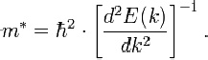

The effective mass is important as it affects many of the electrical properties of the semiconductor, such as the electron or hole mobility, which in turn influences the diffusivity of the charge carriers and the electrical conductivity of the semiconductor . Typically the effective mass of electrons and holes are different. This affects the relative performance of p -channel and n-channel IGFETs The top of the valence band and the bottom of the conduction band might not occur at that same value of k. Materials with this situation, such as silicon and germanium, are known as indirect band gap materials . Materials in which the band extreme are aligned in k, for example gallium arsenide, are called direct band gap semiconductors. Direct gap semiconductors are particularly important in optoelectronics because they are much more efficient as light emitters than indirect gap materials.

Carrier generation and recombination

When ionizing radiation strikes a semiconductor, it may excite an electron out of its energy level and consequently leave a hole. This process is known as electron–hole pair generation. Electron-hole pairs are constantly generated from thermal energy as well, in the absence of any external energy source . Electron-hole pairs are also apt to recombine. Conservation of energy demands that these recombination events, in which an electron loses an amount of energy larger than the band gap, be accompanied by the emission of thermal energy (in the form of phonons) or radiation (in the form of photons).In some states, the generation and recombination of electron–hole pairs are in equipoise. The number of electron-hole pairs in the steady state at a given temperature is determined by quantum statistical mechanics. The precise quantum mechanical mechanisms of generation and recombination are governed by conservation of energy and conservation of momentum

As the probability that electrons and holes meet together is proportional to the product of their amounts , the product is in steady state nearly constant at a given temperature, providing that there is no significant electric field (which might "flush" carriers of both types, or move them from neighbor regions containing more of them to meet together) or externally driven pair generation. The product is a function of the temperature, as the probability of getting enough thermal energy to produce a pair increases with temperature, being approximately exp (−EG/kT), where k is Boltzmann's constant, T is absolute temperature and EG is band gap .The probability of meeting is increased by carrier traps—impurities or dislocations which can trap an electron or hole and hold it until a pair is completed. Such carrier traps are sometimes purposely added to reduce the time needed to reach the steady state.

Doping

The property of semiconductors that makes them most useful for constructing electronic devices is that their conductivity may easily be modified by introducing impurities into their crystal lattice. The process of adding controlled impurities to a semiconductor is known as doping. The amount of impurity, or dopant, added to an intrinsic (pure) semiconductor varies its level of conductivity. Doped semiconductors are often referred to as extrinsic. By adding impurity to pure semiconductors, the electrical conductivity may be varied not only by the number of impurity atoms but also, by the type of impurity atom and the changes may be thousand folds and million folds. For example, 1 cm3 of a metal or semiconductor specimen has a number of atoms on the order of 1022. Since every atom in metal donates at least one free electron for conduction in metal, 1 cm3 of metal contains free electrons on the order of 1022. At the temperature close to 20 °C , 1 cm3 of pure germanium contains about 4.2×1022 atoms and 2.5×1013 free electrons and 2.5×1013 holes (empty spaces in crystal lattice having positive charge) The addition of 0.001% of arsenic (an impurity) donates an extra 1017 free electrons in the same volume and the electrical conductivity increases about 10,000 times."

Preparation of semiconductor materials

Semiconductors with predictable, reliable electronic properties are necessary for mass production. The level of chemical purity needed is extremely high because the presence of impurities even in very small

proportions can have large effects on the properties of the material. A high degree of crystalline perfection is also required, since faults in crystal structure (such as dislocations, twins, and stacking faults) interfere with the semiconducting properties of the material. Crystalline faults are a major cause of defective semiconductor devices. The larger the crystal, the more difficult it is to achieve the necessary perfection. Current mass production processes use crystal ingots between 100 mm and 300 mm (4-12inches) in diameter which are grown as cylinders and sliced into wafers.

Because of the required level of chemical purity and the perfection of the crystal structure which are needed to make semiconductor devices, special methods have been developed to produce the initial semiconductor material. A technique for achieving high purity includes growing the crystal using the Czochralski process. An additional step that can be used to further increase purity is known as zone refining. In zone refining, part of a solid crystal is melted. The impurities tend to concentrate in the melted region, while the desired material recrystalizes leaving the solid material more pure and with fewer crystalline faults.

In manufacturing semiconductor devices involving hetero junctions between different semiconductor materials, the lattice constant, which is the length of the repeating element of the crystal structure, is important for determining the compatibility of materials.

Application of Semiconductors and Semiconductor Materials

Semiconductors and semiconductor materials are used to fabricate microelectronic devices and optoelectronic devices such as transistors, photo detectors and solar cells. Silicon (Si) is the most commonly used semiconductor material today; however, other semiconductor material types are also available. The number of valence shell electrons in a semiconductor material places this category of material between insulators (poor electrical conductors) and metals (good semiconductors). Insulators have a filled valence shell (eight electrons) and a large band gap , which results in poor electrical conductivity. Metals have a partially-filled valence shell and overlapping band gap, which results in free-traveling electrons and high electrical conductivity . Semiconductors and semiconductor materials are useful because their electrical conductivity can be altered with dopants, an applied electric field, or electromagnetic radiation . There are two basic categories of semiconductors and semiconductor materials: electrical semiconductors and compound semiconductors. Silicon (Si) and germanium (Ge), the most common electrical semiconductors, are used in many semiconductor components. Gallium arsenide (GaAs) and indium phosphide (InP) are examples of composite semiconductors that contain added materials or dopants. Semiconductor doping, the addition of a very small amount of a foreign substance to a pure semiconductor crystal, provides a semiconductor with an excess of conducting electrons or an excess of conducting holes. The first semiconductors and semiconductor materials produced electrical conduction through contact with a metal wire . Subsequent technologies used semiconductor crystals and semiconductor diodes. A semiconductor diode allows current to flow in one direction only.

There are many applications for semiconductors and semiconductor materials in materials engineering, such as the fabrication of transistors, photo detectors and solar cells. Major semiconductor manufacturers and providers of semiconductors and semiconductor materials include Lattice Semiconductor Corporation, Xilinx, Altera, Actel and Quick logic. In semiconductor manufacturing, transistors are placed together to create a silicon chip. The semiconductor manufacturer than creates a microprocessor from the silicon chip . The term PN junction diode is normally reserved for what may be called the basic form of diode , although in reality the term applies to virtually any form of semiconductor diode. The PN junction diode gains its name from the fact that it is formed from a semiconductor PN junction and by its nature it only allows current to flow in one direction. However the PN junction diode also has other properties that can be used in many other applications. These range from light emission to light detection and variable capacitance to voltage regulation. Many of these types of diode are described in other pages on this section of the Radio-Electronics.Com website . The basic form of PN junction finds many uses in electronics circuits. The standard PN junction diodes are available in a variety of forms. They are mainly manufactured from silicon, although germanium diodes are also available. PN junction diodes can also be manufactured from other semiconductor materials, but these are generally specialised diodes used for particular applications . The basic PN junction diodes are able to perform a variety of roles in electronics circuits. The serange from applications as small signal diodes, to switching, to those required in applications such as power supplies as high current or high voltage rectifiers.

2.0 TYPES OF SEMICONDUCTORS

There are two types of semiconductors;

- Intrinsic Semiconductors
- Extrinsic Semiconductors

2.1 INTRINSIC SEMICONDUCTORS

A pure semiconductor which is free of every impurity is called intrinsic semiconductor. Silicon and Germanium are important examples of intrinsic semiconductors widely used in electronic and transistor manufacturing industry. At room temperature, the conductivity of intrinsic semiconductors is relatively low because there are very few charge carriers available. The electronic configuration of Silicon and Germanium are as follows;

Silicon (14), 1s 2s 2p 3s 3p
Germanium (32), 1s 2s 2p 3s 3p 3d 4s 4p

Both the atoms have thus four valence electrons. The crystal structure of Germanium in two dimensions is shown in Figure – A.

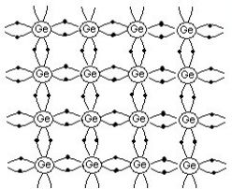

Figure – A

When an electron breaks away from a covalent bond, the empty place or vacancy left in the bond is called a hole depicting in above Figure – A by a hollow circle. When an external electrical field is applied, these free electrons and holes move in opposite directions and constitute a current flow through the germanium crystal.

Thus in intrinsic semiconductor, ne = nh = ni where

Ne = number density of electrons in conduction band
Nh = number density of holes in valence band
Ni = number density of intrinsic carriers (electrons or holes) in a pure semiconductor

It is, however, very difficult to make an intrinsic semiconductor because of the difficulty in preparing extremely pure material.

2.2 LIMITATIONS OF DEVELOPING PURE SEMICONDUCTOR BASED DEVICES

2.21 At room temperature, the number of intrinsic charge carriers (electrons and holes) in a pure semiconductor is very small (=10 m) and that is the reason precisely why the pure semiconductor is a low conductivity material.

2.22 In a pure semiconductor, the intrinsic charge carriers are always produced due to breakage of covalent bonds by virtue of thermal motion. Hence there is not enough flexibility to control their number in a pure semiconductor.

2.23 In a pure semiconductor, the number of electrons (ne) is always equal to number of holes (nh). It is never possible in a pure semiconductor to have either number of conduction electrons only or large number of conduction holes only. That is precisely why pure semiconductor is not of much use.

2.3 EXTRINSIC SEMICONDUCTORS

A doped semiconductor or a semiconductor with suitable impurity atom added to it, is termed as extrinsic semiconductor.

Extrinsic Semiconductors are of two types

- N – type semiconductors
- P – type semiconductors

2.31 N – type semiconductors

N – type material is one in which electrons are majority charge carriers, i.e., they are negatively charged materials(- - - -). In other words, when a pure semiconductor of Silicon (Si) or Germanium (Ge) is doped with a controlled amount of pentavalent atoms say, Arsenic or Phosphorus or Antimony Bismuth, which have five valence electrons, the impurity atom will replace the Si or Ge atom as shown in Figure – B.

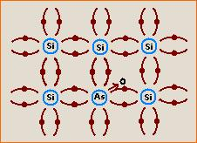

Figure – B

The four of the five valence electrons of the impurity atoms will form covalent bonds by sharing the electrons with the adjoining four atoms of silicon while the fifth electron is very loosely bound with the parent impurity atom and is comparatively free to move. Each impurity atom added donates one free electron to the crystal structure. These impurity atoms donating free electrons for conduction are also called Donor atoms. Since the conduction of electricity is due to the motion of electrons, i.e., negative charges or n – type carriers, the resulting semiconductor is therefore termed as Donor Type or n – type semiconductor.

2.32 P – TYPE SEMICONDUCTORS

A p – type semiconductor is one in which holes are majority carriers, i.e., they are positively charged materials (+ + + +). In other words, when a pure semiconductor of Germanium (Ge) or Silicon (Si), in which each atom has four valence electrons, is doped with a controlled amount of trivalent atoms say Boron (B), Aluminium (Al) or Indium (In) which have three valence electrons, the impurity atom will replace Ge or Si atom as shown in Figure – C.0

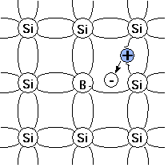

Figure – C

The three valence electrons of the impurity atom will form covalent bonds by electrons sharing of the adjoining three atoms of Ge, while there will be one incomplete covalent bond with a neighbouring Ge atom due to the deficiency of an electron. This deficiency is completed by taking an electron from one of the Ge – Ge bonds. This makes Indium ionised (- vely charged) and creates a “hole”. An electron moving from a Ge – Ge bond to fill a hole, leaves a hole behind. This explains vividly how holes move in the semiconductor system.
These trivalent atoms are termed as acceptor items and the conduction of electricity which occurs due to the motion of holes, i.e., +ve charges or in other words p type carriers. Thus, the resulting semiconductor is called acceptor type or p-type semiconductor. In the p-type semiconductors, electrons are minority carriers and holes are majority carriers. When an external electric field is applied to a p-type semiconductor, these holes act as carriers of current.

3.0 SEMICONDUCTOR DEVICES

3.1 Semiconductor devices are electronic components that exploit the electronic properties of semiconductor materials, principally silicon, germanium and gallium arsenide as well as organic semiconductors. Semiconductor devices have replaced thermionic devices (Vacuum tubes in most applications). As opposed to the gaseous state or thermionic emission in a high vacuum, semiconductor devices use electronic conduction in the solid state.

3.2 SOME COMMON SEMICONDUCTOR DEVICES

TWO TERMINAL DEVICES

- Diode (Rectifier Diode)
- Laser Diode
- Light – Emitting Diode (LED)
- Photocell
- Solar Cell
- Zener Diode

THREE TERMINAL DEVICES

- Bipolar Transistor
- Field Effect Transistor
- IGBT Transistor
- Thyristor
- Unijunction Transistor

MULTI TERMINAL DEVICES

- Integrated Circuit (IC)
- Charge – Coupled Device (CCD)
- Microprocessor
- Random Access Memory (RAM)
- Read Only Memory (ROM)

3.3 APPLICATION OF SEMICONDUCTOR DEVICES

- All transistor types can be used as the building blocks of logic gates which are fundamental in the design of digital circuits. In digital circuits like microprocessors, transistors act as on – off switches.
- Transistors used for analog circuits do not act as on – off switches; rather they respond to a continuous range of inputs with a continuous range of outputs. Continuous analog circuits include amplifiers and oscillators.
- Circuits that interface or translate between digital circuits and analog circuits are called mixed – signal circuits.
- Other applications include Power semiconductor devices which are discrete devices or integrated circuits intended for high current or high voltage applications.
- “Smart” Power devices where Power integrated circuits combine IC Technology with Power Semiconductor Technology.

3.4 ADVANTAGES OF SEMICONDUCTOR DEVICES

- A transistorised equipment does not get heated, while operating. Therefore, no cooling arrangement is required.
- Semiconductor devices are not to be heated for emission of electrons. They start operating instantly. This saves a lot of electric power.
- The semiconductor devices are more rugged than the vacuum tubes. They can withstand rough handling.
- Semiconductor devices have much longer life as compared to the life of vacuum tubes.

3.5 DISADVANTAGES OF SEMICONDUCTOR DEVICES

- Semiconductor devices are very sensitive to changes of temperature whereas the vacuum tubes are less sensitive.
- It is difficult to produce semiconductor devices with exactly identical characteristics.

- The noise level in semiconductor devices is higher than that of vacuum tubes.
- Semiconductor devices cannot handle as much power as vacuum tubes.

4.0 P – N JUNCTION

When a p-type semiconductor crystal is brought into close contact with an n – type semiconductor crystal, the resulting arrangement is called a p – n junction or junction diode.

4.1 FORMATION OF P – N JUNCTION

To make a p – n junction, the n – type and p – type silicon crystals are cut into thin slices called wafers. If on a wafer of n type silicon, an aluminium film is placed and heated to a high temperature, say 580 degrees C, aluminium diffuses into silicon. In this way, a p – type semiconductor is formed on an n – type semiconductor. Such a formation of p – type region on n – region is called p – n junction.

Another way to make a p – n junction is by diffusion of phosphorus into a p – type semiconductor.

The wafer of which a p – n junction is formed, is cut into small pieces. Each piece is enclosed in a casing with electric connections coming out from p and n regions.

4.2 DEPLETION REGION AND BARRIER ELECTRIC FIELD IN P – N JUNCTION

Two important processes occur during the formation of a p – n junction; diffusion and drift. We know that in an n – type semiconductor, electrons are majority carriers and holes are minority carriers. In p – type semiconductor holes are majority carriers and electrons are minority carriers. When p – n junction is formed, due to difference in concentration of charge carriers in the two regions of p – n junction, the electrons from n – region diffuse through the junction into p – region and holes from p – region diffuse into n – region. The motion of charge carriers gives rise to diffusion current across the junction.

When an electron diffuses from n – region to p – region of p – n junction, it leaves behind an ionised donor atom in n – region, having positive charge which is immobile as it is bonded to the surrounding atoms. As diffusion of electrons continues from n – region to p – region of p – n region, more positively charged donor atoms are created in n – region resulting a layer of positive charge (i.e., a positive space charge region) near the junction in n – region.

Similarly, when a hole diffuses from p – region to n – region of p – n junction, it leaves behind an ionised acceptor atom in p – region having negative charge which is immobile. As the diffusion of holes continues from p – region to n – region of p – n junction, more negatively charged acceptor atoms are created in p – region resulting a layer of negative charge (i.e., a negative charge space region) near the junction in p – region.

The space – charge regions on both the sides of p – n junction which has immobile ions and is devoid of any charge carrier will form a region called depletion region or depletion layer (Figure – D).

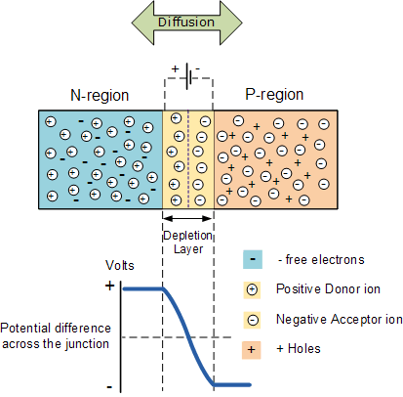

Figure - D

It is like a no man land on a border. The thickness of this depletion region is of the order of one-tenth of a micrometer. Due to positive space charge region on n – side of junction and negative space charge region on p – side of junction, an electric field is set up across the junction from positive charge towards negative charge, as if a fictitious battery is connected across the junction with its positive terminal to n – region and negative terminal to p – region. This electric field sets a potential barrier at the junction which opposes further diffusion of majority charge carriers into opposite regions.

The width of the depletion layer and the magnitude of the barrier potential depend on the nature of semiconductor and doping concentration on the two sides of p – n junction. If the doping concentration in n – type and p – type semiconductor forming p – n junction is small, the diffusing electrons and holes across the junction can move to quite large distances before suffering a collision with another hole or electron to be recombined. Due to this, the width of p – n junction is large and junction field is small. On the other hand, if the doping concentration in n – type and p – type semiconductor forming p – n junction is large, the width of p – n junction would be small and junction field would be large. It means the p – n junction will show different behaviour by changing the doping levels on both the sides.

4.3 BREAKDOWN OF P – N JUNCTION DIODES

- Diode breakdown is caused by thermally generated electrons in the depletion region.

- When the reverse voltage across diode reaches breakdown voltage these electrons will get sufficient energy to collide and dislodge other electrons.

- The number of high energy electrons increases in geometric progression leading to an avalanche effect causing heavy current and ultimately destruction of diode.

4.4 BIASING OF THE P – N JUNCTION

Two methods of biasing the p – n junction are as under;

- Forward biasing

- Reverse biasing

4.41 FORWARD BIASING

A p – n junction is said to be forward biased if the positive terminal of the external battery is connected to p – side and the negative terminal is connected to the n – side of the p – n junction. This is illustrated in the circuit diagram (Figure – E) below in the case of Forward Biasing.

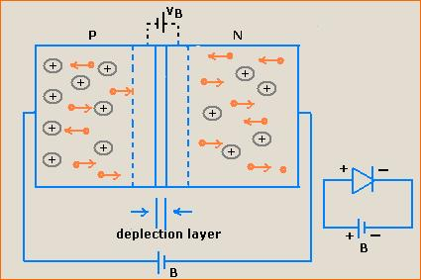

Figure – E

In forward biasing, the applied voltage V of Battery B mostly drops across the depletion region and the voltage drop across the p – side and n – side of the p – n junction is negligible small because of the fact that the resistance of the depletion region is VERY HIGH as it has no free charge carriers. What happens is that the forward voltage opposes the potential barrier Vb, resulting thereby in reduction of potential barrier height and consequently in the decrease of depletion layer width.

The majority carriers, electrons in the n – region are repelled by the negative potential due to Battery B and move towards the p – n junction. Similar phenomenon occurs in holes in the p – region where the majority carriers are repelled by the positive potential due to Battery B towards the junction. An electric current would flow due to migration of majority carriers across the p – n junction which is called forward current, the measured in milliampere (Ma). Since the small increase in forward voltage shows large increase in forward current, hence the resistance of p – n junction is low to the flow of current when forward biased.

4.42 REVERSE BIASING

A p – n junction is said to be reverse biased if the +ve terminal of the external battery ‘B’ is connected to n – side and the –ve terminal to the p – side of the p – n junction (Figure – G).

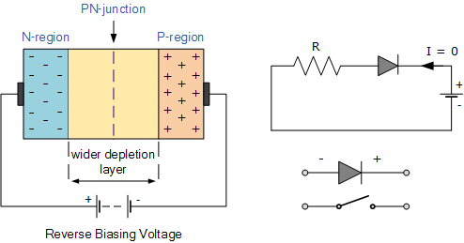

Figure – G

The circuit diagram for reverse biasing of p – n junction is depicted in Figure – F. In the case of reverse biasing the applied voltage V of Batter B, mostly drops across depletion region of p – n junction and its direction of voltage is same as that of potential barrier. Due to this the reverse bias voltage supports the potential barrier. This results in the increase of barrier height and consequent increase in the width of depletion region. (Refer Figure - )

In the case of reverse biasing, there is no conduction across the junction due to majority carriers. However, a few minority carriers of the p – n junction cross the junction after being accelerated by high reverse bias voltage. A current is constituted which flows in the opposite direction termed as reverse current or leakage current. Resistence of p – n junction is high due to the flow of current in the case of reverse biased p – n junction.

5.0 P – N JUNCTION DIODE AS A RECTIFIER

5.1 P – N JUNCTION DIODE AS A HALF WAVE RECTIFIER

Its working is based on the fact that the resistance of p – n junction becomes low when forward biased and becomes high when reverse biased.

AC Voltage to be rectified is connected to the primary P1 P2 of a stepdown transformer. S1 S2 is the secondary coil of the same transformer. S1 is connected to the portion p of the p – n junction. S2 is connected to the portion n through load resistance R. Output is taken across the load resistance R (Figure – K).

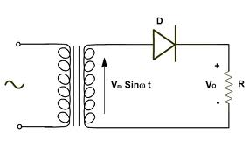
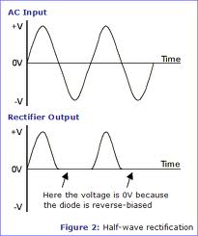

Figure - K

During the positive half cycle of the input A.C., suppose P1 is negative and P2 is positive. On account of induction, S1 becomes positive, S2 becomes negative. The p – n junction is forward biased. The resistance of p – n junction becomes low. The forward current flows in the direction shown by arrow heads. Thus, we get output across-load.

During the negative half cycle of the input A.C., P1 is positive and P2 is negative. On account of mutual induction, S1 becomes negative and S2 is positive. The p – n junction is reverse biased. It offers high resistance and hence there is no flow of current and thus no output across load. The process is repeated. In the output, we have current corresponding to one half of the wave, the other half is missing.

5.2 P – N JUNCTION DIODE AS A FULL WAVE RECTIFIER

For full wave rectification, we have to use two p – n junction diodes D1 and D2. The arrangement is shown in Figure – L.

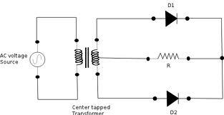

Figure – L

During the positive half cycle of the input A.C , the junction diode D1 is forward biased , and the p-n junction diode D2 is reverse biased. During the negative half of the cycle of in A.C, the junction diode D1 is reverse biased and the junction diode D2 is forward biased as shown in Figure - N. In both the halves, current flows in the same direction
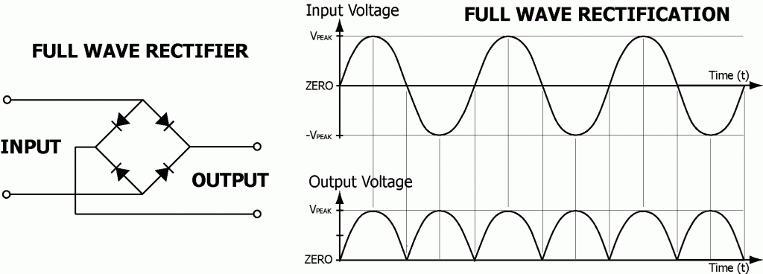

Figure - N

6.0 SPECIAL PURPOSE P – N JUNCTION DIODE

Some devices which are basically junction diodes are developed for different applications. They are as follows:

6.1 ZENER DIODE

It is a specially designed diode to operate in the reverse breakdown voltage region continuously without being damaged. It is designed such that it may have greatly reduced breakdown voltage called Zener voltage. The same can be achieved by changing the thickness of the depletion layer to which the voltage is applied. This is possible by doping heavily both p-side and n-side of the p-n junction. The symbol for zener diode is shown in the Figure - O.

The I-V curve is shown in Figure - P. It can be seen that under reverse bias and low voltage , the current assumes a low negative value, just as in a normal p-n junction diode. But when a sufficiently large reverse voltage is reached, the current increases at a very high rate.

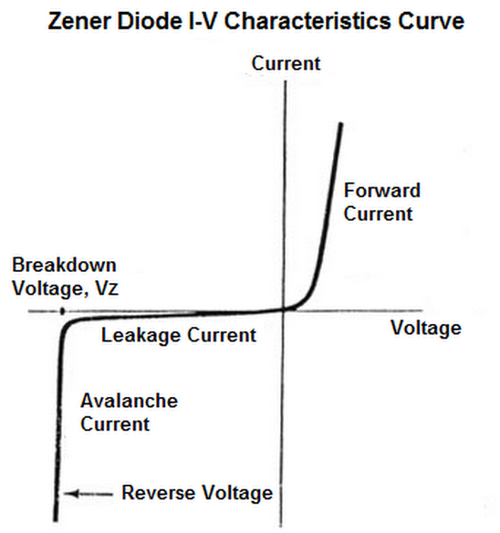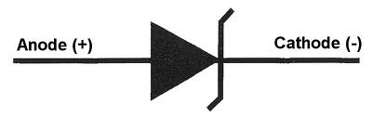

Figure – O and P

6.11 ZENER DIODE AS A VOLTAGE REGULATOR

When the input D.C voltage across Zener diode increases beyond a certain limit (i.e Zener breakdown voltage), the current through the ciruit rises sharply, causing thereby a sufficient increase in the voltage drop across the dropping resistor R. As a result of it the voltage across the Zener diode remains constant and hence the output voltage lowers back to normal value. Further, when the input D.C voltage across Zener diode decreases, the current through the circuit goes down sharply causing thereby sufficient decrease in the voltage across the dropping resistor. As a result of it, the voltage across the zener diode remains constant and hence the output voltage is raised to normal. Hence the output voltage remains constant.
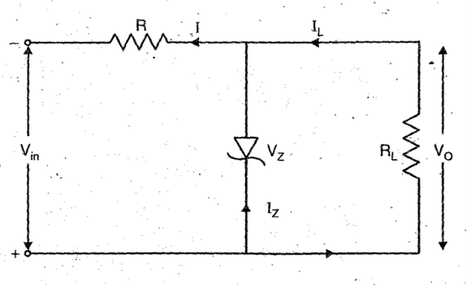 Figure - Q

6.2 PHOTODIODE

Photodiode is an Optoelectronic device in which current carriers are generated by photons through photoexcitation or in other words termed as photoconduction by light. It is a special type p-n junction diode which is made of photosensitive semiconducting material. In such a diode a provision i.e a transparent window is made to allow the light of suitable frequency to fall on it. It is operated under reverse bias. The conductivity of the p-n junction photodiode increases with the increase in intensity of light falling on it. It is symbolically shown in Figure - R.

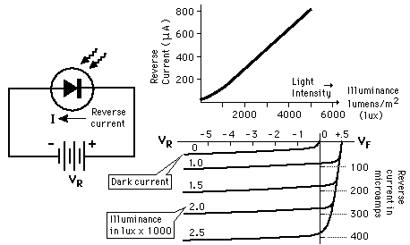 Figure - R

USAGES :

- In photodetection for optical signals.
- In demodulation for optical signals.
- In switching the light on and off.
- In optical communication equipments.
- In certain logic circuits.
- In reading of computers, punched cards and tapes etc.

6.3 LIGHT EMITTING DIODE (LED)

LED is a heavily doped p-n junction diode which under forward bias emits spontaneous radiation. The diode is covered with a transparent cover so that the emitted light may come out. This is shown in Figure-S.

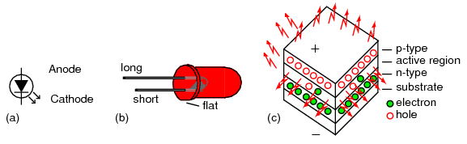

In an LED, the upper layer of p-type semiconductor is deposited by diffusion on n-type layer of semiconductor. The metalized contacts are provided for applying the forward bias voltage to the p-n junction diode from battery B, through a resistance R which controls the brightness of light emitted. The voltage V current I characteristics of LED is similar to that of silicon junction diode.

USAGES:

- In burglar alarm systems.
- In calculators and digital watches.
- In the field of optical communication .
- In computers , LEDs are used in optical mouses for the computers.
- In picture phones and video displays.
- In traffic lights and remote control.

6.4 SOLAR CELL

Solar cell is basically a solar energy convertor. It is a p-n junction device which converts solar energy into electrical energy. It is depicted in Figure-T.

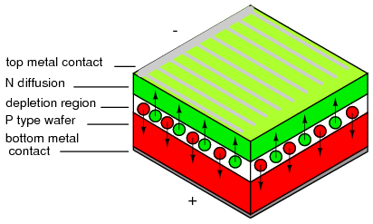
Figure - T
It consists of a silicon or gallium arsenide p-n junction diode packed in a can with glass window on top. The upper layer is of p-type semiconductor. Its very thin so that the incident light photons may easily reach the p-n junction. On the top face of p-layer, the metal finger electrodes are prepared in order to have enough spacing between the fingers for the light to reach the p-n junction through p-layer.

USAGES:

- For charging storage batteries in day time which can supply the power during night.
- In artificial satellites to operate the various electrical instruments inside the satellite.
- For generating electrical energy in cooking food and pumping water.
- In calculators, wrist watches and light meters in photography.
- To produce electric power in remote ares.
- To power traffic signs.
- In remote radiotelephones.

6.5 TRANSISTORS

Another use of semiconductor technology is in the fabrication of transistors, devices that amplify voltages or currents in many kinds of circuits. As an example, consider an npn – junction transistor, which consists of a thin layer of p – type semiconductor sandwiched between two n – type semiconductors. The three terminals (one on each semiconducting material) are known as the collector, emitter and base.

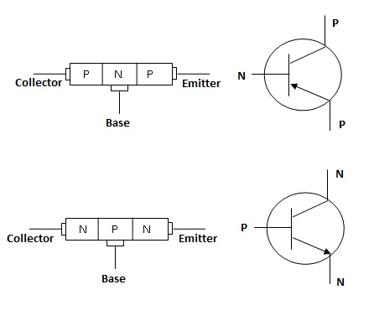 Figure – U

Common applications are transistor as a switch, amplifier, oscillator, etc.

6.6 SEMICONDUCTOR LASERS

They operate using population inversion – an artificially high number of electrons in excited stage. In a semiconductor laser, the band gap determines the energy difference between the excited state and the ground state. They use injection pumping, where a large forward current is passed through a diode creating electron – hole pairs, with electrons in the conduction band and holes in the valence band. A photon is emitted when an electron falls back to the valence band to recombine with the hole.

Since their development, they have been used in a number of applications, mostly in fiber optics communication. One great advantage of using these lasers is their application in their small size with dimensions typically of the order of 10 (-4) m. Being solid-state devices, they are more robust than gas filled tubes.

6.7 INTEGRATED CIRCUITS

The most important use of these semiconductor devices today is not in discrete components, but rather in integrated circuits called chips. Some integrated circuits contain a million or more components such as resistors, capacitors and transistors. Two vital benefits are its use in miniaturization and processing speed.

