CONTENTS

- Abstract
- Hardware(configuration of the system)/Software requirement
- Code
- Input Screen
- Output screen
- Bibliography

ABSTRACT

The title of the term paper is ‘LIBRARY MANAGEMENT USING C++’. This project is based on c++ language and it includes many function of c++ language. This project has done under the guidance of Dr. Pinkey Chauhan in 8 weeks.
This program automates the basic library function to aid in the day-to-day operations in library. It supports function such as issue, return, the vary basic function of searching for a particular book etc. It also maintains data about book, members that are required during various library operations. The project aims to make the program user friendly and efficient. This program is fully meny-driven program so that it is comfortable to understand more easy to do all work.
The function that the program provides are as follows:
- Insert : This operations is perfoermed when new data needs to be added to the file.
- Books: The choice allows entering data about newly purchase books into the book database. The most entered includes book’s author, title, price, No. of copies.
- Member: This option is used for entering data for a new member. The data enters includes name, contact no., address.
- Delete: This operation clers the existing record in the various databases. It is used whwn for eg. a member leaves the membership or when is book disposed from library.
- Issue: This operation is used for issuing a book to a member of the library. For this operation to be successful the member must meet some criteria like member should not have issued books to members maximum limit previously. All the checks are dne by the program is the operation is successful the the program automatically store the data of issue and the due rate by which the book must be returned.
- Return: Using this operation a member returned the books which member loaned from the library back to it. If the book which is loaned is not returned with in specified time the member ends up as a defaulter and the member is required to pay fine which is calculated automatically by the program.
- Disply: This is used to display each and every record i.e. record of every book, member in the library.
- Book: Record of every book i.e. it’s code no., author, title, price.
- Member: Record of every member i.e. member id, no. of books issued, name of book.
- Update: This function updates data in the various records. This peration is supported by both two entries:
- Book: This function generally woult not be required fr updating a book’s status as that data wouldn’t change.
- Member: This will update the data of members like address, contact no. by entering member’s id.
- Exit: This take user out of the application.

HARDWARE CONFIGURATION

System:
Microsoft windowsXP Professional
Version 2002
Service Pack 3

Registered to:

Admin
55274-645-3222066-23343
Computer:

Intel®
Pentinum®D CPU 3.00GHz
3.00 GHZ, 0.99GB of RAM

CODE

//**********************************************************
// PROJECT BOOK LIBRARY
//**********************************************************

//**********************************************************
// INCLUDED HEADER FILES
//**********************************************************

# include <iostream.h>
# include <fstream.h>
# include <process.h>
# include <string.h>
# include <stdlib.h>
# include <stdio.h>
# include <ctype.h>
# include <conio.h>
# include <dos.h>

//**********************************************************
// THIS CLASS CONTROL ALL THE FUNCTIONS IN THE MENU
//**********************************************************

class MENU
{
public :
void main_menu(void) ;
void introduction(void) ;
private :
void edit_menu(void) ;
void edit_book(void) ;
void edit_member(void) ;
} ;

//**********************************************************
// THIS CLASS CONTAINS FUNCTIONS RELATED TO BOOKS
//**********************************************************

class BOOK
{
public :
void list(void) ;
char *bookname(int) ;
protected :
void add_new_book(int, char tname[33], char tauthor[26], float, int, int) ;
void update_copies(int, int, int) ;
void modify(int, char[], char[], float) ;
void deletion(void) ;
int book_found(int) ;
int bookname_found(char []) ;
int recordno(int) ;
int available(int) ;
char *authorname(int) ;
float bookprice(int) ;
int no_of_copies(int) ;
int bookcodeof(char[]) ;
void display(int) ;
int reccount(void) ;
void delete_rec(int) ;
private :
int bookcode, copies ;
char name[33], author[26] ;
float price ;
int avail ;

} ;

//**********************************************************
// THIS CLASS CONTAINS FUNCTIONS RELATED TO MEMBERS
//**********************************************************

class MEMBER
{
public :
void list(void) ;
protected :
void add_mem(int, int, char [], char [], char[], int, int, int) ;
void modify(int, char[], char[], char[]) ;
void deletion(void) ;
int member_found(int) ;
void update_book(int, int, int, int, int) ;
char *membername(int) ;
char *memberphone(int) ;
char *memberaddress(int) ;
int recordno(int) ;
int lastcode(void) ;
int issued(int) ;
int fine(int) ;
void display(int) ;
void delete_rec(int) ;
private :
int memcode, bookcode ;
char name[26], phone[10], address[33] ;
int dd, mm, yy ; // DATE OF RETURNING THE BOOK //
} ;

//**********************************************************
// THIS IS DERIVED FROM CLASS BOOK & MEMBER AND CONTAINS
// FUNCTIONS FOR WORKING (ISSUE,RETURN,ETC).
//**********************************************************

class WORKING : public BOOK, public MEMBER
{
public :
void issuebook(void) ;
void returnbook(void) ;
void add_book(void) ;
void add_member(void) ;
void modify_book(void) ;
void modify_member(void) ;
void delete_book(void) ;
void delete_member(void) ;
} ;

//**********************************************************
// THIS CLASS CONTAINS FUNCTIONS RELATED DATE & FINE
//**********************************************************

class DATE
{
public :
void extend_date(int,int,int,int) ;
int diff(int, int, int, int, int, int) ;
int day, mon, year ;
} ;

//**********************************************************
// FUNCTION TO EXTEND GIVEN DATE BY 15 DAYS
//**********************************************************

void DATE :: extend_date(int d1, int m1, int y1, int days)
{
static int month[] = {31,29,31,30,31,30,31,31,30,31,30,31} ;
for (int i=1; i<=days; i++)
{
d1++ ;
if ((d1 > month[m1-1]) || (y1%4 != 0 && m1 == 2 && d1 > 28))
{
d1 = 1 ;
m1++ ;
}
if (m1 > 12)
{
m1 = 1 ;
y1++ ;
}
}
day = d1 ;
mon = m1 ;
year = y1 ;
}

//**********************************************************
// THIS FUNCTION RETURN THE DIFFERENCE BETWEEN TWO GIVEN
// DATES
//**********************************************************

int DATE :: diff(int d1, int m1, int y1, int d2, int m2, int y2)
{
int days = 0 ;
if ((y2<y1) || (y2==y1 && m2<m1) || (y2==y1 && m2==m1 && d2<d1))
return days ;
static int month[] = {31,29,31,30,31,30,31,31,30,31,30,31} ;
while (d1 != d2 || m1 != m2 || y1 != y2)
{
days++ ;
d1++ ;
if ((d1 > month[m1-1]) || (y1%4 != 0 && m1 == 2 && d1 > 28))
{
d1 = 1 ;
m1++ ;
}
if (m1 > 12)
{
m1 = 1 ;
y1++ ;
}
}
return days ;
}

//**********************************************************
// FUNCTION TO DISPLAY MAIN MENU & CONTROL ALL THE FUNCTION
// IN THE MAIN MENU.
//**********************************************************

void MENU :: main_menu(void)
{
char ch ;
while (1)
{
clrscr() ;
gotoxy(29,6) ;
cout <<”B O O K L I B R A R Y” ;
gotoxy(29,7) ;
cout <<”~~~~~~~~~~~~~~~~~~~~~~” ;
gotoxy(30,10) ;
cout <<”1. INTRODUCTION” ;
gotoxy(30,11) ;
cout <<”2. ADD NEW BOOK” ;
gotoxy(30,12) ;
cout <<”3. ADD NEW MEMBER” ;
gotoxy(30,13) ;
cout <<”4. ISSUE BOOK” ;
gotoxy(30,14) ;
cout <<”5. RETURN BOOK” ;
gotoxy(30,15) ;
cout <<”6. LIST OF BOOKS” ;
gotoxy(30,16) ;
cout <<”7. LIST OF MEMBERS” ;
gotoxy(30,17) ;
cout <<”8. EDIT” ;
gotoxy(30,18) ;
cout <<”0. QUIT” ;
gotoxy(30,20) ;
cout <<”Enter your choice : ” ;
ch = getche() ;
if (ch == 27)
break ;
else
if (ch == ’1')
introduction() ;
else
if (ch == ’2')
{
WORKING W ;
W.add_book() ;
}
else
if (ch == ’3')
{
WORKING W ;
W.add_member() ;
}
else
if (ch == ’4')
{
WORKING W ;
W.issuebook() ;
}
else
if (ch == ’5')
{
WORKING W ;
W.returnbook() ;
}
else
if (ch == ’6')
{
BOOK B ;
B.list() ;
}
else
if (ch == ’7')
{
MEMBER M ;
M.list() ;
}
else
if (ch == ’8')
edit_menu() ;
else
if (ch == ’0')
break ;
}
}

//**********************************************************
// FUNCTION TO DISPLAY EDIT MENU
//**********************************************************

void MENU :: edit_menu(void)
{
char ch ;
while (1)
{
clrscr() ;
gotoxy(32,9) ;
cout <<”E D I T M E N U”;
gotoxy(32,10) ;
cout <<”~~~~~~~~~~~~~~~~” ;
gotoxy(34,13) ;
cout <<”1. BOOKS” ;
gotoxy(34,14) ;
cout <<”2. MEMBERS” ;
gotoxy(34,15) ;
cout <<”0. EXIT” ;
gotoxy(31,17) ;
cout <<”Enter your choice : ” ;
ch = getche() ;
if (ch == 27)
break ;
else
if (ch ==’1')
edit_book() ;
else
if (ch == ’2')
edit_member() ;
else
if (ch == ’0')
break ;
}
}

//**********************************************************
// FUNCTION TO DISPLAY EDIT MENU FOR BOOK & CONTROL
// ALL THE FUNCTION IN THE EDIT MENU.
//**********************************************************

void MENU :: edit_book(void)
{
char ch ;
while (1)
{
clrscr() ;
gotoxy(31,9) ;
cout <<”E D I T B O O K S”;
gotoxy(31,10) ;
cout <<”~~~~~~~~~~~~~~~~~~” ;
gotoxy(34,13) ;
cout <<”1. MODIFY” ;
gotoxy(34,14) ;
cout <<”2. DELETE” ;
gotoxy(34,15) ;
cout <<”0. EXIT” ;
gotoxy(31,17) ;
cout <<”Enter your choice : ” ;
ch = getche() ;
if (ch == 27)
break ;
else
if (ch == ’1')
{
WORKING W ;
W.modify_book() ;
}
else
if (ch == ’2')
{
WORKING W ;
W.delete_book() ;
}
else
if (ch == ’0')
break ;
}
}

//**********************************************************
// FUNCTION TO DISPLAY EDIT MENU FOR MEMBERS & CONTROL
// ALL THE FUNCTION IN THE EDIT MENU.
//**********************************************************

void MENU :: edit_member(void)
{
char ch ;
while (1)
{
clrscr() ;
gotoxy(29,9) ;
cout <<”E D I T M E M B E R S”;
gotoxy(29,10) ;
cout <<”~~~~~~~~~~~~~~~~~~~~~~” ;
gotoxy(34,13) ;
cout <<”1. MODIFY” ;
gotoxy(34,14) ;
cout <<”2. DELETE” ;
gotoxy(34,15) ;
cout <<”0. EXIT” ;
gotoxy(29,17) ;
cout <<”Enter your choice : ” ;
ch = getche() ;
if (ch == 27)
break ;
else
if (ch == ’1')
{
WORKING W ;
W.modify_member() ;
}
else
if (ch == ’2')
{
WORKING W ;
W.delete_member() ;
}
else
if (ch == ’0')
break ;
}
}

//**********************************************************
// FUNCTION TO DISPLAY THE INTRODUCTION FOR THE PROJECT.
//**********************************************************

void MENU :: introduction(void)
{
clrscr() ;
gotoxy(31,5) ;
cout <<”Welcome to Project” ;
textcolor(BLACK+BLINK) ; textbackground(WHITE) ;
gotoxy(33,7) ;
cprintf(” BOOK LIBRARY “) ;
textcolor(LIGHTGRAY) ; textbackground(BLACK) ;
gotoxy(15,10) ;
cout <<”This project has facility of maintaining records” ;
gotoxy(15,11) ;
cout <<”of BOOKS and MEMBERS.” ;
gotoxy(15,13) ;
cout <<”This project can hold more than 10,000 books” ;
gotoxy(15,14) ;
cout <<”records.” ;
gotoxy(15,16) ;
cout <<”One member can issue one book at a time. If he/she” ;
gotoxy(15,17) ;
cout <<”does not return book upto 15 days he/she have to” ;
gotoxy(15,18) ;
cout <<”pay fine of Rs.2/- per day.” ;
textcolor(LIGHTGRAY+BLINK) ;
gotoxy(27,24) ;
cprintf(“Press any key to continue”) ;
textcolor(LIGHTGRAY) ;
getch() ;
}

//**********************************************************
// THIS FUNCTION RETURN 0 IF GIVEN BOOK CODE NOT FOUND
//**********************************************************

int BOOK :: book_found(int tcode)
{
fstream file ;
file.open(“BOOK.DAT”, ios::in) ;
file.seekg(0,ios::beg) ;
int found=0 ;
while (file.read((char *) this, sizeof(BOOK)))
{
if (bookcode == tcode)
{
found = 1 ;
break ;
}
}
file.close() ;
return found ;
}

//**********************************************************
// THIS FUNCTION RETURN 0 IF GIVEN BOOK NAME NOT FOUND
//**********************************************************

int BOOK :: bookname_found(char t1code[33])
{
fstream file ;
file.open(“BOOK.DAT”, ios::in) ;
file.seekg(0,ios::beg) ;
int found=0 ;
while (file.read((char *) this, sizeof(BOOK)))
{
if (!strcmpi(name,t1code))
{
found = 1 ;
break ;
}
}
file.close() ;
return found ;
}

//**********************************************************
// THIS FUNCTION RETURN RECORD NO. FOR THE BOOK CODE
//**********************************************************

int BOOK :: recordno(int tcode)
{
fstream file ;
file.open(“BOOK.DAT”, ios::in) ;
file.seekg(0,ios::beg) ;
int count=0 ;
while (file.read((char *) this, sizeof(BOOK)))
{
count++ ;
if (bookcode == tcode)
break ;
}
file.close() ;
return count ;
}

//**********************************************************
// THIS FUNCTION RETURNS THE AVAILABLE COPIES FOR THE GIVEN
// BOOK CODE.
//**********************************************************

int BOOK :: available(int tcode)
{
fstream file ;
file.open(“BOOK.DAT”, ios::in) ;
file.seekg(0,ios::beg) ;
int tavail=0 ;
while (file.read((char *) this, sizeof(BOOK)))
{
if (bookcode == tcode)
{
tavail = avail ;
break ;
}
}
file.close() ;
return tavail ;
}

//**********************************************************
// THIS FUNCTION RETURNS THE NO. OF COPIES FOR THE GIVEN
// BOOK CODE.
//**********************************************************

int BOOK :: no_of_copies(int tcode)
{
fstream file ;
file.open(“BOOK.DAT”, ios::in) ;
file.seekg(0,ios::beg) ;
int tcopies=0 ;
while (file.read((char *) this, sizeof(BOOK)))
{
if (bookcode == tcode)
{
tcopies = copies ;
break ;
}
}
file.close() ;
return tcopies ;
}

//**********************************************************
// THIS FUNCTION RETURNS THE BOOK NAME OF THE GIVEN BOOK
// CODE.
//**********************************************************

char *BOOK :: bookname(int tcode)
{
fstream file ;
file.open(“BOOK.DAT”, ios::in) ;
file.seekg(0,ios::beg) ;
char tname[33] ;
while (file.read((char *) this, sizeof(BOOK)))
{
if (bookcode == tcode)
{
strcpy(tname,name) ;
break ;
}
}
file.close() ;
return tname ;
}

//**********************************************************
// THIS FUNCTION RETURNS THE AUTHOR NAME OF THE GIVEN BOOK
// CODE.
//**********************************************************

char *BOOK :: authorname(int tcode)
{
fstream file ;
file.open(“BOOK.DAT”, ios::in) ;
file.seekg(0,ios::beg) ;
char tauthor[26] ;
while (file.read((char *) this, sizeof(BOOK)))
{
if (bookcode == tcode)
{
strcpy(tauthor,author) ;
break ;
}
}
file.close() ;
return tauthor ;
}

//**********************************************************
// THIS FUNCTION RETURNS THE BOOK PRICE OF THE GIVEN BOOK
// CODE.
//**********************************************************

float BOOK :: bookprice(int tcode)
{
fstream file ;
file.open(“BOOK.DAT”, ios::in) ;
file.seekg(0,ios::beg) ;
float tprice=0.0 ;
while (file.read((char *) this, sizeof(BOOK)))
{
if (bookcode == tcode)
{
tprice = price ;
break ;
}
}
file.close() ;
return tprice ;
}

//**********************************************************
// THIS FUNCTION RETURNS THE BOOK CODE OF THE GIVEN BOOK
// NAME.
//**********************************************************

int BOOK :: bookcodeof(char t1code[33])
{
fstream file ;
file.open(“BOOK.DAT”, ios::in) ;
file.seekg(0,ios::beg) ;
int tcode=0 ;
while (file.read((char *) this, sizeof(BOOK)))
{
if (!strcmpi(name,t1code))
{
tcode = bookcode ;
break ;
}
}
file.close() ;
return tcode ;
}

//**********************************************************
// THIS FUNCTION RETURNS THE NO. OF THE RECORDS IN THE BOOK
// FILE.
//**********************************************************

int BOOK :: reccount(void)
{
fstream file ;
file.open(“BOOK.DAT”, ios::in) ;
file.seekg(0,ios::beg) ;
int count=0 ;
while (file.read((char *) this, sizeof(BOOK)))
count++ ;
file.close() ;
return count ;
}

//**********************************************************
// THIS FUNCTION DELETES THE RECORD OF THE GIVEN BOOK CODE.
//**********************************************************

void BOOK :: delete_rec(int tcode)
{
fstream file ;
file.open(“BOOK.DAT”, ios::in) ;
fstream temp ;
temp.open(“temp.dat”, ios::out) ;
file.seekg(0,ios::beg) ;
while ( !file.eof() )
{
file.read((char *) this, sizeof(BOOK)) ;
if ( file.eof() )
break ;
if ( bookcode != tcode )
temp.write((char *) this, sizeof(BOOK)) ;
}
file.close() ;
temp.close() ;
file.open(“BOOK.DAT”, ios::out) ;
temp.open(“temp.dat”, ios::in) ;
temp.seekg(0,ios::beg) ;
while ( !temp.eof() )
{
temp.read((char *) this, sizeof(BOOK)) ;
if ( temp.eof() )
break ;
file.write((char *) this, sizeof(BOOK)) ;
}
file.close() ;
temp.close() ;
}

//**********************************************************
// THIS FUNCTION ADD THE RECORD IN THE BOOK FILE
//**********************************************************

void BOOK :: add_new_book(int tcode,char tname[33], char tauthor[26], float tprice, int tcopies, int tavail)
{
fstream file ;
file.open(“BOOK.DAT”, ios::app) ;
bookcode = tcode ;
strcpy(name,tname) ;
strcpy(author,tauthor) ;
price = tprice ;
copies = tcopies ;
avail = tavail ;
file.write((char *) this, sizeof(BOOK)) ;
file.close() ;
}

//**********************************************************
// THIS FUNCTION UPDATE THE RECORD IN THE BOOK FILE FOR THE
// GIVEN BOOK CODE
//**********************************************************

void BOOK :: update_copies(int tcode, int tcopies, int tavail)
{
int recno ;
recno = recordno(tcode) ;
fstream file ;
file.open(“BOOK.DAT”, ios::out | ios::ate) ;
copies = tcopies ;
avail = tavail ;
int location ;
location = (recno-1) * sizeof(BOOK) ;
file.seekp(location) ;
file.write((char *) this, sizeof(BOOK)) ;
file.close() ;
}

//**********************************************************
// THIS FUNCTION MODIFY THE RECORD IN THE BOOK FILE FOR THE
// GIVEN BOOK CODE
//**********************************************************

void BOOK :: modify(int tcode, char tname[33], char tauthor[26], float tprice)
{
int recno ;
recno = recordno(tcode) ;
fstream file ;
file.open(“BOOK.DAT”, ios::out | ios::ate) ;
strcpy(name,tname) ;
strcpy(author,tauthor) ;
price = tprice ;
int location ;
location = (recno-1) * sizeof(BOOK) ;
file.seekp(location) ;
file.write((char *) this, sizeof(BOOK)) ;
file.close() ;
}

//**********************************************************
// THIS FUNCTION DISPLAY THE RECORD FROM THE BOOK FILE
// FOR THE GIVEN BOOK CODE
//**********************************************************

void BOOK :: display(int tcode)
{
fstream file ;
file.open(“BOOK.DAT”, ios::in) ;
file.seekg(0,ios::beg) ;
while (file.read((char *) this, sizeof(BOOK)))
{
if (bookcode == tcode)
{
gotoxy(5,5) ;
cout <<”Book Code : ” <<bookcode ;
gotoxy(5,7) ;
cout <<”Book Name : ” <<name ;
gotoxy(5,8) ;
cout <<”Author Name : ” <<author ;
gotoxy(5,9) ;
cout <<”Price : Rs.” <<price ;
gotoxy(5,10) ;
cout <<”Copies : ” <<price ;
gotoxy(5,11) ;
cout <<”Available : ” <<avail ;
break ;
}
}
file.close() ;
}

//**********************************************************
// THIS FUNCTION DISPLAY THE LIST OF BOOKS.
//**********************************************************

void BOOK :: list(void)
{
clrscr() ;
int row = 6 , found=0, flag=0 ;
char ch ;
gotoxy(33,2) ;
cout <<”LIST OF BOOKS” ;
gotoxy(32,3) ;
cout <<”~~~~~~~~~~~~~~~” ;
gotoxy(1,4) ;
cout <<”CODE BOOK NAME AUTHOR PRICE COPIES” ;
gotoxy(1,5) ;
cout <<”~~~~~~~~~~~~~~~~~~~~~~~~~~~~~~~~~~~~~~~~~~~~~~~~~~~~~~~~~~~~~~~~~~~~~~~~~~~~~~” ;
fstream file ;
file.open(“BOOK.DAT”, ios::in) ;
file.seekg(0,ios::beg) ;
while (file.read((char *) this, sizeof(BOOK)))
{
flag = 0 ;
delay(20) ;
found = 1 ;
gotoxy(2,row) ;
cout <<bookcode ;
gotoxy(7,row) ;
cout <<name ;
gotoxy(40,row) ;
cout <<author ;
gotoxy(66,row) ;
cout <<price ;
gotoxy(73,row) ;
cout <<copies ;
textbackground(WHITE) ; textcolor(BLACK) ;
gotoxy(40,row+1) ;
cprintf(“STATUS: “) ;
textcolor(BLACK+BLINK) ;
cprintf(“%d copies available”,avail) ;
textbackground(BLACK) ; textcolor(LIGHTGRAY) ;
if ( row == 22 )
{
flag = 1 ;
row = 6 ;
gotoxy(1,25) ;
cout <<”Press any key to continue or Press <ESC> to exit” ;
ch = getch() ;
if (ch == 27)
break ;
clrscr() ;
gotoxy(33,2) ;
cout <<”LIST OF BOOKS” ;
gotoxy(32,3) ;
cout <<”~~~~~~~~~~~~~~~” ;
gotoxy(1,4) ;
cout <<”CODE BOOK NAME AUTHOR PRICE COPIES” ;
gotoxy(1,5) ;
cout <<”~~~~~~~~~~~~~~~~~~~~~~~~~~~~~~~~~~~~~~~~~~~~~~~~~~~~~~~~~~~~~~~~~~~~~~~~~~~~~~” ;
}
else
row = row + 2 ;
}
if (!found)
{
gotoxy(5,10) ;
cout <<”\7Records not found” ;
}
if (!flag)
{
gotoxy(1,25) ;
cout <<”Press any key to continue…” ;
getche() ;
}
file.close () ;
}

//**********************************************************
// THIS FUNCTION RETURN 0 IF THE GIVEN MEMBER CODE NOT FOUND
//**********************************************************

int MEMBER :: member_found(int mcode)
{
fstream file ;
file.open(“MEMBER.DAT”, ios::in) ;
file.seekg(0,ios::beg) ;
int found=0 ;
while (file.read((char *) this, sizeof(MEMBER)))
{
if (memcode == mcode)
{
found = 1 ;
break ;
}
}
file.close() ;
return found ;
}

//**********************************************************
// THIS FUNCTION RETURN 0 IF THE MEMBER HAVE NOT ISSUED ANY
// BOOK.
//**********************************************************

int MEMBER :: issued(int mcode)
{
fstream file ;
file.open(“MEMBER.DAT”, ios::in) ;
file.seekg(0,ios::beg) ;
int missue=0 ;
while (file.read((char *) this, sizeof(MEMBER)))
{
if (memcode == mcode)
{
missue = bookcode ;
break ;
}
}
file.close() ;
return missue ;
}

//**********************************************************
// THIS FUNCTION CALCULATE AND RETURN FINE FOR THE GIVEN
// MEMBER CODE.
//**********************************************************

int MEMBER :: fine(int mcode)
{
DATE D ;
int d1, m1, y1 ;
struct date d;
getdate(&d);
d1 = d.da_day ;
m1 = d.da_mon ;
y1 = d.da_year ;
fstream file ;
file.open(“MEMBER.DAT”, ios::in) ;
file.seekg(0,ios::beg) ;
int days, t_fine ;
while (file.read((char *) this, sizeof(MEMBER)))
{
if (memcode == mcode)
{
days = D.diff(dd,mm,yy,d1,m1,y1) ;
t_fine = days * 2 ;
break ;
}
}
file.close() ;
return t_fine ;
}

//**********************************************************
// THIS FUNCTION RETURN THE LAST CODE OF THE MEMBER FILE.
//**********************************************************

int MEMBER :: lastcode(void)
{
fstream file ;
file.open(“MEMBER.DAT”, ios::in) ;
file.seekg(0,ios::beg) ;
int mcode=0 ;
while (file.read((char *) this, sizeof(MEMBER)))
mcode = memcode ;
file.close() ;
return mcode ;
}

//**********************************************************
// THIS FUNCTION RETURNS MEMBER NAME OF THE GIVEN MEMBER
// CODE.
//**********************************************************

char *MEMBER :: membername(int mcode)
{
fstream file ;
file.open(“MEMBER.DAT”, ios::in) ;
file.seekg(0,ios::beg) ;
char mname[26] ;
while (file.read((char *) this, sizeof(MEMBER)))
{
if (memcode == mcode)
{
strcpy(mname,name) ;
break ;
}
}
file.close() ;
return mname ;
}

//**********************************************************
// THIS FUNCTION RETURNS MEMBER PHONE OF THE GIVEN MEMBER
// CODE.
//**********************************************************

char *MEMBER :: memberphone(int mcode)
{
fstream file ;
file.open(“MEMBER.DAT”, ios::in) ;
file.seekg(0,ios::beg) ;
char mphone[10] ;
while (file.read((char *) this, sizeof(MEMBER)))
{
if (memcode == mcode)
{
strcpy(mphone,phone) ;
break ;
}
}
file.close() ;
return mphone ;
}

//**********************************************************
// THIS FUNCTION RETURNS MEMBER ADDRESS OF THE GIVEN MEMBER
// CODE.
//**********************************************************

char *MEMBER :: memberaddress(int mcode)
{
fstream file ;
file.open(“MEMBER.DAT”, ios::in) ;
file.seekg(0,ios::beg) ;
char maddress[33] ;
while (file.read((char *) this, sizeof(MEMBER)))
{
if (memcode == mcode)
{
strcpy(maddress,address) ;
break ;
}
}
file.close() ;
return maddress ;
}

//**********************************************************
// THIS FUNCTION RETURNS RECORD NO. OF THE GIVEN MEMBER
// CODE.
//**********************************************************

int MEMBER :: recordno(int mcode)
{
fstream file ;
file.open(“MEMBER.DAT”, ios::in) ;
file.seekg(0,ios::beg) ;
int count=0 ;
while (file.read((char *) this, sizeof(MEMBER)))
{
count++ ;
if (memcode == mcode)
break ;
}
file.close() ;
return count ;
}

//**********************************************************
// THIS FUNCTION DELETE RECORD FOR THE GIVEN MEMBER CODE.
//**********************************************************

void MEMBER :: delete_rec(int mcode)
{
fstream file ;
file.open(“MEMBER.DAT”, ios::in) ;
fstream temp ;
temp.open(“temp.dat”, ios::out) ;
file.seekg(0,ios::beg) ;
while ( !file.eof() )
{
file.read((char *) this, sizeof(MEMBER)) ;
if ( file.eof() )
break ;
if ( memcode != mcode )
temp.write((char *) this, sizeof(MEMBER)) ;
}
file.close() ;
temp.close() ;
file.open(“MEMBER.DAT”, ios::out) ;
temp.open(“temp.dat”, ios::in) ;
temp.seekg(0,ios::beg) ;
while ( !temp.eof() )
{
temp.read((char *) this, sizeof(MEMBER)) ;
if ( temp.eof() )
break ;
file.write((char *) this, sizeof(MEMBER)) ;
}
file.close() ;
temp.close() ;
}

//**********************************************************
// THIS FUNCTION UPDATE RECORD FOR THE GIVEN MEMBER CODE.
//**********************************************************

void MEMBER :: update_book(int mcode, int tcode, int d1, int m1, int y1)
{
fstream file ;
file.open(“MEMBER.DAT”, ios::in) ;
fstream temp ;
temp.open(“temp.dat”, ios::out) ;
file.seekg(0,ios::beg) ;
while ( !file.eof() )
{
file.read((char *) this, sizeof(MEMBER)) ;
if ( file.eof() )
break ;
if ( memcode == mcode )
{
bookcode = tcode ;
dd = d1 ;
mm = m1 ;
yy = y1 ;
temp.write((char *) this, sizeof(MEMBER)) ;
}
else
temp.write((char *) this, sizeof(MEMBER)) ;
}
file.close() ;
temp.close() ;
file.open(“MEMBER.DAT”, ios::out) ;
temp.open(“temp.dat”, ios::in) ;
temp.seekg(0,ios::beg) ;
while ( !temp.eof() )
{
temp.read((char *) this, sizeof(MEMBER)) ;
if ( temp.eof() )
break ;
file.write((char *) this, sizeof(MEMBER)) ;
}
file.close() ;
temp.close() ;
}

//**********************************************************
// THIS FUNCTION MODIFY RECORD FOR THE GIVEN MEMBER CODE.
//**********************************************************

void MEMBER :: modify(int mcode, char mname[26], char mphone[10], char maddress[33])
{
int recno ;
recno = recordno(mcode) ;
fstream file ;
file.open(“MEMBER.DAT”, ios::out | ios::ate) ;
strcpy(name,mname) ;
strcpy(phone,mphone) ;
strcpy(address,maddress) ;
int location ;
location = (recno-1) * sizeof(MEMBER) ;
file.seekp(location) ;
file.write((char *) this, sizeof(MEMBER)) ;
file.close() ;
}

//**********************************************************
// THIS FUNCTION ADD RECORD IN THE FILE FOR THE GIVEN
// MEMBER CODE.
//**********************************************************

void MEMBER :: add_mem(int mcode, int bcode, char mname[26], char maddress[33], char mphone[10], int d1, int m1, int y1)
{
fstream file ;
file.open(“MEMBER.DAT”, ios::app) ;
memcode = mcode ;
bookcode = bcode ;
strcpy(name,mname) ;
strcpy(address,maddress) ;
strcpy(phone,mphone) ;
dd = d1 ;
mm = m1 ;
yy = y1 ;
file.write((char *) this, sizeof(MEMBER)) ;
file.close() ;
}

//**********************************************************
// THIS FUNCTION DISPLAY THE RECORD FOR THE GIVEN MEMBER
// CODE.
//**********************************************************

void MEMBER :: display(int mcode)
{
fstream file ;
file.open(“MEMBER.DAT”, ios::in) ;
file.seekg(0,ios::beg) ;
while (file.read((char *) this, sizeof(MEMBER)))
{
if (memcode == mcode)
{
gotoxy(5,3) ;
cout <<”Member Code # ” <<mcode ;
gotoxy(5,4) ;
cout <<”~~~~~~~~~~~~~~~~~” ;
gotoxy(5,6) ;
cout <<”Name : ” <<name ;
gotoxy(5,7) ;
cout <<”Phone : ” <<phone ;
gotoxy(5,8) ;
cout <<”Address : ” <<address ;
break ;
}
}
file.close() ;
}

//**********************************************************
// THIS FUNCTION DISPLAY THE LIST OF THE MEMBERS
//**********************************************************

void MEMBER :: list(void)
{
clrscr() ;
BOOK B ;
int row = 6 , found=0, flag=0 ;
char ch ;
gotoxy(32,2) ;
cout <<”LIST OF MEMBERS” ;
gotoxy(31,3) ;
cout <<”~~~~~~~~~~~~~~~~~” ;
gotoxy(1,4) ;
cout <<”CODE BOOK CODE NAME PHONE ADDRESS” ;
gotoxy(1,5) ;
cout <<”~~~~~~~~~~~~~~~~~~~~~~~~~~~~~~~~~~~~~~~~~~~~~~~~~~~~~~~~~~~~~~~~~~~~~~~~~~~~~~” ;
fstream file ;
file.open(“MEMBER.DAT”, ios::in) ;
file.seekg(0,ios::beg) ;
while (file.read((char *) this, sizeof(MEMBER)))
{
flag = 0 ;
delay(20) ;
found = 1 ;
gotoxy(2,row) ;
cout <<memcode ;
gotoxy(10,row) ;
cout <<bookcode ;
gotoxy(19,row) ;
cout <<name ;
gotoxy(38,row) ;
cout <<phone ;
gotoxy(50,row);
cout<<address;
textbackground(WHITE) ; textcolor(BLACK) ;
gotoxy(7,row+1) ;
if (bookcode == 0)
cprintf(“BOOK NAME: (Not Issued)”) ;
else
{
cprintf(“BOOK NAME: %s”,B.bookname(bookcode)) ;
gotoxy(42,row+1) ;
cprintf(“Date of return: “) ;
textcolor(BLACK+BLINK) ;
cprintf(“%d/%d/%d”,dd,mm,yy) ;
}
textbackground(BLACK) ; textcolor(LIGHTGRAY) ;
if ( row == 22 )
{
flag = 1 ;
row = 6 ;
gotoxy(1,25) ;
cout <<”Press any key to continue or Press <ESC> to exit” ;
ch = getch() ;
if (ch == 27)
break ;
clrscr() ;
gotoxy(32,2) ;
cout <<”LIST OF MEMBERS” ;
gotoxy(31,3) ;
cout <<”~~~~~~~~~~~~~~~~~” ;
gotoxy(1,4) ;
cout <<”CODE BOOK CODE NAME PHONE” ;
gotoxy(1,5) ;
cout <<”~~~~~~~~~~~~~~~~~~~~~~~~~~~~~~~~~~~~~~~~~~~~~~~~~~~~~~~~~~~~~~~~~~~~~~~~~~~~~~” ;
}
else
row = row + 2 ;
}
if (!found)
{
gotoxy(5,10) ;
cout <<”\7Records not found” ;
}
if (!flag)
{
gotoxy(1,25) ;
cout <<”Press any key to continue…” ;
getche() ;
}
file.close () ;
}

//**********************************************************
// THIS FUNCTION GIVES DATA TO ADD RECORD IN THE BOOK FILE.
//**********************************************************

void WORKING :: add_book(void)
{
if (!reccount()) // MEMBER FUNCTION OF BOOK
{
add_new_book(0,”null”,”null”,0.0,0,0) ;
BOOK::delete_rec(0) ;
}
char ch ;
int tcode, tcopies, tavail ;
char tname[33], tauthor[26] ;
float tprice=0.0 ;
do
{
int found=0, valid=0 ;
int tc ;
float t2=0.0 ;
char t[10], t1[10] ;
clrscr() ;
gotoxy(29,3) ;
cout <<”ADDITION OF THE BOOKS” ;
gotoxy(29,4) ;
cout <<”~~~~~~~~~~~~~~~~~~~~~” ;
gotoxy(72,1) ;
cout <<”<0>=Exit” ;
gotoxy(5,25) ;
cout <<”Enter code no. of the book” ;
gotoxy(5,5) ;
cout <<”Code no. ” ;
gets(t) ;
tc = atoi(t) ;
tcode = tc ;
if (tcode == 0)
return ;
if (book_found(tcode))
{
found = 1 ;
gotoxy(19,8) ;
cout <<bookname(tcode) ;
gotoxy(19,9) ;
cout <<authorname(tcode) ;
gotoxy(22,10) ;
cout <<bookprice(tcode) ;
}
gotoxy(5,8) ;
cout <<”Book Name : ” ;
gotoxy(5,9) ;
cout <<”Author Name : ” ;
gotoxy(5,10) ;
cout <<”Price : Rs.” ;
gotoxy(5,12) ;
cout <<”Copies : ” ;
valid = 0 ;
while (!valid && !found)
{
valid = 1 ;
gotoxy(5,25) ; clreol() ;
cout <<”Enter the name of the book” ;
gotoxy(19,8) ; clreol() ;
gets(tname) ;
strupr(tname) ;
if (tname[0] == ’0')
return ;
if (strlen(tname) < 1 || strlen(tname) > 32)
{
valid = 0 ;
gotoxy(5,25) ; clreol() ;
cout <<”\7Enter correctly (Range: 1..32)” ;
getch() ;
}
}
valid = 0 ;
while (!valid && !found)
{
valid = 1 ;
gotoxy(5,25) ; clreol() ;
cout <<”Enter the author’s name of the book” ;
gotoxy(19,9) ; clreol() ;
gets(tauthor) ;
strupr(tauthor) ;
if (tauthor[0] == ’0')
return ;
if (strlen(tauthor) < 1 || strlen(tauthor) > 25)
{
valid = 0 ;
gotoxy(5,25) ; clreol() ;
cout <<”\7Enter correctly (Range: 1..25)” ;
getch() ;
}
}
valid = 0 ;
while (!valid && !found)
{
valid = 1 ;
gotoxy(5,25) ; clreol() ;
cout <<”Enter the price of the book” ;
gotoxy(22,10) ; clreol() ;
gets(t1) ;
t2 = atof(t1) ;
tprice = t2 ;
if (t1[0] == ’0')
return ;
if (tprice < 1 || tprice > 9999)
{
valid = 0 ;
gotoxy(5,25) ; clreol() ;
cout <<”\7Enter correctly” ;
getch() ;
}
}
valid = 0 ;
while (!valid)
{
valid = 1 ;
gotoxy(5,25) ; clreol() ;
cout <<”Enter no. of copies of book to be added” ;
gotoxy(19,12) ; clreol() ;
gets(t) ;
tc = atoi(t) ;
tcopies = tc ;
if (t[0] == ’0')
return ;
if (tcopies < 1 || tcopies > 50)
{
valid = 0 ;
gotoxy(5,25) ; clreol() ;
cout <<”\7Enter correctly” ;
getch() ;
}
}
tavail = available(tcode) + tcopies ;
tcopies = no_of_copies(tcode) + tcopies ;
gotoxy(5,25) ; clreol() ;
do
{
gotoxy(5,15) ; clreol() ;
cout <<”Do you want to save (y/n) : ” ;
ch = getche() ;
ch = toupper(ch) ;
} while (ch != ‘Y’ && ch != ‘N’) ;

if (ch == ‘Y’)
{
if (found)
update_copies(tcode,tcopies,tavail) ;
else
add_new_book(tcode,tname,tauthor,tprice,tcopies,tavail) ;
}
do
{
gotoxy(5,17) ; clreol() ;
cout <<”Do you want to add more (y/n) : ” ;
ch = getche() ;
ch = toupper(ch) ;
} while (ch != ‘Y’ && ch != ‘N’) ;
} while (ch == ‘Y’) ;
}

//**********************************************************
// THIS FUNCTION GIVES DATA TO ADD RECORD IN THE MEMBER FILE
//**********************************************************

void WORKING :: add_member(void)
{
char ch ;
int mcode, bcode ;
char mname[26], mphone[10], maddress[33] ;
int d1, m1, y1 ;
mcode = lastcode() ;
mcode++ ;
do
{
int valid=0 ;
clrscr() ;
gotoxy(28,3) ;
cout <<”ADDITION OF THE MEMBERS” ;
gotoxy(28,4) ;
cout <<”~~~~~~~~~~~~~~~~~~~~~~~” ;
gotoxy(72,1) ;
cout <<”<0>=Exit” ;
gotoxy(5,7) ;
cout <<”Member Code # ” <<mcode ;
gotoxy(5,8) ;
cout <<”~~~~~~~~~~~~~~~~~” ;
gotoxy(5,10) ;
cout <<”Name : ” ;
gotoxy(5,12) ;
cout <<”Phone : ” ;
gotoxy(5,14) ;
cout <<”Address : ” ;
do
{
valid = 1 ;
gotoxy(5,25) ; clreol() ;
cout <<”Enter the name of the New Member” ;
gotoxy(15,10) ; clreol() ;
gets(mname) ;
strupr(mname) ;
if (mname[0] == ’0')
return ;
if (strlen(mname) < 1 || strlen(mname) > 25)
{
valid = 0 ;
gotoxy(5,25) ; clreol() ;
cout <<”\7Enter correctly (Range: 1..25)” ;
getch() ;
}
} while (!valid) ;
do
{
valid = 1 ;
gotoxy(5,25) ; clreol() ;
cout <<”Enter Phone no. of the Member or Press <ENTER> for none” ;
gotoxy(15,12) ; clreol() ;
gets(mphone) ;
if (mphone[0] == ’0')
return ;
if ((strlen(mphone) < 7 && strlen(mphone) > 0) || (strlen(mphone) > 9))
{
valid = 0 ;
gotoxy(5,25) ; clreol() ;
cout <<”\7Enter correctly” ;
getch() ;
}
} while (!valid) ;
if (strlen(mphone) == 0)
strcpy(mphone,”-”) ;
do
{
valid = 1 ;
gotoxy(5,25) ; clreol() ;
cout <<”Enter the address of the New Member” ;
gotoxy(15,14) ; clreol() ;
gets(maddress) ;
strupr(maddress) ;
if (maddress[0] == ’0')
return ;
if (strlen(maddress) < 1 || strlen(maddress) > 32)
{
valid = 0 ;
gotoxy(5,25) ; clreol() ;
cout <<”\7Enter correctly (Range: 1..32)” ;
getch() ;
}
} while (!valid) ;
gotoxy(5,25) ; clreol() ;
do
{
gotoxy(5,17) ; clreol() ;
cout <<”Do you want to save (y/n) : ” ;
ch = getche() ;
ch = toupper(ch) ;
if (ch == ’0')
return ;
} while (ch != ‘Y’ && ch != ‘N’) ;
if (ch == ‘Y’)
{
bcode = 0 ;
d1 = 0 ;
m1 = 0 ;
y1 = 0 ;
add_mem(mcode,bcode,mname,maddress,mphone,d1,m1,y1) ;
mcode++ ;
}
do
{
gotoxy(5,19) ; clreol() ;
cout <<”Do you want to add more (y/n) : ” ;
ch = getche() ;
ch = toupper(ch) ;
if (ch == ’0')
return ;
} while (ch != ‘Y’ && ch != ‘N’) ;
} while (ch == ‘Y’) ;
}

//**********************************************************
// THIS FUNCTION ISSUES THE BOOK
//**********************************************************

void WORKING :: issuebook(void)
{
BOOK B ;
MEMBER M ;
DATE D ;
char t1code[33], ch ;
int t2code=0, tcode=0, mcode=0 ;
int valid ;
int d1, m1, y1 ;
struct date d;
getdate(&d);
d1 = d.da_day ;
m1 = d.da_mon ;
y1 = d.da_year ;
do
{
valid = 1 ;
while (1)
{
clrscr() ;
gotoxy(5,2) ;
cout <<”Date : ” <<d1 <<”/” <<m1 <<”/” <<y1 ;
gotoxy(72,1) ;
cout <<”<0>=Exit” ;
gotoxy(5,5) ;
cout <<”Enter Code or Name of the Book to be issued” ;
gotoxy(5,6) ;
cout <<” or ” ;
gotoxy(5,7) ;
cout <<”Press <ENTER> for help ” ;
gets(t1code) ;
if (t1code[0] == ’0')
return ;
if (strlen(t1code) == 0)
B.list() ;
else
break ;
}
t2code = atoi(t1code) ;
tcode = t2code ;
if ((tcode == 0 && !bookname_found(t1code)) || (tcode != 0 && !book_found(tcode)))
{
valid = 0 ;
gotoxy(5,10) ;
cout <<”\7Record not found” ;
gotoxy(5,11) ;
cout <<”Press <ESC> to exit or any other key to continue…” ;
ch = getch() ;
if (ch == 27)
return ;
}
} while (!valid) ;
if (tcode == 0)
tcode = bookcodeof(t1code) ;
if (!available(tcode))
{
gotoxy(5,10) ;
cout <<”\7Sorry! Book (” <<bookname(tcode) <<”) is not available” ;
gotoxy(5,11) ;
cout <<”Kindly issue any other Book” ;
gotoxy(5,12) ;
cout <<”See List of Books” ;
getch() ;
return ;
}
do
{
valid = 1 ;
while (1)
{
clrscr() ;
gotoxy(72,1) ;
cout <<”<0>=Exit” ;
gotoxy(5,2) ;
cout <<”Date : ” <<d1 <<”/” <<m1 <<”/” <<y1 ;
gotoxy(5,5) ;
cout <<”Book Name: ” <<bookname(tcode) ;
gotoxy(5,7) ;
cout <<”Enter Code no. of the Member” ;
gotoxy(5,8) ;
cout <<” or ” ;
gotoxy(5,9) ;
cout <<”Press <ENTER> for help ” ;
gets(t1code) ;
if (t1code[0] == ’0')
return ;
if (strlen(t1code) == 0)
M.list() ;
else
break ;
}
t2code = atoi(t1code) ;
mcode = t2code ;
if (mcode == 0)
{
valid = 0 ;
gotoxy(5,25) ;
cout <<”\7Enter Correctly” ;
getch() ;
}
if (!member_found(mcode) && valid)
{
valid = 0 ;
gotoxy(5,13) ;
cout <<”\7Record not found” ;
gotoxy(5,14) ;
cout <<”Press <ESC> to exit or any other key to continue…” ;
ch = getch() ;
if (ch == 27)
return ;
}
} while (!valid) ;
int tcopies, tavail ;
tcopies = no_of_copies(tcode) ; // member function of BOOK
tavail = available(tcode) – 1 ; // member function of BOOK
update_copies(tcode,tcopies,tavail) ; // member function of BOOK
D.extend_date(d1,m1,y1,15) ;
d1 = D.day ;
m1 = D.mon ;
y1 = D.year ;
update_book(mcode,tcode,d1,m1,y1) ; // member function of MEMBER
gotoxy(5,13) ;
cout <<”\7Book is issued to ” <<membername(mcode) ;
gotoxy(5,15) ;
cout <<”Date of Return : ” <<d1 <<”/” <<m1 <<”/” <<y1 ;
getch() ;
}

//**********************************************************
// THIS FUNCTION RETURNS THE BOOK FOR THE MEMBER
//**********************************************************

void WORKING :: returnbook(void)
{
MEMBER M ;
char t1code[5], ch ;
int t2code=0, mcode=0, valid ;
int d1, m1, y1 ;
struct date d;
getdate(&d);
d1 = d.da_day ;
m1 = d.da_mon ;
y1 = d.da_year ;
do
{
valid = 1 ;
while (1)
{
clrscr() ;
gotoxy(72,1) ;
cout <<”<0>=Exit” ;
gotoxy(5,2) ;
cout <<”Date : ” <<d1 <<”/” <<m1 <<”/” <<y1 ;
gotoxy(5,7) ;
cout <<”Enter Code no. of the Member who wants to return book” ;
gotoxy(5,8) ;
cout <<” or ” ;
gotoxy(5,9) ;
cout <<”Press <ENTER> for help ” ;
gets(t1code) ;
if (t1code[0] == ’0')
return ;
if (strlen(t1code) == 0)
M.list() ;
else
break ;
}
t2code = atoi(t1code) ;
mcode = t2code ;
if (mcode == 0)
{
valid = 0 ;
gotoxy(5,25) ;
cout <<”\7Enter Correctly” ;
getch() ;
}
if (!member_found(mcode) && valid)
{
valid = 0 ;
gotoxy(5,13) ;
cout <<”\7Record not found” ;
gotoxy(5,14) ;
cout <<”Press <ESC> to exit or any other key to continue…” ;
ch = getch() ;
if (ch == 27)
return ;
}
if (!issued(mcode) && valid)
{
valid = 0 ;
gotoxy(5,13) ;
cout <<”\7Member have no book to return” ;
gotoxy(5,14) ;
cout <<”Press <ESC> to exit or any other key to continue…” ;
ch = getch() ;
if (ch == 27)
return ;
}
} while (!valid) ;
int bcode, tcopies, tavail ;
bcode = issued(mcode) ;
gotoxy(5,13) ;
cout <<”Book Code : ” <<bcode ;
gotoxy(5,14) ;
cout <<”Book Name : ” <<bookname(bcode) ;
tcopies = no_of_copies(bcode) ;
tavail = available(bcode) + 1 ;
int f ;
f = fine(mcode) ;
if (f != 0)
{
gotoxy(5,16) ;
cout <<”You have to pay a fine of Rs.” <<f ;
gotoxy(5,17) ;
cout <<”Please do not delay the Return of Book again” ;
}
update_copies(bcode,tcopies,tavail) ;
update_book(mcode,0,0,0,0) ;
gotoxy(5,19) ;
cout <<”\7Book has been returned” ;
getch() ;
}

//**********************************************************
// THIS FUNCTION GIVES DATA TO MODIFY THE BOOK RECORD
//**********************************************************

void WORKING :: modify_book(void)
{
BOOK B ;
char t1code[5], tname[33], tauthor[26], *t1, ch ;
int t2code=0, tcode=0 ;
float t2=0.0, tprice=0.0 ;
int valid ;
do
{
valid = 1 ;
while (1)
{
clrscr() ;
gotoxy(72,1) ;
cout <<”<0>=Exit” ;
gotoxy(5,5) ;
cout <<”Enter Code or Name of the Book to be modified” ;
gotoxy(5,6) ;
cout <<” or ” ;
gotoxy(5,7) ;
cout <<”Press <ENTER> for help ” ;
gets(t1code) ;
if (t1code[0] == ’0')
return ;
if (strlen(t1code) == 0)
B.list() ;
else
break ;
}
t2code = atoi(t1code) ;
tcode = t2code ;
if ((tcode == 0 && !bookname_found(t1code)) || (tcode != 0 && !book_found(tcode)))
{
valid = 0 ;
gotoxy(5,10) ;
cout <<”\7Record not found” ;
gotoxy(5,11) ;
cout <<”Press <ESC> to exit or any other key to continue…” ;
ch = getch() ;
if (ch == 27)
return ;
}
} while (!valid) ;
if (tcode == 0)
tcode = bookcodeof(t1code) ;
clrscr() ;
gotoxy(72,1) ;
cout <<”<0>=Exit” ;
BOOK::display(tcode) ;
do
{
gotoxy(5,13) ; clreol() ;
cout <<”Do you want to modify this record (y/n) : ” ;
ch = getche() ;
ch = toupper(ch) ;
if (ch == ’0')
return ;
} while (ch != ‘Y’ && ch != ‘N’) ;
if (ch == ‘N’)
return ;
gotoxy(5,16) ;
cout <<”Book Name : ” ;
gotoxy(5,17) ;
cout <<”Author Name : ” ;
gotoxy(5,18) ;
cout <<”Price : Rs.” ;
do
{
valid = 1 ;
gotoxy(5,25) ; clreol() ;
cout <<”Enter the name of the book or <ENTER> for no change” ;
gotoxy(19,16) ; clreol() ;
gets(tname) ;
strupr(tname) ;
if (tname[0] == ’0')
return ;
if (strlen(tname) > 32)
{
valid = 0 ;
gotoxy(5,25) ; clreol() ;
cout <<”\7Enter correctly (Range: 1..32)” ;
getch() ;
}
} while (!valid) ;
if (strlen(tname) == 0)
strcpy(tname,bookname(tcode)) ;
do
{
valid = 1 ;
gotoxy(5,25) ; clreol() ;
cout <<”Enter the author’s name or <ENTER> for no change” ;
gotoxy(19,17) ; clreol() ;
gets(tauthor) ;
strupr(tauthor) ;
if (tauthor[0] == ’0')
return ;
if (strlen(tauthor) > 25)
{
valid = 0 ;
gotoxy(5,25) ; clreol() ;
cout <<”\7Enter correctly (Range: 1..25)” ;
getch() ;
}
} while (!valid) ;
if (strlen(tauthor) == 0)
strcpy(tauthor,authorname(tcode)) ;
do
{
valid = 1 ;
gotoxy(5,25) ; clreol() ;
cout <<”Enter price or <ENTER> for no change” ;
gotoxy(22,18) ; clreol() ;
gets(t1) ;
t2 = atof(t1) ;
tprice = t2 ;
if (t1[0] == ’0')
return ;
if (strlen(t1) == 0)
break ;
if (tprice < 1 || tprice > 9999)
{
valid = 0 ;
gotoxy(5,25) ; clreol() ;
cout <<”\7Enter correctly” ;
getch() ;
}
} while (!valid) ;
if (strlen(t1) == 0)
tprice = bookprice(tcode) ;
gotoxy(5,25) ; clreol() ;
do
{
gotoxy(5,20) ; clreol() ;
cout <<”Do you want to save changes (y/n) : ” ;
ch = getche() ;
ch = toupper(ch) ;
if (ch == ’0')
return ;
} while (ch != ‘Y’ && ch != ‘N’) ;
if (ch == ‘N’)
return ;
BOOK::modify(tcode,tname,tauthor,tprice) ;
gotoxy(5,23) ;
cout <<”\7Record Modified” ;
getch() ;
}

//**********************************************************
// THIS FUNCTION GIVES DATA TO MODIFY THE MEMBER RECORD
//**********************************************************

void WORKING :: modify_member(void)
{
MEMBER M ;
char m1code[10], mname[26], mphone[10], maddress[33], ch ;
int m2code=0, mcode=0 ;
int valid ;
do
{
valid = 1 ;
while (1)
{
clrscr() ;
gotoxy(72,1) ;
cout <<”<0>=Exit” ;
gotoxy(5,7) ;
cout <<”Enter Code no. of the Member to be Modify” ;
gotoxy(5,8) ;
cout <<” or ” ;
gotoxy(5,9) ;
cout <<”Press <ENTER> for help ” ;
gets(m1code) ;
m2code = atoi(m1code) ;
mcode = m2code ;
if (m1code[0] == ’0')
return ;
if (strlen(m1code) == 0)
M.list() ;
else
break ;
}
if (mcode == 0)
{
valid = 0 ;
gotoxy(5,25) ;
cout <<”\7Enter Correctly” ;
getch() ;
}
if (valid && !member_found(mcode))
{
valid = 0 ;
gotoxy(5,13) ;
cout <<”\7Record not found” ;
gotoxy(5,14) ;
cout <<”Press <ESC> to exit or any other key to continue…” ;
ch = getch() ;
if (ch == 27)
return ;
}
} while (!valid) ;
clrscr() ;
gotoxy(72,1) ;
cout <<”<0>=Exit” ;
MEMBER::display(mcode) ;
do
{
gotoxy(5,10) ; clreol() ;
cout <<”Do you want to modify this record (y/n) : ” ;
ch = getche() ;
ch = toupper(ch) ;
if (ch == ’0')
return ;
} while (ch != ‘Y’ && ch != ‘N’) ;
if (ch == ‘N’)
return ;
gotoxy(5,13) ;
cout <<”Name : ” ;
gotoxy(5,14) ;
cout <<”Phone : ” ;
gotoxy(5,15) ;
cout <<”Address : ” ;
do
{
valid = 1 ;
gotoxy(5,25) ; clreol() ;
cout <<”Enter the name of the member or <ENTER> for no change” ;
gotoxy(19,13) ; clreol() ;
gets(mname) ;
strupr(mname) ;
if (mname[0] == ’0')
return ;
if (strlen(mname) > 25)
{
valid = 0 ;
gotoxy(5,25) ; clreol() ;
cout <<”\7Enter correctly (Range: 1..25)” ;
getch() ;
}
} while (!valid) ;
if (strlen(mname) == 0)
strcpy(mname,membername(mcode)) ;
do
{
valid = 1 ;
gotoxy(5,25) ; clreol() ;
cout <<”Enter the Phone no. of Member or <ENTER> for no change” ;
gotoxy(19,14) ; clreol() ;
gets(mphone) ;
if (mphone[0] == ’0')
return ;
if ((strlen(mphone) < 7 && strlen(mphone) > 0) || (strlen(mphone) > 9))
{
valid = 0 ;
gotoxy(5,25) ; clreol() ;
cout <<”\7Enter correctly” ;
getch() ;
}
} while (!valid) ;
if (strlen(mphone) == 0)
strcpy(mphone,memberphone(mcode)) ;
do
{
valid = 1 ;
gotoxy(5,25) ; clreol() ;
cout <<”Enter the address of the member or <ENTER> for no change” ;
gotoxy(19,15) ; clreol() ;
gets(maddress) ;
strupr(maddress) ;
if (maddress[0] == ’0')
return ;
if (strlen(maddress) > 32)
{
valid = 0 ;
gotoxy(5,25) ; clreol() ;
cout <<”\7Enter correctly (Range: 1..32)” ;
getch() ;
}
} while (!valid) ;
if (strlen(maddress) == 0)
strcpy(maddress,memberaddress(mcode)) ;
gotoxy(5,25) ; clreol() ;
do
{
gotoxy(5,18) ; clreol() ;
cout <<”Do you want to save changes (y/n) : ” ;
ch = getche() ;
ch = toupper(ch) ;
if (ch == ’0')
return ;
} while (ch != ‘Y’ && ch != ‘N’) ;
if (ch == ‘N’)
return ;
MEMBER::modify(mcode,mname,mphone,maddress) ;
gotoxy(5,23) ;
cout <<”\7Record Modified” ;
getch() ;
}

//**********************************************************
// THIS FUNCTION GIVES BOOK CODE TO DELETE THE BOOK RECORD
//**********************************************************

void WORKING :: delete_book(void)
{
BOOK B ;
char t1code[5], tname[33], tauthor[26], ch ;
int t2code=0, tcode=0 ;
int valid ;
do
{
valid = 1 ;
while (1)
{
clrscr() ;
gotoxy(72,1) ;
cout <<”<0>=Exit” ;
gotoxy(5,5) ;
cout <<”Enter Code or Name of the Book to be Deleted” ;
gotoxy(5,6) ;
cout <<” or ” ;
gotoxy(5,7) ;
cout <<”Press <ENTER> for help ” ;
gets(t1code) ;
if (t1code[0] == ’0')
return ;
if (strlen(t1code) == 0)
B.list() ;
else
break ;
}
t2code = atoi(t1code) ;
tcode = t2code ;
if ((tcode == 0 && !bookname_found(t1code)) || (tcode != 0 && !book_found(tcode)))
{
valid = 0 ;
gotoxy(5,10) ;
cout <<”\7Record not found” ;
gotoxy(5,11) ;
cout <<”Press <ESC> to exit or any other key to continue…” ;
ch = getch() ;
if (ch == 27)
return ;
}
} while (!valid) ;
if (tcode == 0)
tcode = bookcodeof(t1code) ;
clrscr() ;
gotoxy(72,1) ;
cout <<”<0>=Exit” ;
BOOK::display(tcode) ;
do
{
gotoxy(5,13) ; clreol() ;
cout <<”Do you want to delete this record (y/n) : ” ;
ch = getche() ;
ch = toupper(ch) ;
if (ch == ’0')
return ;
} while (ch != ‘Y’ && ch != ‘N’) ;
if (ch == ‘N’)
return ;
int tavail, tcopies ;
tavail = available(tcode) ;
tcopies = no_of_copies(tcode) ;
if (tavail != tcopies)
{
gotoxy(5,15) ;
cout <<”\7Record cannot be deleted. This book is issued.” ;
getch() ;
return ;
}
BOOK::delete_rec(tcode) ;
gotoxy(5,23) ;
cout <<”\7Record Deleted” ;
getch() ;
}

//**********************************************************
// THIS FUNCTION GIVES MEMBER CODE TO DELETE THE MEMBER
// RECORD
//**********************************************************

void WORKING :: delete_member(void)
{
MEMBER M ;
char m1code[5], mname[26], mphone[10], maddress[33], ch ;
int m2code=0, mcode=0 ;
int valid ;
do
{
valid = 1 ;
while (1)
{
clrscr() ;
gotoxy(72,1) ;
cout <<”<0>=Exit” ;
gotoxy(5,7) ;
cout <<”Enter Code no. of the Member to be Deleted” ;
gotoxy(5,8) ;
cout <<” or ” ;
gotoxy(5,9) ;
cout <<”Press <ENTER> for help ” ;
gets(m1code) ;
m2code = atoi(m1code) ;
mcode = m2code ;
if (m1code[0] == ’0')
return ;
if (strlen(m1code) == 0)
M.list() ;
else
break ;
}
if (mcode == 0)
{
valid = 0 ;
gotoxy(5,25) ;
cout <<”\7Enter Correctly” ;
getch() ;
}
if (valid && !member_found(mcode))
{
valid = 0 ;
gotoxy(5,13) ;
cout <<”\7Record not found” ;
gotoxy(5,14) ;
cout <<”Press <ESC> to exit or any other key to continue…” ;
ch = getch() ;
if (ch == 27)
return ;
}
} while (!valid) ;
clrscr() ;
gotoxy(72,1) ;
cout <<”<0>=Exit” ;
MEMBER::display(mcode) ;
do
{
gotoxy(5,10) ; clreol() ;
cout <<”Do you want to Delete this record (y/n) : ” ;
ch = getche() ;
ch = toupper(ch) ;
if (ch == ’0')
return ;
} while (ch != ‘Y’ && ch != ‘N’) ;
if (ch == ‘N’)
return ;
if (issued(mcode))
{
gotoxy(5,15) ;
cout <<”\7Record cannot be delete. Member has a book” ;
getch() ;
return ;
}
MEMBER::delete_rec(mcode) ;
gotoxy(5,23) ;
cout <<”\7Record Modified” ;
getch() ;
}

//**********************************************************
// MAIN FUNCTION CALLING INTRODUCTION AND MAIN MENU
//**********************************************************

void main(void)
{
MENU menu ;
menu.introduction() ;
menu.main_menu() ;
}

OUTPUT

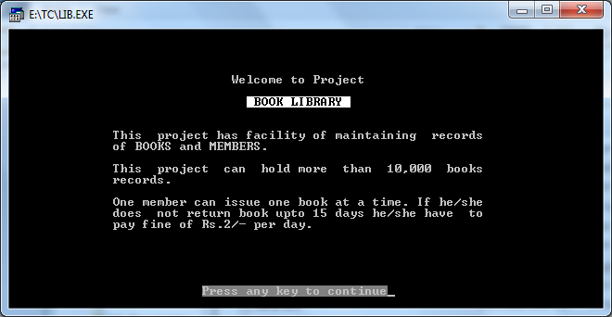

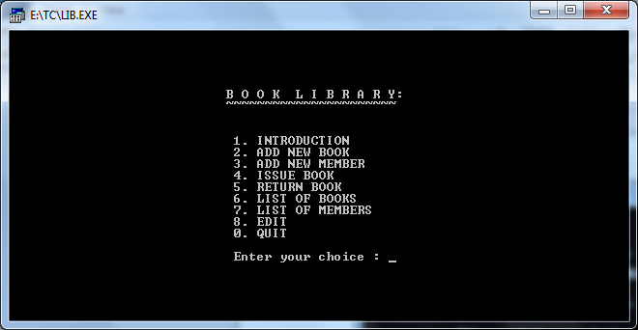

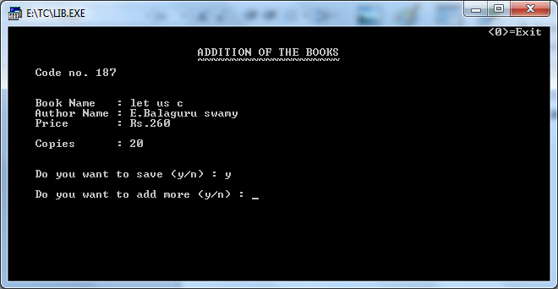

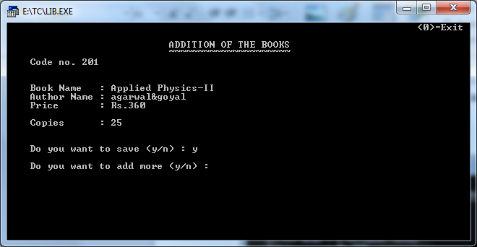

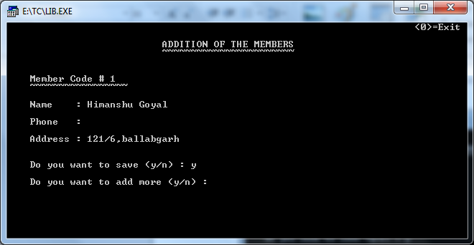

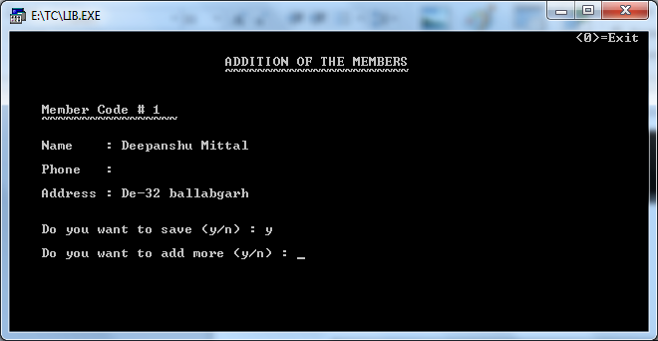

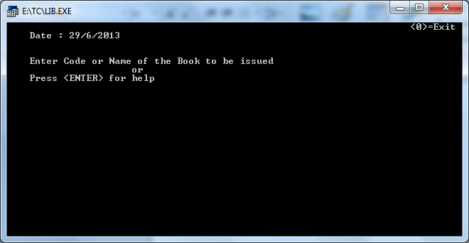

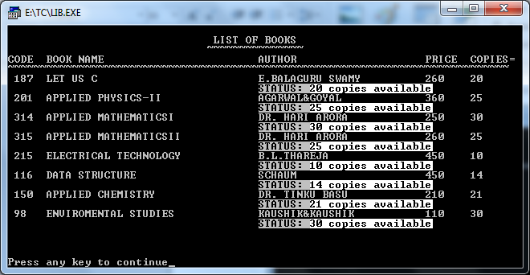

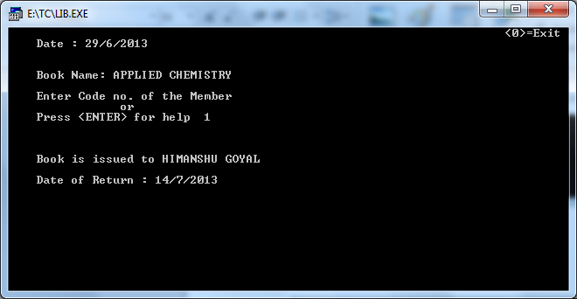

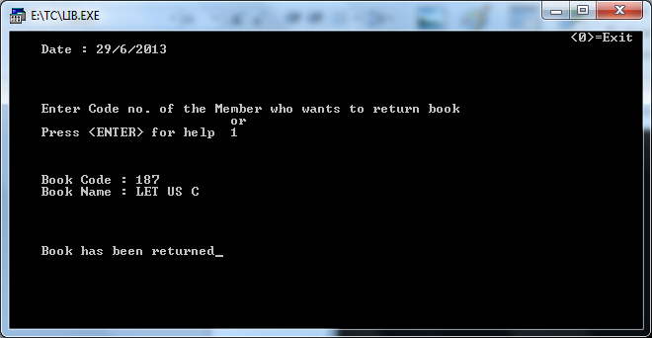

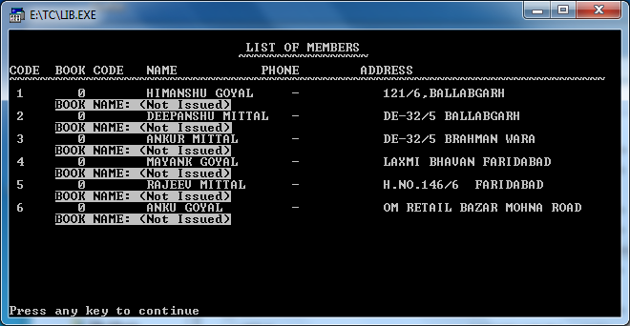

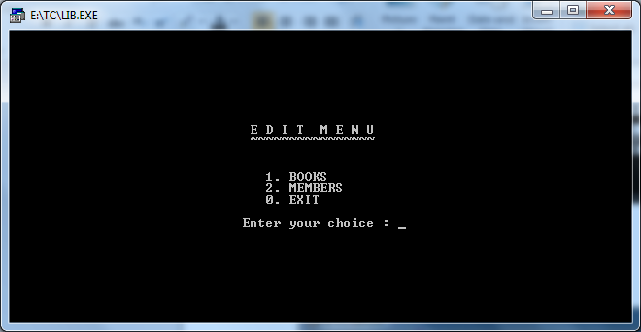

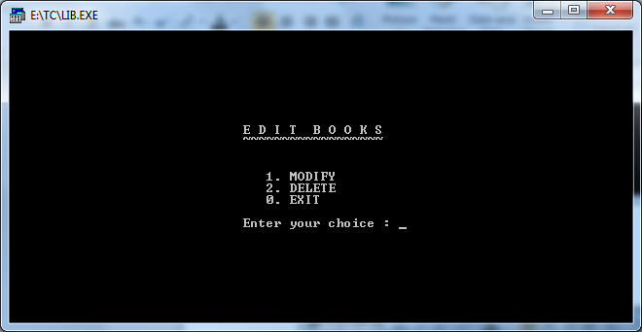

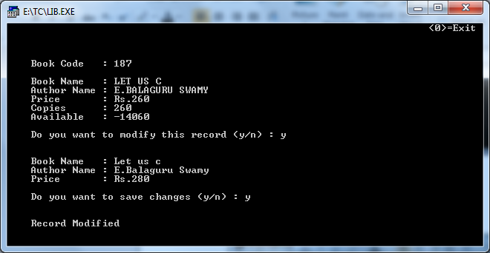

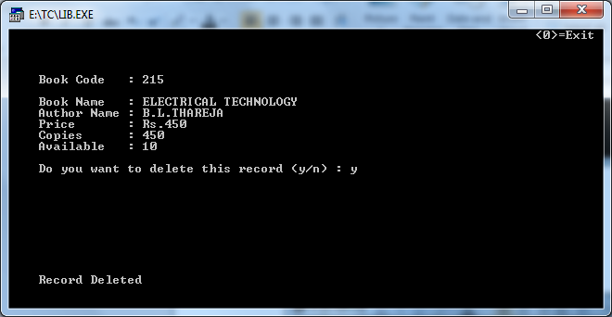

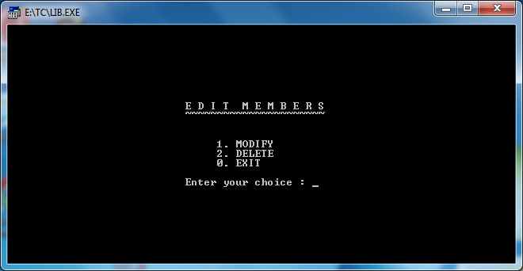

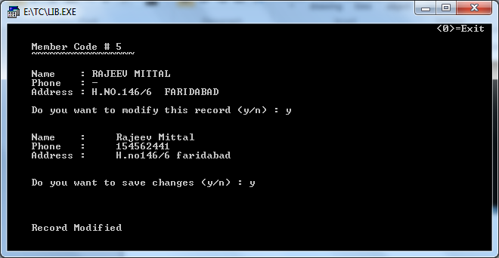

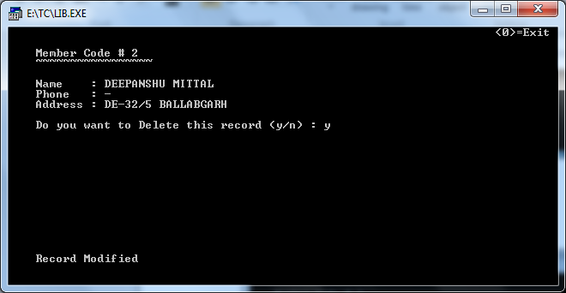

BIBLIOGRAPHY

C.B.S.E. Website
E.Balaguruswamy
Dr. Pinkey Chauhan
WWW.GOOGLE.COM

