CONTENTS

ABSTRACT: THE RISE OF GRAPHENE
Graphene is a rapidly rising star on the horizon of materials science and condensed-matter physics. This strictly two-dimensional material exhibits exceptionally high crystal and electronic quality, and, despite its short history, has already revealed a cornucopia of new physics and potential applications, which are briefly discussed here. Whereas one can be certain of the realness of applications only when commercial products appear, Graphene no longer requires any further proof of its importance in terms of fundamental physics. Owing to its unusual electronic spectrum, Graphene has led to the emergence of a new paradigm of 'relativistic' condensed-matter physics, where quantum relativistic phenomena, some of which are unobservable in high-energy physics, can now be mimicked and tested in table-top experiments. More generally, Graphene represents a conceptually new class of materials that are only one atom thick, and, on this basis, offers new inroads into low-dimensional physics that has never ceased to surprise and continues to provide a fertile ground for applications.

INTRODUCTION
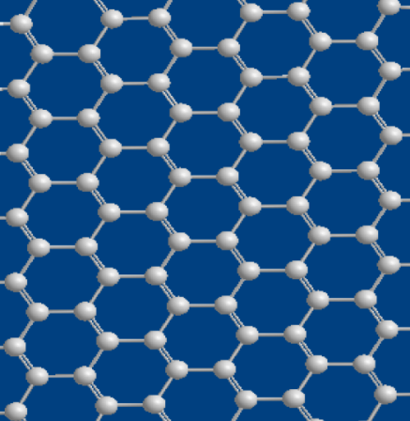
Graphene is a flat monolayer of carbon atoms tightly packed into a two-dimensional (2D) honeycomb lattice, and is a basic building block for graphitic materials of all other dimensionalities. It can be wrapped up into 0D fullerenes, rolled into 1D nanotubes or stacked into 3D graphite. Graphene is an allotrope of carbon whose structure is a single planar sheet of sp²-bonded carbon atoms, that are densely packed in a honeycomb crystal lattice. The term Graphene was coined by Hanns-Peter Boehm, who described single-layer carbon foils in 1962.
The carbon-carbon bond length in Graphene is about 0.142 nanometers. Graphene sheets stack to form graphite with an interplanar spacing of 0.335 nm. Graphene is the basic structural element of some carbon allotropes including graphite, charcoal, carbon nanotubes and fullerenes. It can also be considered as an indefinitely large aromatic molecule, the limiting case of the family of flat polycyclic aromatic hydrocarbons. 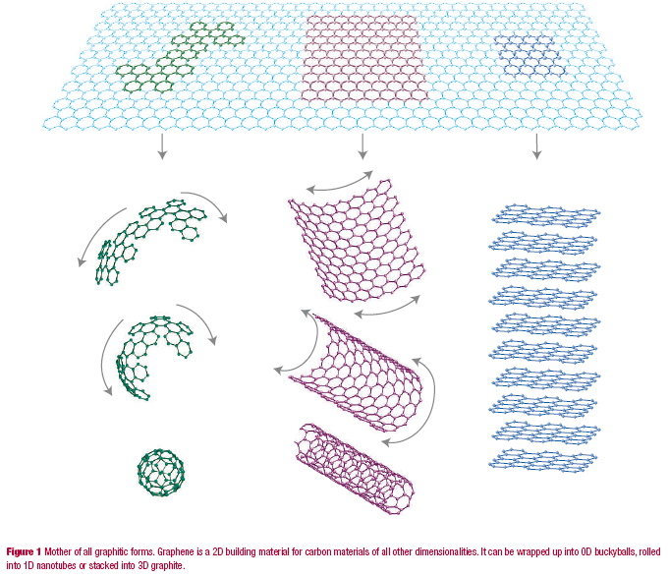
THE GRAPHENE TIMELINE
1947 | Graphene first studied as a limiting case for theoretical work on graphite by Phillip Wallace.
1966 | First attempts to grow multilayer graphite Hess W M and Ban L L also Karu A E and Beer M.
1984 | Massless charge carriers in Graphene pointed out theoretically by Gordon Walter Semenoff , David P. DeVincenzo and Eugene J. Mele.
1987 | Name “Graphene” first mentioned by S. Mouras and co-workers.
2004 | Graphene isolated in free form by Andre Geim and Kostya Novoselov.
2004 | Observation of Graphene’s ambipolar field effect by Andre Geim and Kostya  Novoselov.
2005 | Anomalous quantum hall effect detected showing massless nature of charge  carriers in Graphene Andre and Kostya and by Philip Kim and Yuanbo Zhang.
2006 | Quantum Hall effect seen at room temperature by Novoselov et. Al.
2007 | The first ever detection of a single molecule adsorption event by Schedin et. al.
2008 | Measurements of extremely high carrier mobility by Bolotin et. al.
2010 | Andre and Kostya were awarded the Nobel prize in physics for their work on Graphene.

THE DISCOVERY OF GRAPHENE

A key advance in the science of Graphene came when Andre Geim and Kostya Novoselov at Manchester University managed to extract single-atom-thick crystallites (Graphene) from bulk graphite in 2004 and transferred them onto thin SiO₂ on a silicon wafer in a process sometimes called micromechanical cleavage or, simply, the Scotch tape technique. The SiO₂ electrically isolated the Graphene, and was weakly interacting with the Graphene, providing nearly charge-neutral Graphene layers. The silicon beneath the SiO₂ could be used as a "back gate" electrode to vary the charge density in the Graphene layer over a wide range.
This technique led directly to the first observation of the anomalous quantum Hall effect in Graphene which provided direct evidence of the theoretically predicted pi Berry's phase of massless Dirac fermions in Graphene. The anomalous quantum Hall effect in Graphene was reported around the same time by Geim and Novoselov and by Philip Kim and Yuanbo Zhang in 2005.
On October 5, 2010, the Nobel Prize in Physics for the year was awarded to Andre Geim and Konstantin Novoselov from the University of Manchester for their work on Graphene.

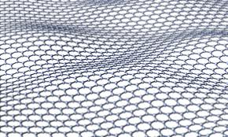
Single atom sheet of Graphene-a 2D crystal
PROPERTIES OF GRAPHENE

- Electronic properties
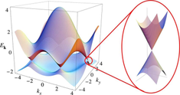
One of the hottest areas of graphene research focuses on the intrinsic electronic properties; how electrons flow through a sheet – only one atom thick – while under the influence of various external forces. So why is graphene such an exciting material?
Firstly, graphene is great conductor; electrons
are able to flow through graphene more easily than through even copper. The electrons travel through the graphene sheet as if they carry no mass, as fast as just one hundredth that of the speed of light.
Secondly, the way electrons behave in graphene make it very useful to study some fundamental physical properties. Graphene’s near perfect crystal lattice mean it is a very clean system in which to experiment. By restricting the electrons to only two dimensions, they exhibit some interesting properties such as the 'anomalous quantum Hall effect' and 'Klein tunnelling'.

- Thermal and Thermoelectric properties
Graphene is a perfect thermal conductor.
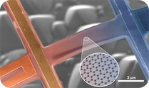
Its thermal conductivity was measured recently at room temperature and it is much higher than the value observed in all the other carbon structures as carbon nanotubes, graphite & diamond(> 5000 W/m/K).
The ballistic thermal conductance of graphene is isotropic, i.e. same in all directions. Similarly to all the other physical properties of this material, its 2 dimensional structure make it particularly special. Graphite, the 3 D version of graphene, shows a thermal conductivity about 5 times smaller (1000 Wm-1K-1). The phenomenon is governed by the presence of elastic waves propagating in the graphene lattice, called phonons.
The study of thermal conductivity in graphene may have important implications in graphene-based electronic devices. As devices continue to shrink and circuit density increases, high thermal conductivity, which is essential for dissipating heat efficiently to keep electronics cool, plays an increasingly larger role in device reliability.

- Mechanical properties
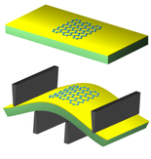
To calculate the strength of graphene, scientists used a technique called Atomic Force Microscopy. By pressing graphene that was lying on top of circular wells, they measured just how far you can push graphene with a small tip without breaking it.

It was found that graphene is harder than diamond and about 300 times harder than steel. To put this into context, it will take the weight of an elephant balanced on a needle-point in order to break this one atom thick fabric! The tensile strength of graphene exceeds 1 TPa.
Even though graphene is so robust, it is also very stretchable. You can stretch graphene up to 20% of its initial length. It is expected that graphene’s mechanical properties will find applications into making a new generation of super strong composite materials and along combined with its optical properties, making flexible displays.

- Optical properties
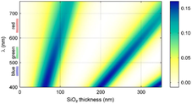
Graphene, despite being the thinnest material ever made, is still visible to the naked eye. Due to its unique electronic properties, it absorbs a high 2.3% of light that passes through it, which is enough that you can see it in air (if you could manage to hold it up!).
To help enhance the visibility of graphene flakes we deposit them on to silicon wafers which have a thin surface layer of silicon dioxide. Light shining on to these three-layer structures will be partially transmitted and partially reflected at each interface.
This leads to complex optical interference effects such that, depending on the thickness of the silicon-dioxide layer (which we can control to a high degree of accuracy), some colours are enhanced and some are suppressed. This technique takes advantage of the same physics which causes the "rainbow effect" that you see when you have a thin layer of oil floating on water. In this case, the different colours correspond to longer/shorter optical path lengths that the light has had to travel through the oil film.

- Chemical properties
Similar to the surface of graphite, graphene can adsorb and desorb various atoms and molecules (for example, NO2, NH3, K, and OH).
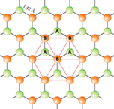
Weakly attached adsorbates often act as donors or acceptors and lead to changes in the carrier concentration, so graphene remains highly conductive. This can be exploited for applications as sensors for chemicals.
Other than weakly attached adsobates, graphene can be functionalized by several chemical groups (for instances OH-, F-) forming graphene oxide and fluorinated graphene. It has also been revealed that single-layer graphene is much more reactive than 2, 3 or higher numbers or layers.
Also, the edge of graphene has been shown to be more reactive than the surface. Unless exposed to reasonably harsh reaction conditions, graphene is a fairly inert material, and does not react readily despite every atom being exposed and vulnerable to it's surroundings.
FUTURE APPLICATIONS OF GRAPHENE

- Flexible touchscreens
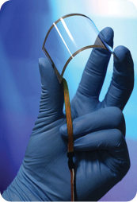
Researchers from the University of Exeter have come up with a competitive alternative to rare and expensive Iridium Tin Oxide. Using graphene and ferric chloride they have developed the “most transparent, lightweight and flexible material ever for conducting electricity”. The reason why researchers for graphene gcience turned to graphene is because it is the thinnest flexible electro-conducting material available for the industry for these applications. The combination of all these qualities makes it a perfect candidate for flexible touchscreen application. Some electro-conductivity problems were solved by sandwiching ferric chloride layer between two layers of graphene; using this method did not affect its optical transparency. The resulting material, called Graph-exeter turned out to be the most light-weight, flexible, inexpensive, transparent and electro-conducting material ever produced.

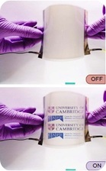
- LCD “Smart Windows”
Graphene is flexible, absorbs only 2.3% of light and conducts electricity very well. A layer of liquid crystals is sandwiched between two flexible electrodes comprised of graphene and transparent polymer. When there is no applied bias between the electrodes, liquid crystals scatter light and the smart window is opaque. When a bias is applied, the voltage aligns them, allowing light to pass through and the smart window turns transparent.

- Composite Materials

Graphene is one of the strongest and stiffest known materials and is also very light weight. These properties mean that graphene can be mixed with plastics such as epoxy to make composites which have good specific physical properties (i.e. strength per unit mass). Such graphene-plastic composites could be used to replace metals in the manufacture of aircraft and cars, making them lighter and more fuel efficient. Graphene is also electrically conductive which means it can be added to plastics to make them conductive as well. Conductive plastics are needed to protect carbon fibre aircraft wings against lightning strikes and prevent sparks from static electricity in the fuel lines and tanks of vehicles.

- Magnetism and Graphene
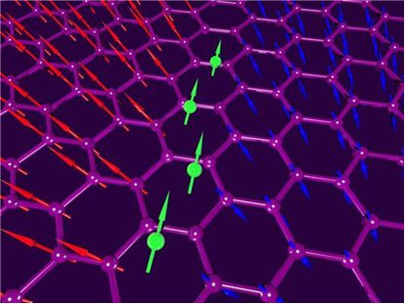
Given the great versatility of graphene’s properties and especially the ability to control many of its characteristics by external electric field (gate voltage), graphene has a potential to become an excellent material for spintronics. The current efforts concentrate on ‘making graphene magnetic’ by introducing point defects, such as vacancies or adatoms. Vacancies in graphene act as individual magnetic moments and lead to pronounced paramagnetism. The study also revealed significant limitations on defect-induced magnetism in graphene: it appears to be impossible to make graphene ferromagnetic in this way, because adatoms attached to neighbouring carbon atoms effectively cancel each other’s magnetism, while high densities of vacancies destroy graphene’s crystal structure and its essential properties. Nevertheless, even the achieved weak magnetism makes it an exciting potential candidate for spin-based devices. The next step is to learn how to reversibly control this magnetism by electric field.

- Graphene for Terahertz Electronics
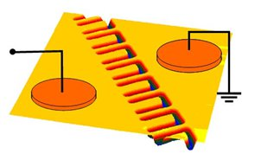
Conventional electronic devices are made up of silicon semiconductors, metal contacts, doped junctions or barrier structures, etc. Each of these components must be added vertically on top of one another. In contrast, novel concepts of nano-diodes and transistors that are based on single-layered device architecture have been developed. By using nano-scale electronic channels and tailoring the geometrical symmetry, the new devices have been demonstrated to have extremely high speed up to 1.5THz (1,500GHz), making them by far the fastest nanodevices to date. The single-layered device structures are particularly ideal for the unique, single-atom-layer graphene materials, with much greater performance envisaged. The immediate applications include high-speed electronics for next generation of computations and communications, far-infrared THz detection and emission, ultra-high sensitive chemical sensors, etc.

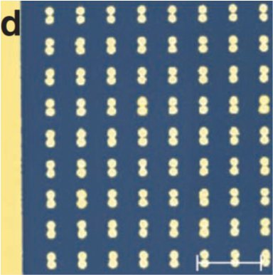
- Electrochemical Applications of Graphene
Graphene is the ideal electrode material: it is conducting, relatively inert, light, strong, flexible and has maximum surface area - essential because electrochemical conversion processes are interfacial by definition, so depend on the amount of surface available. Consequently, there is huge effort in developing batteries, fuel cells, photovoltaic cells and supercapacitors based on graphene. Electrochemical methods can also contribute to the synthesis of Graphene.

- Graphene Plasmonics
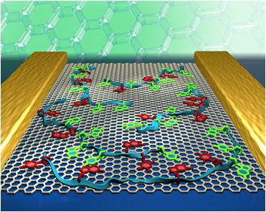
Graphene plasmonics: extraordinary electronic properties of graphene combined with extraordinary optical properties of plasmonic metamaterials promise new exciting applications. There are two main directions in developing graphene plasmonics:
- Plasmons can be used to modify the optoelectronic properties of graphene with possible application in graphene photovoltaics. This could lead to extremely fast photo-detectors and effective photocells.

- Graphene can be used to modify and electrically govern the optical properties of plasmonic systems. This could lead to the development of inexpensive, fast and small active optical elements.

- Graphene sensors

University of Manchester scientists were the first to demonstrate single-atom sensitivity in graphene Hall-bar devices. The most sensitive electronic detection is achieved by constructing a Hall-bar with graphene. Measurements are performed under the influence of a magnetic field, which deflects the electrons in the transverse direction to the applied electric field, generating a Hall voltage which is measured. This transverse Hall resistivity is very sensitive to changes in carrier concentration. The binding event between the graphene sensor and analyte leads to the donation or withdrawal of an electron from the graphene, which changes its electrical conductivity which can be measured. When a device is fabricated with a graphene sheet suspended in free space between two electrodes, it has a resonance frequency of vibration proportional to its mass. When an analyte interacts with such a graphene sensor, it changes the mass of the sensor. Some examples of sensor applications being pursued at Manchester include Genome-based graphene biosensor for detection of plant-to-plant and plant-to-pest signaling pathways in e-Agri and low-cost photonic sensors for environmental/health monitoring.

CONCLUSION
Graphene has an interesting history, but many now wonder about its future. The subject of considerable scholarly debate, it does seem reasonable to assert a few things looking ahead:
First, the quality and availability of “synthetic” Graphene will continue to improve. Whether high quality material comes in the form of an alternative chemical route to the complete exfoliation of graphite or from optimization of the thermal processes required for substrate-based methods, there is no sign that synthetic techniques are nearing their upper limit. This means that device engineers will have ample access to improved materials for developing novel structures and finding ways to integrate Graphene into present-day electronic devices.
Second, chemical modification of Graphene’s basal plane or its edges will substantially influence Graphene-based devices. For electronic applications, one can imagine the attachment of functional groups aimed at self-assembly of simple circuits or the incorporation of chemical dopants to limit leakage current under zero gate bias. For sensors, lock and-key type binding sites could provide selective sensitivity to a wide variety of analytes. These might include chemical warfare agents or even biological species.
Third, industrial use of Graphene as a transparent conductor could have huge implications for the solar industry. As synthetic routes improve, the prospect of replacing ITO with a low-cost carbon-based coating seems feasible. This would not only remove significant uncertainty about the availability and cost of indium but also enable non evaporative roll-to roll processing of transparent conductors.

