Dislocations and Strengthening Mechanisms
6.1 Dislocations & Plastic deformation and Mechanisms of plastic deformation in metals
6.1.1 Dislocations & Plastic deformation
While some materials are elastic in nature up point of fracture, many engineering materials like metals and thermo-plastic polymers can undergo substantial permanent deformation. This characteristic property of materials makes it feasible to shape them. However, it imposes some limitations on the engineering usefulness of such materials. Permanent deformation is due to process of shear where particles change their neighbors. During this process inter-atomic or inter-molecular forces and structure plays important roles, although the former are much less significant than they are in elastic behavior. Permanent deformation is broadly two types – plastic deformation and viscous flow. Plastic deformation involves the relative sliding of atomic planes in organized manner in crystalline solids, while the viscous flow involves the switching of neighbors with much more freedom that does not exist in crystalline solids.
It is well known that dislocations can move under applied external stresses. Cumulative movement of dislocations leads to the gross plastic deformation. At microscopic level, dislocation motion involves rupture and reformation of inter-atomic bonds. It has been concluded that one-dimensional crystal defects – dislocations – plays an important role in plastic deformation of crystalline solids. Their importance in plastic deformation is relevant to their characteristic nature of motion in specific directions (slip-directions) on specific planes (slip-planes), where edge dislocation move by slip and climb while screw dislocation can be moved by slip and cross-slip.
The onset of plastic deformation involves start of motion of existing dislocations in real crystal, while in perfect crystal it can be attributed to generation of dislocations and subsequently their motion. During the motion, dislocations will tend to interact among themselves. Dislocation interaction is very complex as number of dislocations moving on number of slip planes in various directions. When they are in the same plane, they repel each other if they have the same sign, and annihilate if they have opposite signs (leaving behind a perfect crystal). In general, when dislocations are close and their strain fields add to a larger value, they repel, because being close increases the potential energy (it takes energy to strain a region of the material). When unlike dislocations are on closely spaced neighboring slip planes, complete annihilation cannot occur. In this situation, they combine to form a row of vacancies or an interstitial atom.
An important consequence interaction of dislocations that are not on parallel planes is that they intersect each other or inhibit each other’s motion. Intersection of two dislocations results in a sharp break in the dislocation line. These breaks can be of two kinds:
(a) A jog is break in dislocation line moving it out of slip plane.
(b) A kink is break in dislocation line that remains in slip plane.
Other hindrances to dislocation motion include interstitial and substitutional atoms, foreign particles, grain boundaries, external grain surface, and change in structure due to phase change. Important practical consequences of hindrance of dislocation motion are that dislocations are still movable but at higher stresses (or forces), and in most instances that leads to generation of more dislocations. Dislocations can spawn from existing dislocations, and from defects, grain boundaries and surface irregularities. Thus, the number of dislocations increases dramatically during plastic deformation. As further motion of dislocations requires increase of stress, material can be said to be strengthened i.e. materials can be strengthened by controlling the motion of dislocation.
6.1.2 Mechanisms of plastic deformation in metals
Plastic deformation, as explained in earlier section, involves motion of dislocations. There are two prominent mechanisms of plastic deformation, namely slip and twinning.
Slip is the prominent mechanism of plastic deformation in metals. It involves sliding of blocks of crystal over one other along definite crystallographic planes, called slip planes. In physical words it is analogous to a deck of cards when it is pushed from one end. Slip occurs when shear stress applied exceeds a critical value. During slip each atom usually moves same integral number of atomic distances along the slip plane producing a step, but the orientation of the crystal remains the same. Steps observable under microscope as straight lines are called slip lines.
Slip occurs most readily in specific directions (slip directions) on certain crystallographic planes. This is due to limitations imposed by the fact that single crystal remains homogeneous after deformation. Generally slip plane is the plane of greatest atomic density, and the slip direction is the close packed direction within the slip plane. It turns out that the planes of the highest atomic density are the most widely spaced planes, while the close packed directions have the smallest translation distance. Feasible combination of a slip plane together with a slip direction is considered as a slip system. The common slip systems are given in table given below
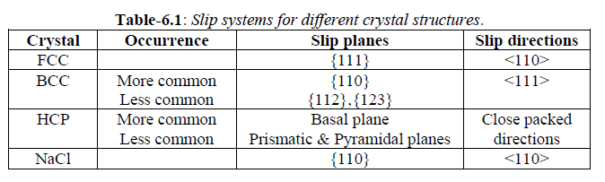
In a single crystal, plastic deformation is accomplished by the process called slip, and sometimes by twinning. The extent of slip depends on many factors including external load and the corresponding value of shear stress produced by it, the geometry of crystal structure, and the orientation of active slip planes with the direction of shearing stresses generated. Schmid first recognized that single crystals at different orientations but of same material require different stresses to produce slip. The dependence of various factors has been summarized using a parameter – critical resolved shear stress, $τ_{R}$, given as
$τ_{R}$ = $\frac{P\cos{σ}}{A/\cos{β}}$ = $\frac{P\cos{α\cos{β}}}{A}$
Where P – external load applied, A – cross-sectional area over which the load applied, $α$ – angle between slip direction and tensile axis, $β$– angle between normal to the slip plane and the tensile axis.
Shear stress is maximum for the condition where λ = ø = 45 ْ. If either of the angles are equal to 90 ْ, resolved shear stress will be zero, and thus no slip occurs. If the conditions are such that either of the angles is close to 90 ْ, crystal will tend to fracture rather than slip. Single crystal metals and alloys are used mainly for research purpose and only in a few cases of engineering applications.
Almost all engineering alloys are polycrystalline. Gross plastic deformation of a polycrystalline specimen corresponds to the comparable distortion of the individual grains by means of slip. Although some grains may be oriented favorably for slip, yielding cannot occur unless the unfavorably oriented neighboring grains can also slip. Thus in a polycrystalline aggregate, individual grains provide a mutual geometrical constraint on one other, and this precludes plastic deformation at low applied stresses. That is to initiate plastic deformation, polycrystalline metals require higher stresses than for equivalent single crystals, where stress depends on orientation of the crystal. Much of this increase is attributed to geometrical reasons.
Slip in polycrystalline material involves generation, movement and (re-)arrangement of dislocations. Because of dislocation motion on different planes in various directions, they may interact as well. This interaction can cause dislocation immobile or mobile at higher stresses. During deformation, mechanical integrity and coherency are maintained along the grain boundaries; that is, the grain boundaries are constrained, to some degree, in the shape it may assume by its neighboring grains. Once the yielding has occurred, continued plastic deformation is possible only if enough slip systems are simultaneously operative so as to accommodate grain shape changes while maintaining grain boundary integrity. According to von Mises criterion, a minimum of five independent slip systems must be operative for a polycrystalline solid to exhibit ductility and maintain grain boundary integrity. This arises from the fact that an arbitrary deformation is specified by the six components of strain tensor, but because of requirement of constant volume, there are only independent strain components. Crystals which do not possess five independent slip systems are never ductile in polycrystalline form, although small plastic elongation may be noticeable because of twinning or a favorable preferred orientation.
The second important mechanism of plastic deformation is twinning. It results when a portion of crystal takes up an orientation that is related to the orientation of the rest of the untwined lattice in a definite, symmetrical way. The twinned portion of the crystal is a mirror image of the parent crystal. The plane of symmetry is called twinning plane. Each atom in the twinned region moves by a homogeneous shear a distance proportional to its distance from the twin plane. The lattice strains involved in twinning are small, usually in order of fraction of inter-atomic distance, thus resulting in very small gross plastic deformation. The important role of twinning in plastic deformation is that it causes changes in plane orientation so that further slip can occur. If the surface is polished, the twin would be still visible after etching because it possesses a different orientation from the untwined region. This is in contrast with slip, where slip lines can be removed by polishing the specimen.
Twinning also occurs in a definite direction on a specific plane for each crystal structure. However, it is not known if there exists resolved shear stress for twinning. Twinning generally occurs when slip is restricted, because the stress necessary for twinning is usually higher than that for slip. Thus, some HCP metals with limited number of slip systems may preferably twin. Also, BCC metals twin at low temperatures because slip is difficult. Of course, twinning and slip may occur sequentially or even concurrently in some cases. Twinning systems for some metals are given in table-
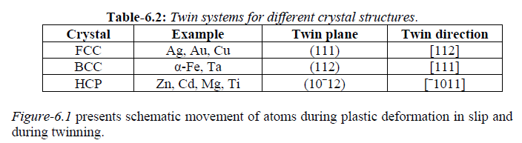

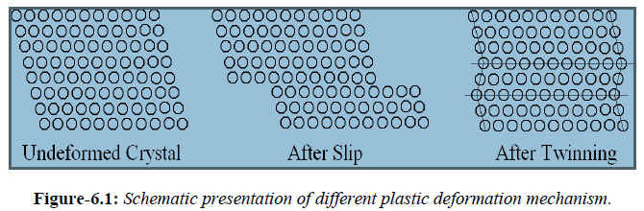

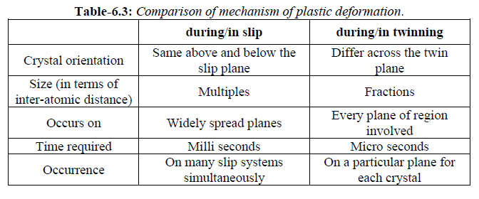
6.3 Recovery, Recrystallization and Grain Growth
As mentioned in earlier sections, annealing is an important industrial process to relieve the stresses from cold working. During cold working grain shape changes, while material strain hardens because of increase in dislocation density. Between 1-10% of the energy of plastic deformation is stored in material in the form of strain energy associated with point defects and dislocations. On annealing i.e. on heating the deformed material to higher temperatures and holding, material tends to lose the extra strain energy and revert to the original condition before deformation by the processes of recovery and recrystallization. Grain growth may follow these in some instances.

6.3.1 Recovery
This is the first stage of restoration after cold working where physical properties of the cold-worked material are restored without any observable change in microstructure. The properties that are mostly affected by recovery ate those sensitive to point defects, for example – thermal and electrical conductivities. During recovery, which takes place at low temperatures of annealing, some of the stored internal energy is relieved by virtue of dislocation motion as a result of enhanced atomic diffusion. There is some reduction, though not substantial, in dislocation density as well apart from formation of dislocation configurations with low strain energies. Excess point defects that are created during deformation are annihilated either by absorption at grain boundaries or dislocation climbing process. Stored energy of cold work is the driving force for recovery.
6.3.2 Recrystallization
This stage of annealing follows after recovery stage. Here also driving force is stored energy of cold work. Even after complete recovery, the grains are still in relatively high strain energy state. This stage, thus, involves replacement of cold-worked structure by a new set of strain-free, approximately equi-axed grains i.e. it is the process of nucleation and growth of new, strain-free crystals to replace all the deformed crystals. It starts on heating to temperatures in the range of 0.3-0.5 Tm, which is above the recovery stage. There is no crystal structure change during recrystallization. This process is characterized by recrystallization temperature which is defined as the temperature at which 50% of material recrystallizes in one hour time. The recrystallization temperature is strongly dependent on the purity of a material. Pure materials may recrystallizes around 0.3 Tm, while impure materials may recrystallizes around 0.5-0.7 Tm.
There are many variables that influence recrystallization behavior, namely amount of prior deformation, temperature, time, initial grain size, composition and amount of recovery prior to the start of the recrystallization. This dependence leads to following empirical laws:
- A minimum amount of deformation is needed to cause recrystallization.
- Smaller the degree of deformation, higher will be the recrystallization temperature.
- The finer is the initial grain size; lower will be the recrystallization temperature.
- The larger the initial grain size, the greater degree of deformation is required to produce an equivalent recrystallization temperature.
- Greater the degree of deformation and lower the annealing temperature, the smaller will be the recrystallized grain size.
- The higher is the temperature of cold working, the less is the strain energy stored and thus recrystallization temperature is correspondingly higher.
- The recrystallization rate increases exponentially with temperature.
During recrystallization, the mechanical properties that were changes during deformation are restored to their pre-cold-work values. Thus material becomes softer, weaker and ductile. During this stage of annealing impurity atoms tend to segregate at grain boundaries, and retard their motion and obstruct the processes of nucleation and growth. This solute drag effect can be used to retain cold worked strength at higher service temperatures. Presence of second phase particles causes slowing down of recrystallization – pinning action of the particles.
6.3.3 Grain growth
This stage follows complete crystallization if the material is left at elevated temperatures. However, grain growth does not need to be preceded by recovery and recrystallization; it may occur in all polycrystalline materials. During this stage newly formed strain-free grains tend to grow in size. This grain growth occurs by the migration of grain boundaries. Driving force for this process is reduction in grain boundary energy i.e. decreasing in free energy of the material. As the grains grow larger, the curvature of the boundaries becomes less. This results in a tendency for larger grains to grow at the expense of smaller grains. In practical applications, grain growth is not desirable. Incorporation of impurity atoms and insoluble second phase particles are effective in retarding grain growth.
Because the driving force for grain growth is lower than the driving force for recrystallization, grain growth occurs slowly at a temperature where recrystallization occurs at substantially high speeds. However, grain growth is strongly temperature dependent.

