Chloroplast
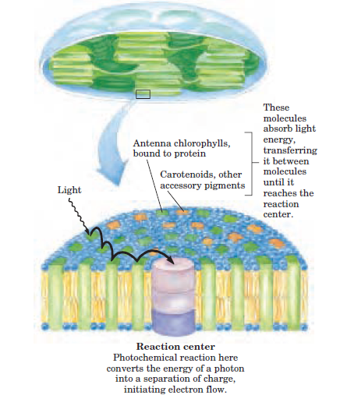

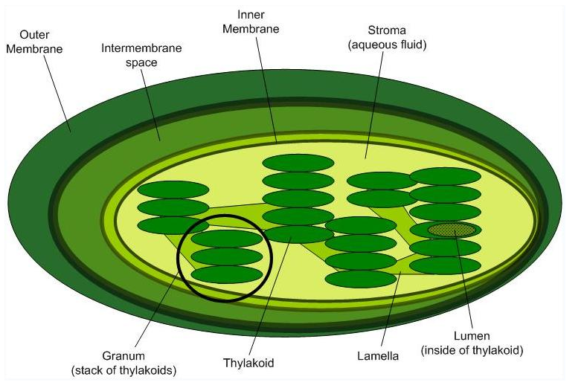

Ultra structure of a chloroplast
Chloroplast are about 4-5 um in diameter and 1 im thick. there are around 20-40 chloroplast / cell (plant cells ). They are evenly distributed in the cytoplasm and are oval or spherical in shape.
Chloroplast is surrounded by 2 membranes, the outer membrane and the inner membrane and the space between them is known as the inter membrane space.
Inner membrane encloses an aqueous fluid known as the stroma. Embedded in the stroma are present many flattened sac like structures known as the thylakoid, which are usually arranged in stacks known as grana. Embedded in the thylakoid membrane (commonly called as lamellae) are the photosynthetic pigments and the enzyme complexes that carry out light reaction and ATP synthesis. the phtosynthetic pigments in the thylakoid membrane are organized in the form of a photosystem. Each photosystem is made up of several antennae chlorophyll and accessory pigments surrounding a photoreaction center. Absorption of a photon of light by the antennae chlorophyll leads to excitation of the reaction center. excited reaction center emits and electron which travels through a range of electron carries and in the process a molecule of NADPH and ATP. The stroma contains more enzymes required for carbon assimilation reaction.
Photosynthesis is the main function of chloroplast. water and CO2 are used and sugars and oxygen are made during photosynthesis. It is divided into 2 phases light reaction - during which photolysis of water takes place and ATP and NADPH are generated and dark reaction during which CO2 is fixed and converted to sugars.

