Index
- HTML
- DHTML
- CSS
- PHP
- Java Script
- Basics of Photoshop

HTML & DHTML & CSS
As the HTML is a very easy language for creating the web pages. It can be learned in few hours or in few days. It is the basic format of the HTML file it can be displayed on mostly operating system which supports the web browser.
With the help of HTML you can easily create the web pages like:
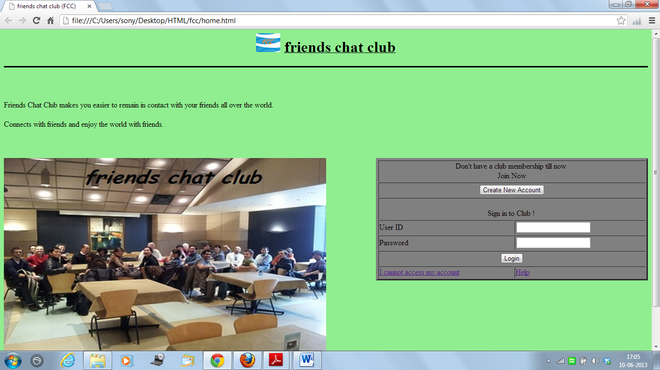
I have created this page and in this page there are many types of controls are used.
First of all let me explain the above web page and how it is created, how easily it can be created.
It is very easy to insert the element in the HTML pages simply by writing their tags and provide their attribute.
Basic Description of HTML File
The HTML file can be divided into the three parts:
HTML Header
HTML Body
HTML Footer
So let us see the Body of the HTML File:
HTML Header is the top most part of the HTML file in this section of the file we define the header of file and also Title of the file can be provided.
HTML Body is the middle part of file, in this section we define all text and elements which is to displayed on web page.
HTML Footer is the end section of the file.
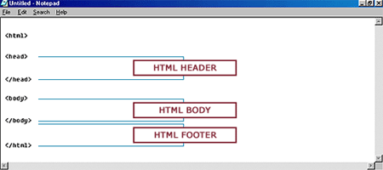
How To Write a HTML File
To write a HTML file you need an text editor, open the text editor and start writing file as given below:
Steps to write a file & view the web page:
1. Open the text editor (e.g. notepad).
2. Write the above file in it OR copy the above file and paste it on the notepad.
3. Save this file as .htm or .html file extension (e.g. <filename>.htm , .html).
4. Now open the Internet Browser and open the saved file.
5. Now you can see your web page.
The file starts from an <html> tag and ends with the </html>. <html> tag identifies that it is an HTML file. <html> is also called as open tag and it also need its closed tag which is </html>. Between these tags we will define the Header of the file, so add the <head> tag and below it write to close <head> tag.
More to display the Title to the Web Browser use the special tag <title> write here title </title>. Text written between the <title> & </title> tag will be displayed as the header of the your web page. The important tag is <body> tag. Whatever you want to display on the web page you must write it in between <body> & </body>.
There are many HTML tags which are used to create web pages and helps to add other effects. Some of tags are given bellow

Tags Ordered Alphabetically
Tags | Description
<!--...--> | Defines a comment
<a> | Defines an anchor
<abbr> | Defines an abbreviation
<acronym> | Defines an acronym
<address> | Defines an address element
<area> | Defines an area inside an image map
<b> | Defines bold text
<bdo> | Defines the direction of text display
<big> | Defines big text
<blink> | Defines the blinking text in a document
<blockquote> | Defines a long quotation
<body> | Defines the body element
<br> | Inserts a single line break
<button> | Defines a push button
<caption> | Defines a table caption
<center> | Deprecated. Defines centered text
<cite> | Defines a citation
<code> | Defines computer code text
<col> | Defines attributes for table columns
<colgroup> | Defines groups of table columns
<dd> | Defines a definition description
<del> | Defines deleted text
<dir> | Deprecated. Defines a directory list
<dfn> | Defines a definition term
<div> | Defines a section in a document
<dl> | Defines a definition list
<dt> | Defines a definition term
<em> | Defines emphasized text
<frameset> | Defines a fieldset
<font> | Deprecated. Defines the font face, size, and color of text
<form> | Defines a form
<frame> | Defines a sub window (a frame)
<fieldset> | Defines a set of frames
<h1> to <h6> | Defines header 1 to header 6
<head> | Defines information about the document
<hr> | Defines a horizontal rule
<html> | Defines an html document
<i> | Defines italic text
<iframe> | Defines an inline sub window (frame)
<img> | Defines an image
<input> | Defines an input field
<ins> | Defines inserted text
<kbd> | Defines keyboard text
<label> | Defines a label for a form control
<li> | Defines a list item
<map> | Defines an image map
<marquee> | Defines the moving text in a document
<menu> | Deprecated. Defines a menu list
<noframes> | Defines a noframe section
<ol> | Defines an ordered list
<optgroup> | Defines an option group
<option> | Defines an option in a drop-down list
<p> | Defines a paragraph
<pre> | Defines preformatted text
<q> | Defines a short quotation
<s> | Deprecated. Defines strikethrough text
<samp> | Defines sample computer code
<select> | Defines a selectable list
<small> | Defines small text
<span> | Defines a section in a document
<strike> | Deprecated. Defines strikethrough text
<strong> | Defines strong text
<style> | Defines a style definition
<sub> | Defines subscripted text
<sup> | Defines superscripted text
<table> | Defines a table
<tbody> | Defines a table body
<td> | Defines a table cell
<textarea> | Defines a text area
<tfoot> | Defines a table footer
<th> | Defines a table header
<thead> | Defines a table header
<title> | Defines the document title
<tr> | Defines a table row
<tt> | Defines teletype text
<u> | Deprecated. Defines underlined text;
<ul> | Defines an unordered list
<var> | Defines a variable

Tags Ordered by Function
Basic Tags
Tags | Description
<html> | Defines a html document
<head> | Defines information about the document
<title> | Defines the document title
<body> | Defines the body element
<h1> to <h6> | Defines header 1 to header 6
<p> | Defines a paragraph
<br> | Inserts a single line break
<hr> | Defines a horizontal rule
<!--...--> | Defines a comment

Links
Tags | Description
<a> | Defines an anchor

Lists
Tags | Description
<form> | <ul> Defines an unordered list
<input> | <ol> Defines an ordered list
<textarea> | <li> Defines a list item
<button> | <dir> Deprecated. Defines a directory list
<select> | <dl> Defines a definition list
<optgroup> | <dt> Defines a definition term
<option> | <dd> Defines a definition description
<label> | <menu> Deprecated. Defines a menu list

Images
Tags | Description
<img> | Defines an image
<map> | Defines an image map
<area> | Defines an area inside an image map

Tables
Tags | Description
<table> | Defines a table
<caption> | Defines a table caption
<th> | Defines a table header
<tr> | Defines a table row
<td> | Defines a table cell
<thead> | Defines a table header
<tbody> | Defines a table body
<tfoot> | Defines a table footer

Hyperlink

To hyperlink an image first we have to insert the image on the web page. So question is how to insert the image on the web page. In html the image can be inserted using the <img> tag. <img> tag has the attributes like width, height and src, which specifies the height and width of the image that is to displayed on the web page and scr has the value of the path where the image is stored. <img> tag does not have the end tag. so now use the <img> tag.
<img> tag
Format:
<img src="path" width="number" height="number">
Example:
<img src="img\logo_in.gif" width="200" height="200">
The example inserts the image "logo_in.gif" with the height of 200 pixel and width of 200 pixel. By using this tag you can insert the image in your html file, now if you want to create this image the hyperlink then follow the steps:
How to make the image as Hyperlink
Format:
<a href="path_of_file" ><img src="path" width="number" height="number"></a>
Example:
<a href="list_tags.php"><img src="img\logo_in.gif" width="200" height="200"></a>
To make an image as hyperlink just enter the <img> tag between the <a> anchor tag. And it will get Hyperlinked.

Now how to link 2 pages

The HTML <a> tag defines a hyperlink.
A hyperlink (or link) is a word, group of words, or image that you can click on to jump to another document.
When you move the cursor over a link in a Web page, the arrow will turn into a little hand.
The most important attribute of the <a> element is the href attribute, which indicates the link’s destination.
By default, links will appear as follows in all browsers:
- An unvisited link is underlined and blue
- A visited link is underlined and purple
- An active link is underlined and red

HTML Link Syntax
The HTML code for a link is simple. It looks like this:
<a href="url">Link text</a>
The href attribute specifies the destination of a link.

There are few other option i.e. Frames, Table, Input & Output elements.

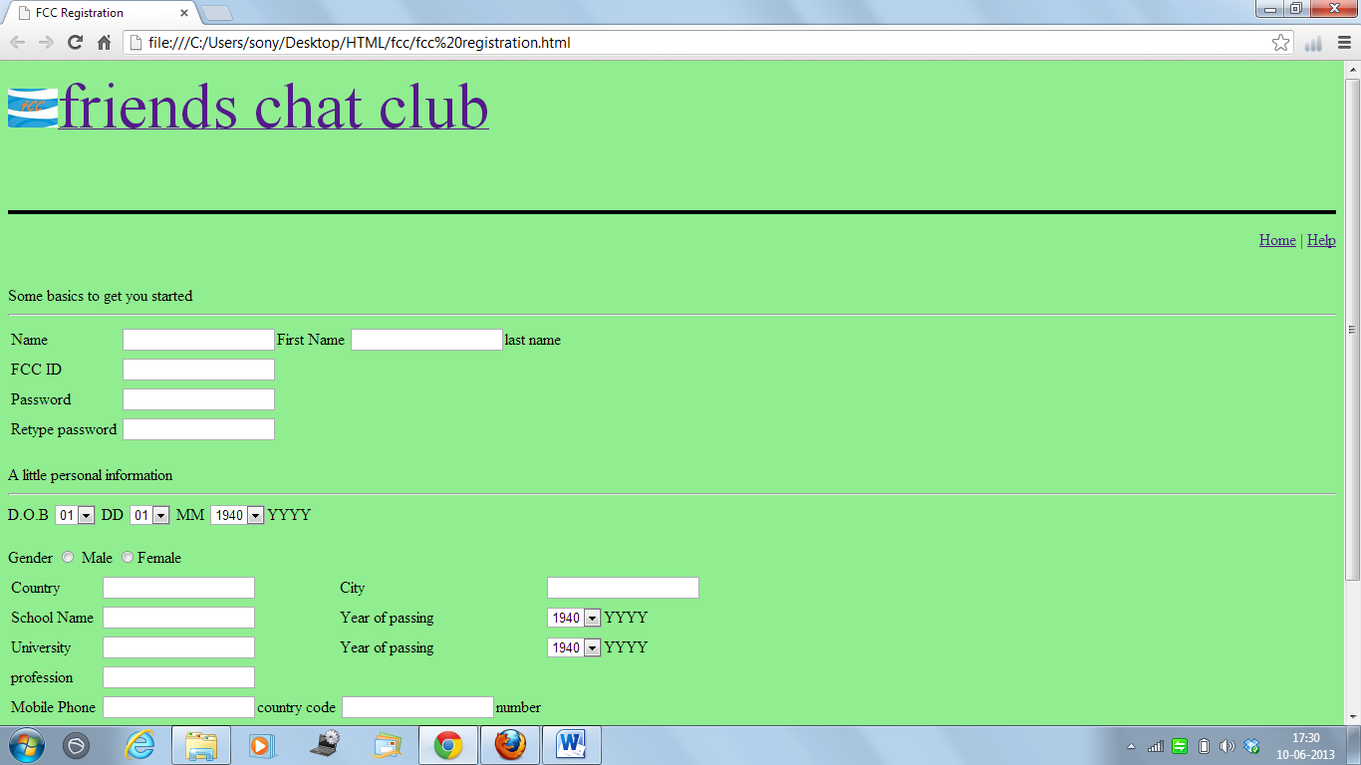
This is another page which is linked to previous page that is shown away and all links and attributes ,tables, frames,tags,elements are used here in this, this is all about html

DHTML

Dynamic HTML, or DHTML, is an umbrella term for a collection of technologies used together to create interactive and animated web sites by using a combination of a static markup language (such as HTML), a client-side scripting language (such as JavaScript), a presentation definition language (such as CSS), and the Document Object Model.
DHTML allows scripting languages to change variables in a web page's definition language, which in turn affects the look and function of otherwise "static" HTML page content, after the page has been fully loaded and during the viewing process. Thus the dynamic characteristic of DHTML is the way it functions while a page is viewed, not in its ability to generate a unique page with each page load.
By contrast, a dynamic web page is a broader concept, covering any web page generated differently for each user, load occurrence, or specific variable values. This includes pages created by client-side scripting, and ones created by server-side scripting (such as PHP, Perl, JSP or ASP.NET) where the web server generates content before sending it to the client.
DHTML is differentiated from AJAX by the fact that a DHTML page is still request/reload-based. With DHTML, there may not be any interaction between the client and server after the page is loaded; all processing happens in Javascript on the client side. By contrast, an AJAX page uses features of DHTML to initiate a request (or 'subrequest') to the server to perform actions such as loading more content.

Uses
DHTML allows authors to add effects to their pages that are otherwise difficult to achieve. In short words: scripting language is changing the DOM and style. For example, DHTML allows the page author to:
- Animate text and images in their document, independently moving each element from any starting point to any ending point, following a predetermined path or one chosen by the user.
- Embed a ticker that automatically refreshes its content with the latest news, stock quotes, or other data.
- Use a form to capture user input, and then process, verify and respond to that data without having to send data back to the server.
- Include rollover buttons or drop-down menus.
A less common use is to create browser-based action games. Although a number of games were created using DHTML during the late 1990s and early 2000s, differences between browsers made this difficult: many techniques had to be implemented in code to enable the games to work on multiple platforms. Recently browsers have been converging towards the web standards, which has made the design of DHTML games more viable. Those games can be played on all major browsers and they can also be ported to Plasma for KDE, Widgets for Mac OS X and Gadgets for Windows Vista, which are based on DHTML code.
The term "DHTML" has fallen out of use in recent years as it was associated with practices and conventions that tended to not work well between various web browsers. DHTML may now be referred to as unobtrusive JavaScript coding (DOM Scripting), in an effort to place an emphasis on agreed-upon best practices while allowing similar effects in an accessible, standards-compliant way.
DHTML support with extensive DOM access was introduced with Internet Explorer 4.0. although there was a basic dynamic system with Netscape Navigator 4.0, not all HTML elements were represented in the DOM. When DHTML-style techniques became widespread, varying degrees of support among web browsers for the technologies involved made them difficult to develop and debug. Development became easier when Internet Explorer 5.0+, Mozilla Firefox 2.0+, and Opera 7.0+ adopted a shared DOM inherited from ECMAscript.
More recently, JavaScript libraries such as jQuery have abstracted away much of the day-to-day difficulties in cross-browser DOM manipulation.
CSS

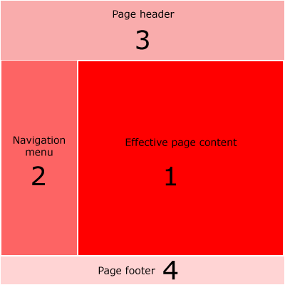

Its is used to change style and colour of the page that all we have discussed above.
PHP

PHP, which is recursive acronyms for "PHP Hypertext Preprocessor", is a server-side, HTML embedded scripting language used to create dynamic Web pages. Much of its syntax is borrowed from C, Java and Perl with some unique features thrown in. The goal of the language is to allow Web developers to write dynamically generated pages quickly.
In an HTML page, PHP code is enclosed within special PHP tags. When a visitor opens the page, the server processes the PHP code and then sends the output (not the PHP code itself) to the visitor's browser. It means that, unlike JavaScript, you don't have to worry that someone can steal your PHP script.
PHP offers excellent connectivity to many databases including MySQL, Informix, Oracle, Sybase, Solid, PostgreSQL, and Generic ODBC. The popular PHP-MySQL combination (both are open-source products) is available on almost every UNIX host. Being web-oriented, PHP also contains all the functions to do things on the Internet - connecting to remote servers, checking email via POP3 or IMAP, url encoding, setting cookies, redirecting, etc.
History of PHP
PHP stands for PHP: Hypertext Preprocessor, with that PHP standing for Personal HomePage/Form Interpreter . This type of acronym is known as a retronym. Originally, in 1994, the language was designed as a small set of binaries used to collect some basic site traffic data. In 1997 the parser was rewritten by two Israelis and the name was changed to the current acronym — it being determined that hypertext preprocessor was a decidedly more acceptable name in the business world.
PHP is an open-source language, used primarily for dynamic web content and server-side applications. It is often pointed to as the main competitor with:
• Microsoft's C# - Visual Basic.NET - ASP family,
• Sun's Java - JSP
• Macromedia's ColdFusion
• CGI – Perl
PHP has many open-source libraries included with the core build, and many more are readily available. Extensions exist to help PHP interface with a number of systems, including IRC, a number of compression formats, and Windows API. Other extensions exist to let PHP generate file formats on-the-fly, such as a popular extension which allows PHP to create Macromedia Flash movies.
Since version 3, PHP has integrated object oriented features. Version 5 built substantially on this limited functionality, and PHP now has robust object oriented capabilities, including interfaces, exceptions, destructions, and abstracts.
PHP reached wide-spread popularity with version 4, released in 2000. In 2004 PHP 5 was debuted, and it is now considered one the top languages used for server-side scripting.
PHP/FI
PHP succeeds an older product, named PHP/FI. PHP/FI was created by Rasmus Lerdorf in 1995, initially as a simple set of Perl scripts for tracking accesses to his online resume.
He named this set of scripts 'Personal Home Page Tools'. As more functionality was required, Rasmus wrote a much larger C implementation, which was able to communicate with databases, and enabled users to develop simple dynamic Web applications. Rasmus chose to » release the source code for PHP/FI for everybody to see, so that anybody can use it, as well as fix bugs in it and improve the code.
PHP/FI, which stood for Personal Home Page / Forms Interpreter, included some of the basic functionality of PHP as we know it today. It had Perl-like variables, automatic interpretation of form variables and HTML embedded syntax. The syntax itself was similar to that of Perl, albeit much more limited, simple, and somewhat inconsistent.
By 1997, PHP/FI 2.0, the second write-up of the C implementation, had a cult of several thousand users around the world (estimated), with approximately 50,000 domains reporting as having it installed, accounting for about 1% of the domains on the Internet. While there were several people contributing bits of code to this project, it was still at large a one-man project.
PHP/FI 2.0 was officially released only in November 1997, after spending most of its life in beta releases. It was shortly afterwards succeeded by the first alphas of PHP 3.0.
PHP 3
PHP 3.0 was the first version that closely resembles PHP as we know it today. It was created by Andi Gutmans and Zeev Suraski in 1997 as a complete rewrite, after they found PHP/FI 2.0 severely underpowered for developing an eCommerce application they were working on for a University project.
In an effort to cooperate and start building upon PHP/FI's existing user-base, Andi, Rasmus and Zeev decided to cooperate and announce PHP 3.0 as the official successor of PHP/FI 2.0, and development of PHP/FI 2.0 was mostly halted.
One of the biggest strengths of PHP 3.0 was its strong extensibility features. In addition to providing end users with a solid infrastructure for lots of different databases, protocols and APIs, PHP 3.0's extensibility features attracted dozens of developers to join in and submit new extension modules.
Arguably, this was the key to PHP 3.0's tremendous success. Other key features introduced in PHP 3.0 were the object oriented syntax support and the much more powerful and consistent language syntax.
The whole new language was released under a new name, that removed the implication of limited personal use that the PHP/FI 2.0 name held. It was named plain 'PHP', with the meaning being a recursive acronym - PHP: Hypertext Preprocessor.
By the end of 1998, PHP grew to an install base of tens of thousands of users (estimated) and hundreds of thousands of Web sites reporting it installed. At its peak, PHP 3.0 was installed on approximately 10% of the Web servers on the Internet. PHP 3.0 was officially released in June 1998, after having spent about 9 months in public testing.
PHP 4
By the winter of 1998, shortly after PHP 3.0 was officially released, Andi Gutmans and Zeev Suraski had begun working on a rewrite of PHP's core. The design goals were to improve performance of complex applications, and improve the modularity of PHP's code base. Such applications were made possible by PHP 3.0's new features and support for a wide variety of third party databases and APIs, but PHP 3.0 was not designed to handle such complex applications efficiently.
The new engine, dubbed 'Zend Engine' (comprised of their first names, Zeev and Andi), met these design goals successfully, and was first introduced in mid 1999.
PHP 4.0, based on this engine, and coupled with a wide range of additional new features, was officially released in May 2000, almost two years after its predecessor, PHP 3.0. In addition to the highly improved performance of this version, PHP 4.0 included other key features such as support for many more Web servers, HTTP sessions, output buffering, more secure ways of handling user input and several new language constructs.
Today, PHP is being used by hundreds of thousands of developers (estimated), and several million sites report as having it installed, which accounts for over 20% of the domains on the Internet.
PHP's development team includes dozens of developers, as well as dozens others working on PHP-related projects such as PEAR and the documentation project.
PHP 5
PHP 5 was released in July 2004 after long development and several pre-releases. It is mainly driven by its core, the Zend Engine 2.0 with a new object model and dozens of other new features.

JAVA SCRIPT
This is mainly used to check validations. Code is like

function validateForm()
{
var x=document.forms["myForm"]["email"].value;
var atpos=x.indexOf("@");
var dotpos=x.lastIndexOf(".");
if (atpos<1 || dotpos<atpos+2 || dotpos+2>=x.length)
{
alert("Not a valid e-mail address");
return false;
}
}
JavaScript is a cross-platform, object-oriented scripting language. JavaScript is a small, lightweight language; it is not useful as a standalone language, but is designed for easy embedding in other products and applications, such as web browsers. Inside a host environment, JavaScript can be connected to the objects of its environment to provide programmatic control over them.
Core JavaScript contains a core set of objects, such as Array, Date, and Math, and a core set of language elements such as operators, control structures, and statements. Core JavaScript can be extended for a variety of purposes by supplementing it with additional objects; for example:
- Client-side JavaScript extends the core language by supplying objects to control a browser (Navigator or another web browser) and its Document Object Model (DOM). For example, client-side extensions allow an application to place elements on an HTML form and respond to user events such as mouse clicks, form input, and page navigation.
- Server-side JavaScript extends the core language by supplying objects relevant to running JavaScript on a server. For example, server-side extensions allow an application to communicate with a relational database, provide continuity of information from one invocation to another of the application, or perform file manipulations on a server.
- Through JavaScript's LiveConnect functionality, you can let Java and JavaScript code communicate with each other. From JavaScript, you can instantiate Java objects and access their public methods and fields. From Java, you can access JavaScript objects, properties, and methods.

Basics of Photoshop

Photoshop is the most leading and popular graphic editing software provided by the adobe system and s used to edit different kinds of pictures, photographs, etc. The software photoshop was created and designed by Thomas Knoll in 1987
Photoshop have many uses: to color correct your digital images, prepare them for printing or web, design web pages, slice pages (make hyperlinks), you can also create gif animations, work with video, 3D content (Extended version), you can also make brand new images painting or drawing them with drawing tools, also in Photoshop you can make real and unreal compositions using masking tools and many, many other things.
Adobe Photoshop is a graphics editing program developed and published by Adobe Systems.
Adobe's 2003 "Creative Suite" rebranding led to Adobe Photoshop 8's renaming to Adobe Photoshop CS. Thus, Adobe Photoshop CS6 is the 13th major release of Adobe Photoshop. The CS rebranding also resulted in Adobe offering numerous software packages containing multiple Adobe programs for a reduced price. Adobe Photoshop is released in two editions: Adobe Photoshop, and Adobe Photoshop Extended, with the Extended having extra 3D image creation, motion graphics editing, and advanced image analysis features. Adobe Photoshop Extended is included in all of Adobe's Creative Suite offerings except Design Standard, which includes the Adobe Photoshop edition.
Alongside Photoshop and Photoshop Extended, Adobe also publishes Photoshop Elements and Photoshop Lightroom, collectively called "The Adobe Photoshop Family". In 2008, Adobe released Adobe Photoshop Express, a free web-based image editing tool to edit photos directly on blogs and social networking sites; in 2011 a version was released for the Android operating system and the iOS operating system.
Adobe distributes Photoshop in Windows and Macintosh versions.

Thank You

