Ankit Singh

Large Hadron Collider
LHC and its components

Contents
Topic Page No
Abstract 5
Objective 6
Introduction 7
Location and Layout 8
Design 9
The Detectors 10
Results of LHC 16
International and National Status 17
Review of Literature 17
More Information 18

Abstract

The construction of Large Hadron Collider (LHC) is a massive achievement. It was a dream for almost 30 years before it came into commissioning. Building a machine with the highest possible energy (7TeV) in a circumference of 27Km is quite a feat.

But that also required quite some innovations in itself.

A superfluid (state of matter with zero viscosity) helium cooling was required for 8.3T magnetic field.

LHC consists of components which work to find some information about universe which cant be found out using conventional physics.

LHC consist of seven detectors, each built to find specific things.

In LHC, micro black holes are produced all the time but they vaporize instantly so it isn’t much of a problem.

However, LHC is one of the biggest milestones in science universe.

Objective

The objective of this term paper is to understand the concept of particle accelerator and LHC in particular.
Through this term paper a person can understand

- what dark matter is and
- what contributions have been made to discover Higgs Boson.
- It also introduces several components of LHC that are used.
- The physics involed.

The reader is introduced to the concept of Supersymmetry and how is it beneficial in discovering dark matter.

Other than megastructures used to hold the LHC, the amazing computing power required for processing massive amount of data by LHC has also been mentioned in this report.

Introduction

LHC is world's most powerful and largest particle accelerator and it was first started on September 10, 2008. LHC is built in a tunnel 27Km in circumference on Franco-Swiss border near Ganeva, Swtizerland with about 10,000 scientists.

LHC has been made in a way that it boosts the energy of particle as it is made up of superconducting magnets with number of structures that increases particle's acceleration.

The method is simple yet very complex. Two beams of particles are made to move in opposite direction at close speed of light before they collide. The beams travel in two separate pipes kept at ultra high vacuum.

LHC is made up of seven detectors ATLAS, CMS, ALICE, TOTEM, MoEDAL, LHCb and LHCf.

ATLAS A Toroidal LHC Apparatus
CMS Compact Muon Solenoid
ALICE A Large Ion Collider Experiment
TOTEM Total elastic and diffractive cross-section measurement
MoEDAL Monopole and Exotics detectors at the LHC
LHCb LHC-beauty
LHCf LHC-forward

Purpose of building the LHC was to answer the following questions:
- Are the masses of elementary particles actually generated by the Higgs mechanism via electroweak symmetry breaking?
- Is supersymmetry, an extension of the Standard Model and Poincaré symmetry?
- Are there extra dimensions?
- What is the nature of the dark matter?
- Why is the fourth fundamental force so many orders of magnitude weaker than the other three fundamental forces?
LHC also has a computing grid which analysis data recieved from collisions. It produces about 25 petabytes of data per year. The grid has 170 computing facilities in about 36 countries.

Location and Layout
The gigantic Large Hadron Collider (LHC) is located near Geneva, where it spans the border between Switzerland and France. It is located in a tunnel 27 kilometres (17 mi) in circumference, as much as 175 metres (574 ft) beneath the Franco-Swiss border.

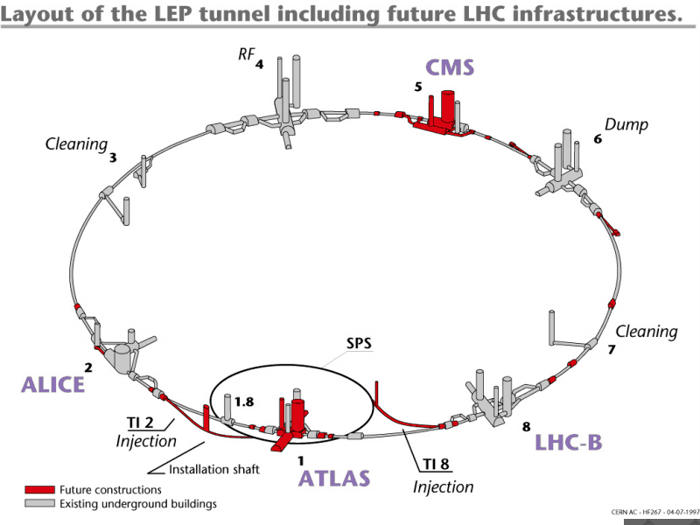

Design
- The LHC is the world's largest and highest-energy particle accelerator. The collider is contained in a circular tunnel, with a circumference of 27 kilometres (17 mi), at a depth ranging from 50 to 175 metres (160 to 574 ft) underground.

- The 3.8-metre (12 ft) wide concrete-lined tunnel, constructed between 1983 and 1988, was formerly used to house the Large Electron–Positron Collider. It crosses the border between Switzerland and France at four points, with most of it in France. Surface buildings hold ancillary equipment such as compressors, ventilation equipment, control electronics and refrigeration plants.

- The collider tunnel contains two adjacent parallel beam pipes that intersect at four points, each containing a proton beam, which travel in opposite directions around the ring. Some1,232 dipole magnets keep the beams on their circular path, while an additional392 quadrupole magnets are used to keep the beams focused, in order to maximize the chances of interaction between the particles in the four intersection points, where the two beams will cross. In total, over 1,600 superconducting magnets are installed, with most weighing over 27 tonnes.

- Approximately 96 tonnes of liquid helium is needed to keep the magnets at their operating temperature of 1.9 K (−271.25 °C), making the LHC the largest cryogenic facility in the world at liquid helium temperature.
The Detectors
As discussed earlier, LHC has seven detectors.

ATLAS

ATLAS stands for A Toroidal LHC Apparatus.

ATLAS is made to investigate many different types of physics that may be detected in the energetic collisions of the LHC.

It also carries the most important tasks for detecting Higgs Boson.

Currently CP violations, interactions of matter and anti-matter, are being investigated.

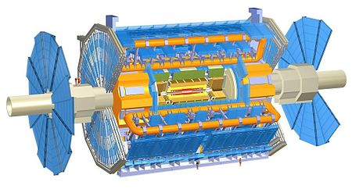

CMS
CMS stands for Compact Muon Solenoid.
It is one of the two general purpose detectors built on LHC.
The goal of CMS experiment is to investigate a wide range of physics, including the search for the Higgs boson, extra dimensions, and particles that could make up dark matter.
It is located in an underground cavern at Cessy in France, just across the border from Geneva. In July 2012, along with ATLAS, CMS discovered a boson, which is very similar to the Standard Model Higgs Particle.
The CMS detector is built around a huge solenoid magnet. This takes the form of a cylindrical coil of superconducting cable that generates a magnetic field of 4 tesla, about 100 000 times that of the Earth. The magnetic field is confined by a steel 'yoke' that forms the bulk of the detector's weight of 12 500 tonnes. An unusual feature of the CMS detector is that instead of being built in-situ underground, like the other giant detectors of the LHC experiments, it was constructed on the surface, before being lowered underground in 15 sections and reassembled.

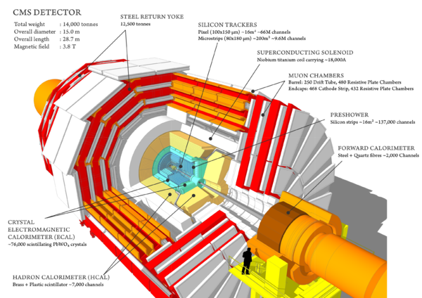
ALICE
ALICE stands for A Large Ion Colloider Experiment.
ALICE is optimized to study heavy ion collisions. Pb-Pb nuclei collisions will be studied at a centre of mass energy of 2.76 TeV per nucleus.
The resulting temperature and energy density are expected to be large enough to generate a quark-gluon plasma, a state of matter wherein quarks and gluons are deconfined.

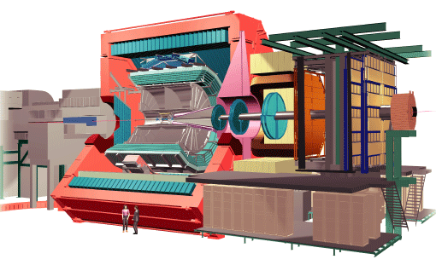

LHCb
LHCb stands for Large Hadron Collider beauty is one of seven particle physics detector experiments collecting data at the Large Hadron Collider accelerator at CERN. LHCb is a specialized b-physics experiment, that is measuring the parameters of CP violation in the interactions of b-hadrons. Such studies can help to explain the Matter-Antimatter asymmetry of the Universe. The detector is also able to perform measurements of production cross sections and electroweak physics in the forward region.

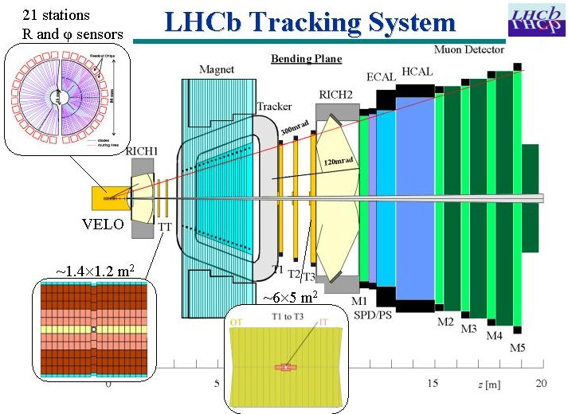

TOTEM
“Total elastic and diffractive cross-section measurement”.
It studies the size of proton and luminosity of LHC. (Luminosity is the number particles per unit area per time)
TOTEM is made up of gas-electron-multiplier detectors and cathode strip chamber and 8 Roman pots. (Roman pots are specially designed vacuum chambers).

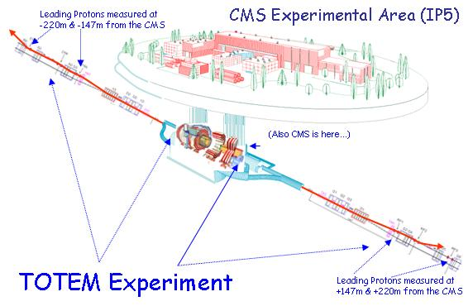

MoEDAL
Monopole and Exotics detectors at the LHC. Its main purpose is to search for magnetic monopole (Magnetic monopole is a hypothetical particle with a magnetic charge).
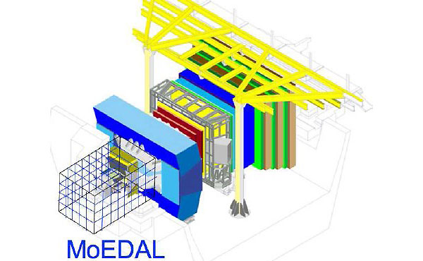

LHCf
The Large Hadron Collider forward (LHCf) experiment uses particles thrown forward by collisions in the Large Hadron Collider as a source to simulate cosmic rays in laboratory conditions.
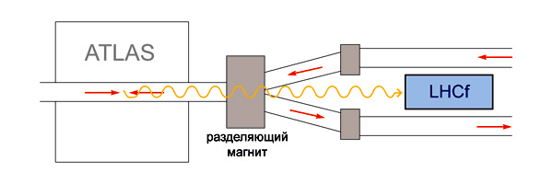

Results of LHC
LHC succeeded in finding a particle that was similar to Higgs Boson. Many people say that Higgs boson was found during the LHC experiment but that is not true. The theoretical calculation of mass gave a different value than the Higgs Boson.
Nevertheless, it was some particle similar to Higgs Boson.
In 1960s, it was proposed that a scalar field produces mass.
According to Quantum Field Theory (QFT), a field will have carrier particles. So Higgs proposed a mechanism, a Lagrangian (A function that summarizes dynamics of a system) that seemed to stick on to other particles and create inertia.
This was later called Higgs field (Higgs field is a scalar field).
So scientists @ CERN later used LHC to find a particle that was tentatively Higgs Boson.
The presence of Higgs boson couldn’t be confirmed because it might be possible that Higgs boson has a family (Higgs 1, Higgs 2 etc.) (This is my personal opinion though)
Even now lots of research is being done.
LHC uses supersymmetry to find exotic particles (sub-nucleonic particles too). These particles can’t be found out using EM waves.

International and National status of LHC
- It would be only fitting if it is quoted that LHC is the marvel of scientific developments.
- The development of LHC was in itself an international buzz.
- LHC has its roots in both France and Switzerland with scientists from all over the world.
- Its own computing grid spans in 36 countries with over 170 centres.

Review of Literature
- The upcoming experiments at the Large Hadron Collider have sparked fears among the public that the LHC particle collisions might produce doomsday phenomena, involving the production of stable microscopic black holes or the creation of hypothetical particles called strangelets.

- Two CERN-commissioned safety reviews have examined these concerns and concluded that the experiments at the LHC present no danger and that there is no reason for concern, a conclusion expressly endorsed by the American Physical Society.

- On the other hand LHC will help to solve major mysteries of universe. The report has a limited scope of creating awareness about LHC to the reader. However, It is also clear that LHC is not dangerous even when in operation.

More Information
More about CERN
CERN stands for European Council for Nuclear Research. At CERN, experiments are done in fields of bio and chemistry too.
CERN mostly uses purpose built particle detectors and accelerators.
The greatest of its experiment being the LHC.
Supersymmetry
Supersymmetry is a proposed symmetry of space and time. The theory states that each type of particle has one or more superpartners (A partner which will have most of the properties same as its partner but differ in a crucial way). For eg: Super parner of a fermion is a boson and vice versa.
Fermion and Boson
In a world where Einstein relativity is true, according to quantum mechanics, this world is made up of fermions and bosons.
An example of fermion is an electron and example of boson is a photon.
Hadron
The term hadron refers to particles composed of quarks.
Computing Grid “GRID”
• The World Wide Web provides seamless access to information that is stored in many millions of different geographical locations
• In contrast, the Grid is an emerging infrastructure that provides seamless access to computing power and data storage capacity distributed over the globe.

