Human genetic disorders (For your exam point of view karyotyping is not in the syllabus, however it is required for understanding the concept of human genetics)
Karyotype Analysis
A group of plants or animals comprising a species is characterized by a set of chromosomes, have certain constant features. These features include chromosome number, size and shape of individual chromosomes etc. The term karyotype is given to the group of characteristics that identifies a particular chromosome set and is usually represented by a diagram called ideogram where chromosomes of haploid set of an organism are ordered in a series of decreasing size. The karyotypes of different groups are sometimes compared and similarities in karyotype are presumed to represent evolutionary relationships.
The karyotype of the human female contains 23 pairs of homologous chromosomes:
- 22 pairs of autosomes
- 1 pair of X chromosomes
The karyotype of the human male contains:
- the same 22 pairs of autosomes
- one X chromosome
- one Y chromosome
A karyotyping is a technique that allows geneticists to visualize chromosomes under a microscope. The chromosomes can be seen using proper extraction and staining techniques when the chromosomes are in the metaphase portion of the cell cycle. Detecting abnormalities is important for prenatal diagnosis, detection of carrier status for certain genetic diseases or traits, and for general diagnostic purposes.
Karyotype analysis can be performed on virtually any population of rapidly dividing cells either grown in tissue culture or extracted from tumors. Chromosomes derived from peripheral blood cells lymphocytes, Skin fibroblasts, bone marrow cells, tumorcells, or amniocytes can be used for analysis.
Photography- Chromosome spreads can be photographed.

Enlargement of photo and rearrangement to form Karyotype- The photographs are enlarged, cut out, and assigned into the appropriate chromosome number or they can be digitally imaged using a computer. In case of Human karyotype, there are seven groups (A-G) that autosomal chromosomes are divided into based on size and position of the centromere. The standard nomenclature for describing a karyotype is based on the International System.

Human chromosomes are divided into 7 groups & sex chromosomes
- A 1-3 Large metacentric 1,2 or submetacentric
- B 4,5 Large submetacentric, all similar
- C 6-12, X Medium sized, submetacentric - difficult
- D 13-15 medium-sized acrocentric plus satellites
- E 16-18 short metacentric 16 or submetacentric 17,18
- F 19-20 Short metacentrics
- G 21,22,Y Short acrocentrics with satellites. Y no satellites.
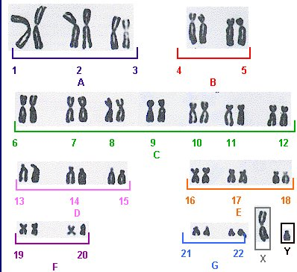

Human genetic disorders
Cytogenetic disorders are characterized by an abnormal karyotype. There are two mechanisms that lead to abnormal chromosomal constitution of abnormal karyotype.
1. Nondisjunction
2. Chromosomal rearrangements
1. Nondisjunction
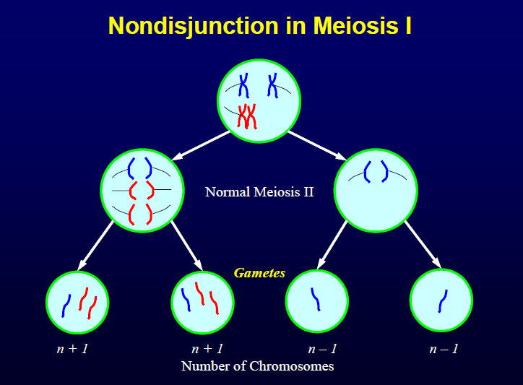
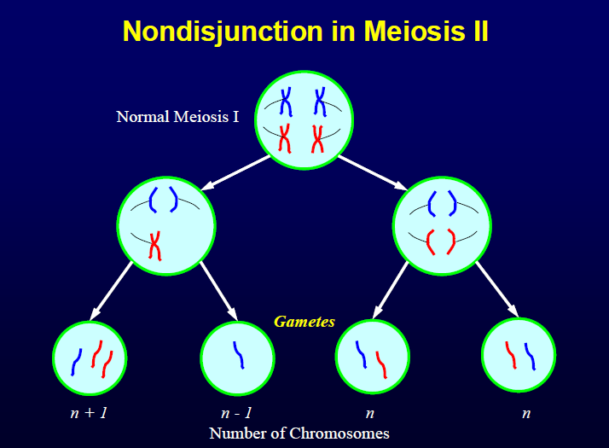
Non-disjunction ("not coming apart") is the failure of chromosome pairs to separate properly during meiosis stage 1 or stage 2, specifically in the anaphase. This could arise from a failure of homologous chromosomes to separate in meiosis I, or the failure of sister chromatids to separate during meiosis II or mitosis. The result of this error is a cell with an imbalance of chromosomes. Such a cell is said to be aneuploid. Loss of a single chromosome (2n-1), in which the daughter cell(s) with the defect will have one chromosome missing from one of its pairs, is referred to as a monosomy. Gaining a single chromosome, in which the daughter cell(s) with the defect will have one chromosome in addition to its pairs is referred to as a trisomy.
In the event that an aneuploidic gamete is fertilized, a number of syndromes might result. The only known survivable monosomy is Turner syndrome, where the individual is monosomic for the X chromosome.
Chromosomal Rearrangements
Translocation
A chromosome translocation is a chromosome abnormality caused by rearrangement of parts between nonhomologous chromosomes. A gene fusion may be created when the translocation joins two otherwise separated genes, the occurrence of which is common in cancer. It is detected on cytogenetics or a karyotype of affected cells.
Inversion
An inversion is a chromosome rearrangement in which a segment of a chromosome is reversed end to end. An inversion occurs when a single chromosome undergoes breakage and rearrangement within itself. An inversion does not involve a loss of genetic information, but simply rearranges the linear gene sequence.
Deletion
A deletion (also called gene deletion, deficiency, or deletion mutation) (sign: Δ) is a mutation (a genetic aberration) in which a part of a chromosome or a sequence of DNA is missing. Deletion is the loss of genetic material. Any number of nucleotides can be deleted, from a single base to an entire piece of chromosome.^{[1]} Deletions can be caused by errors in chromosomal crossover during meiosis. This causes several serious genetic diseases.

1. Trisomy21 (Down Syndrome)
Down syndrome is usually caused by an error in cell division called nondisjunction. However, two other types of chromosomal abnormalities, mosaicism and translocation, are also implicated in Down syndrome — although to a much lesser extent. Regardless of the type of Down syndrome a person may have, all people with Down syndrome have an extra, critical portion of chromosome 21 present in all or some of their cells. This additional genetic material alters the course of development and causes the characteristics associated with the syndrome.

The most common chromosomal disorder with incidence of 1:700 live births in the US.
There is a high correlation between maternal age and meiotic nondisjunction leading to trisomy21. Once you have one baby with Down syndrome your chances of having another child with the condition go up.

most common traits are:
• Muscle hypotonia – low muscle tone
• Flat facial profile – a somewhat depressed nasal bridge and a small nose
• Oblique palpebral fissures – an upward slant to the eyes
• Dysplastic ear – an abnormal shape of the ear
• Single palmar crease – a single deep crease across the center of the palm
• Hyper-flexibility – an excessive ability to extend the joints
• Curvature of the fifth finger, caused by under development of the middle phalanx (bone)
• Epicanthal folds – small skin folds on the inner corner of the eyes
• Excessive space between first and second toe
• Large tongue in relation to size of mouth

People with Down syndrome are at increased risk for certain health problems. While there is an
increased risk for certain medical conditions compared to the general population, advances in
medicine have rendered most of these health problems treatable and most people with Down
syndrome lead healthy lives. Congenital heart defects, increased susceptibility to infection, respiratory and hearing problems, obstructed digestive tracts, sleep apnea and childhood
leukemia occur with greater frequency in children with Down syndrome. Adults with Down
syndrome are also at increased risk for Alzheimer’s disease, thyroid conditions and sleep apnea. The majority of people born with Down syndrome today have an average life expectancy of 55 years, with some living into their seventies.

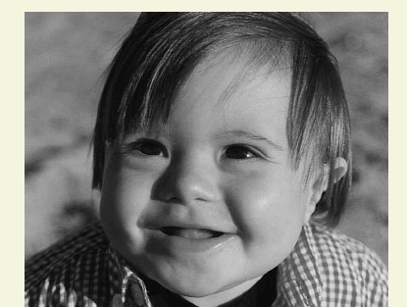

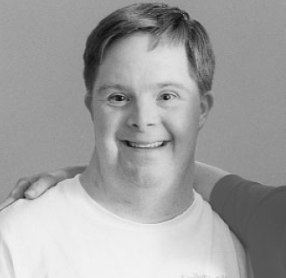

2. Turner Syndrome
It is caused by a sex chromosomal abnormality in females.
they contain a 45+XO genetic complement. and it represent a monosomic X condition. extensive karyotypic heterogenecity questions the existence of pure monosomy X because 99% of 45, X eggs are non-viable. thus it is also possible that post fertilization during the zygotic development few cells develop this abnormality thus the individual might not be a pure monosomic individual.
Researchers have not yet determined which genes on the X chromosome are responsible for most signs and symptoms of Turner syndrome. They have, however, identified one gene called SHOX that is important for bone development and growth. Missing one copy of this gene likely causes short stature and skeletal abnormalities in women with Turner syndrome.
Characteristic features.
Short stature, webbing of the neck, cardiovascular abnormalities, lack of secondary sex characteristics, streak ovaries (accelerated loss of oocytes) and thus infertility.

3. Klinefilter syndrome 47XXY
Can occur due to meiotic nondisjunction and thus formation of defective eggs/ sperm cells
or Can occur during post fertilization zygotic development - ie; mitotic division and thus lead to a condition where by a few cells will be normal (XY) and few will be with XXY condition. Even though all men with Klinefelter syndrome have the extra X chromosome, not every XXY male has all of those symptoms.
Because not every male with an XXY pattern has all the symptoms of Klinefelter syndrome, it is common to use the term XXY male to describe these men, or XXY condition to describe the symptoms.
Scientists believe the XXY condition is one of the most common chromosome abnormalities in humans.
1:850 male births
Rarely diagnosed before puberty
Tall stature,
hypogonadism [(dimisihed functional activity of gonads (testes in males)], lack of secondary male characteristics, gynecomastia (enlargement of breast tissue in males)
The principal cause of male infertility due to reduced spermatogenesis
Hormone therapy -
testosterone replacement therapy can greatly help XXY males get their testosterone levels into normal range. Having a more normal testosterone level can help develop bigger muscles, deepen the voice, and grow facial and body hair. TRT often starts when a boy reaches puberty. Some XXY males can also benefit from fertility treatment to help them father children.

4. Cri du chat syndrome
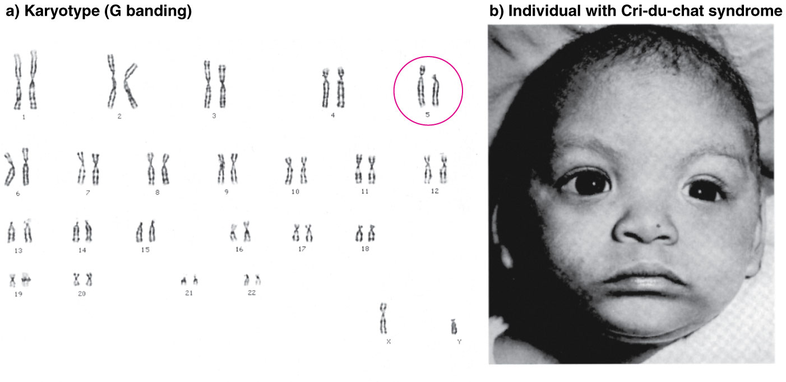
Cri du chat Syndrome is an uncommon and unusual hereditary disorder which is caused by a
deletion of chromosome 5p. Infants with this condition often have a high-pitched cry that sounds
like that of a cat. The disorder is characterized by intellectual disability and delayed
development, small head size (microcephaly), low birth weight, and weak muscle tone
(hypotonia) in infancy. Affected individuals also have distinctive facial features, including
widely set eyes (hypertelorism), low-set ears, a small jaw, and a rounded face. Some children
with cri-du-chat syndrome are born with a heart defect. Cri-du-chat syndrome occurs in an estimated 1 in 20,000 to 50,000 newborns.

Genetic counseling is the process, by which patients or relatives, at risk of an inherited disorder, are advised of the consequences and nature of the disorder, the probability of developing or transmitting it, and the options open to them in management and family planning. This complex process can be separated into diagnostic (the actual estimation of risk) and supportive aspects.

The goals of genetic counseling are to increase understanding of genetic diseases, discuss disease management options, and explain the risks and benefits of testing. Counseling sessions focus on giving vital, unbiased information and non-directive assistance in the patient's decision making process. Seymour Kessler, in 1979, first categorized sessions in five phases: an intake phase, an initial contact phase, the encounter phase, the summary phase, and a follow-up phase. The intake and follow-up phases occur outside of the actual counseling session. The initial contact phase is when the counselor and families meet and build rapport. The encounter phase includes dialogue between the counselor and the client about the nature of screening and diagnostic tests. The summary phase provides all the options and decisions available for the next step. If counselees wish to go ahead with testing, an appointment is organized and the genetic counselor acts as the person to communicate the results.

Some of the genetic disorders result because of an error or mutation occurring during the cell division process (e.g.trisomy). eg Down Syndrome.

Prenatal genetic counseling
If an initial noninvasive screening test reveals a risk to the baby, clients are encouraged to attend genetic counseling to learn about their options. Further prenatal investigation is beneficial and provides helpful details regarding the status of the fetus, contributing to the decision-making process. Decisions made by clients are affected by factors including timing, accuracy of information provided by tests, and risk and benefits of the tests. Counselors present a summary of all the options available. Clients may accept the risk and have no future testing, proceed to diagnostic testing, or take further screening tests to refine the risk. Invasive diagnostic tests possess a small risk of miscarriage (1-2%) but provide more definitive results. While families seek direction and suggestions from the counselors, they are reassured that no right or wrong answer exists. When discussing possible choices, counselor discourse predominates and is characterized by examples of what some people might do. Discussion enables people to place the information and circumstances into the context of their own lives. Clients are given a decision-making framework they can use to situate themselves. Counselors focus on the importance of individual choice based on the experiences, morals, and viewpoints of the couple/individual/family. Testing is offered to provide a definitive answer regarding the presence of a certain genetic condition or chromosomal abnormality. There is often no therapy or treatment available for these conditions, and as such parents may have to make decisions regarding the management of the pregnancy.

Referral
After attending counseling, women have the option of accepting the risk revealed and having no further treatment during their pregnancy. They may choose to undergo noninvasive screening (e.g. triple screen, cell-free fetal DNA screening) or invasive diagnostic testing (amniocentesis).

